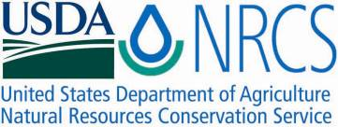

Plant Fact Sheet

# black mangrove

## Avicennia germinans (L.) L

Plant Symbol = AVGE

Contributed by: USDA NRCS Plant Materials Center, Golden Meadow, Louisiana

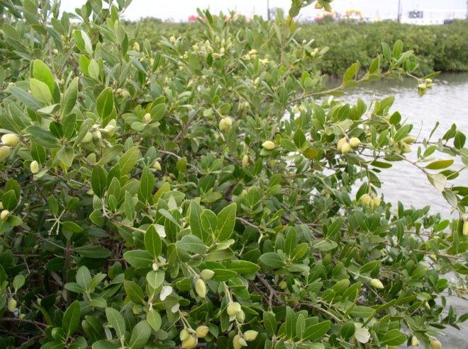

Garret Thomassie, USDA NRCS

Alternate Names

Avicennia nitida

Uses

*Erosion control*: Black mangrove is valuable in restoring brackish and salt water marshes due to its ability to filter and trap sediments. Mangrove forests, which include black mangrove, have a high capacity as a sink for excess nutrients and pollutants. It also mixes well with other native plants to reduce wave energy.

*Wildlife*: Black mangrove serves as nursery habitat for crustaceans and fish. Mangrove detritus (dead leaves and twigs) in water feeds microorganisms that provide food for young marine life. It is estimated that as much as 80% of the organic budget of bays in Florida came from the surrounding mangrove forests. Black mangrove serves as nesting habitat for many coastal birds including brown pelicans.

Status

Please consult the PLANTS Web site and your State Department of Natural Resources for this plant’s current status (e.g. threatened or endangered species, state noxious status, and wetland indicator values).

Description and Adaptation

Black mangrove is a subtropical woody shrub that grows in salt marshes. Mangroves are very hardy and have become adapted to harsh environments where water and salinity levels fluctuate. Pneumatophores, or breather roots, form a network that collects silt and debris, and controls erosion. Pneumatophores are a major adaptation to the stresses of intertidal habitat. They allow root respiration in anaerobic, waterlogged soils. The pneumatophores are also excellent nursery areas for crustaceans in the marsh plant community. The height of black mangrove in Louisiana varies from 4 to 9 feet. In Florida, individual trees can reach 60 feet, but are usually much shorter. Leaves are 1 to 5 inches long, elliptical, opposite, thick, leathery, dark green, glabrous (smooth) above, and grayish with a tight felt-like pubescence beneath. Glands on the underside secrete salt. Clusters of small sessile flowers with white petals, approximately ½ inch in diameter, are borne in the leaf axils and growing tips on the twigs. The fruit are flat, approximately 1 inch long, dark green and glabrous beneath a velvety pericarp. The bark on the black mangrove is thick, dark brown or blackish, with rough irregular flattened scales. Twigs are grayish in color and smooth, with enlargements at the joints.

Black mangrove is adapted to sub-tropical and tropical coastal intertidal zones along the Gulf of Mexico. The spatial distribution across the intertidal zone for black mangrove, red mangrove (Rhizophora mangle), and white mangrove (Laguncularia racemosa) suggests differential flooding tolerance among these species. Black mangrove penetrates farthest inland into brackish water and farthest north of the mangrove species. Black mangrove is able to regulate its internal salt concentration and grow in a wild range of salinities, but its ability to increase leaf area is limited under high salinity. At Bay Champagne near Fourchon, Louisiana, three vegetation zones were delineated in a mangal/salt marsh community: a zone adjacent to the bay and dominated by black mangrove, an inland zone dominated by cordgrass (Spartina alterniflora), and a zone between the two containing both species. Black mangrove is a valuable component of the marsh ecosystem. This plant is susceptible to freezing and the native range can be changed drastically by hard winters.

*Distribution*: Black mangrove is native to the southern U.S., tropical America, and Africa. Please consult the Plant Profile page for this species on the PLANTS Web site.

Establishment

Black mangrove grows in the intertidal zone throughout the Gulf of Mexico. It will establish in nature from seed that floats and can travel some distance on the tides. Seed will germinate quickly and establish young seedlings in good habitat. Mangrove communities will often reestablish by natural volunteer propagule recruitment if natural hydrologic patterns are restored.

Black mangrove may be propagated in the nursery from wild collected seed. Seed collected in the wild will not survive more than three to four weeks. Freshly collected seed should be soaked in water, the pericarp removed and the seed planted into plastic pots with any commercial potting soil. Various sizes of tubes and pots have been used with success. Germination and rooting normally occurs within two weeks of planting. Plants can be maintained in fresh water tanks that hold moisture at the bottom of the pots. One to two year old seedlings (18 inches tall) have been transplanted with great success to provide land stabilization and establish wildlife and marine habitats. The greater the root mass (not root bound pots) the greater the chance of successful out planting. The Florida Department of Natural Resources obtained excellent survival and growth by transplanting 19 to 59 inches tall seedlings, with a rootball diameter equal to one-half the tree height. Pruning seedlings just before or after transplanting enhances recovery and increases growth rate. Plant the seedlings in areas where the tidal flow will cover and uncover the root collar. Various water depths promote extensive root systems, but seedlings do not become established until water depth is reduced to 2 inches or less. Plantings in areas of high wave energy may have to be protected or anchored until the root system is capable of supporting the plant.

Management

There are no data on managing native black mangrove stands. In the Gulf of Mexico the range of black mangrove is “managed” by the winter weather.

Pests and Potential Problems

There are no known pests that could threaten black mangrove stands in the wild.

Environmental Concerns

Black mangrove is a valuable component of the intertidal ecosystem. Loss of black mangrove is a concern as it is a woody species that persists and assists in habitat development and in breaking wave energy and it provides nesting habitat for birds.

Cultivars, Improved, and Selected Materials (and area of origin)

The USDA NRCS Plant Materials Centers have released one variety. Pelican Germplasm black mangrove is a pre-varietal release from the Golden Meadow Plant Materials Center, Galliano, Louisiana. This germplasm was selected to provide a plant for soil conservation in brackish and salt water marshes.

Contact your local Natural Resources Conservation Service office for more information. Look in the phone book under “United States Government”. The Natural Resources Conservation Service will be listed under the subheading “Department of Agriculture.”

Prepared By

*Morris J Houck*, USDA NRCS, Plant Materials Specialist, Alexandria, Louisiana

Species Coordinator

*Richard H. Neill*, USDA NRCS Golden Meadow Plant Materials Center, Galliano, Louisiana

### Citation

Houck, M., Neill, R. 2009. Plant fact sheet for black mangrove (*Avicennia* *germinans* (L.) L.). USDA-Natural Resources Conservation Service, Louisiana Plant Materials Center, Galliano, Louisiana 70354

Published: September 2009

Edited: 18Sep09 jfh; 22Sep09 mws

For more information about this and other plants, please contact your local NRCS field office or Conservation District <<http://www.nrcs.usda.gov/>>, and visit the PLANTS Web site <[http://plants.usda.gov](http://plants.usda.gov/)> or the Plant Materials Program Web site <<http://plant-materials.nrcs.usda.gov>>

**USDA IS AN EQUAL OPPORTUNITY PROVIDER AND EMPLOYER**