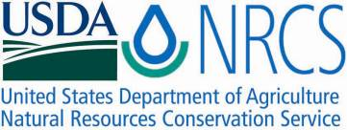

Plant Fact Sheet

**BURNINGBUSH**

***Bassia scoparia* (L.) A.J. Scott**

Plant Symbol = BASC5

Contributed by: USDA NRCS Kansas Plant Materials Center, Manhattan, Kansas

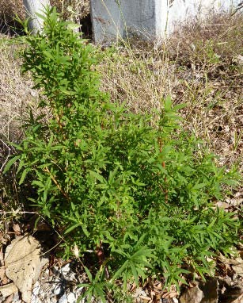

Figure 1. P. Allen Casey. 2009. USDA-NRCS. Burningbush that exhibits red colored stems. Found on a disturbed site along a gravel road. Riley County, Kansas

**Alternate Names**

*Bassia scoparia*; *Bassia sieversiana*; *Kochia alata*; *Kochia trichophila*; *Kochia trichophylla*; kochia, Mexican fireweed; mock cypress; fireweed; mirabel; summer cypress; common kochia; Mexican summer-cypress; railroad weed; belvedere; firebush; poor man’s alfalfa; common red sage

**Caution: This plant is highly invasive.**

**Caution: This plant can be toxic.**

**Uses**

Burningbush is used by wildlife for food and cover. It can be hayed or grazed directly for livestock feed. Burningbush can be planted for soil erosion control and bioremediation of some contaminated sites. It is used in some Asian cultures for food and in some parts of Europe and Asia it is planted for making brooms. Burningbush contains compounds that could be used in medicines.

**Status**

This plant is or can be noxious and/or invasive in some areas. Please consult the PLANTS Web site and your State Department of Natural Resources for this plant’s current status (e.g., threatened or endangered species, state noxious status, and wetland indicator values).

**Weediness**

This plant may become weedy or invasive in some regions or habitats and may displace desirable vegetation if not properly managed. Please consult with your local NRCS Field Office, Cooperative Extension Service office, state natural resource, or state agriculture department regarding its status and use. Weed information is also available from the PLANTS Web site at plants.usda.gov. Please consult the Related Web Sites on the Plant Profile for this species for further information.

**Description and Adaptation**

Burningbush is an introduced, erect, annual forb. The simple, alternately arranged leaves are linear to narrowly ovate to 2 inches (5.5 cm) long and can have hairs, depending on age. Leaves are very short petioled or sessile. Stems are green, red tinged, or red depending on age. The flowers are green leaf-like bracts. It has a spike. Burningbush has small fruits with an oval, brown to black seed. Burningbush varies widely in morphological characters partially due the environment where it is found.

Burningbush is native to central and eastern Europe and Asia. Burningbush can be found in a very wide range of temperatures and climatic regions throughout the world, but is particularly adapted to arid and semi-arid regions. Burningbush is common in rangelands, pastures, fields, disturbed sites, gardens, roadsides, ditchbanks, and in soils with high salinity. It can be found in areas with as little as 6 inches (15.24 cm) of annual rainfall.

Plant Materials <http://plant-materials.nrcs.usda.gov/> Plant Fact Sheet/Guide Coordination Page <http://plant-materials.nrcs.usda.gov/intranet/pfs.html> National Plant Data Center <http://npdc.usda.gov>

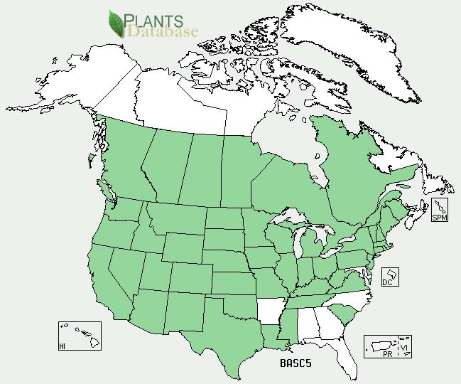Burningbush distribution from USDA-NRCS PLANTS Database.

For updated distribution, please consult the Plant Profile page for this species on the PLANTS Web site.

**Establishment**

Soil should be plowed or disked and weed free. Planting should be done late April to early May. Liming of the soil to a pH of 6.0 is recommended. Nitrogen should be applied before planting and topdressing the remainder later depending on the anticipated yield. Planting can be done by drilling or broadcast planting by hand or by airplane.

**Management**

Burningbush is palatable to all classes of livestock. It can be toxic to livestock and may cause death if consumed in large quantities. It is recommended that burningbush forage should consist of not more than 50% of livestock ration. Burningbush stands can be grazed by livestock directly or it can be cut for hay or silage. Care should be taken to prevent poisoning.

**Pests and Potential Problems**

Burningbush may be host to various fungi, pathogens, and insects, some of which can be detrimental to crops like sugarbeet, potatoes, and tobacco. Grasses will out compete burningbush. Volunteer burningbush is likely to be a problem in crops that are planted following burningbush.

**Environmental Concerns**

Burningbush is highly invasive and is able to establish and persist in harsh environments where other plants are limited. Burningbush may be hard to control once it is established in an area.

**Control**

Please contact your local agricultural extension specialist or county weed specialist to learn what works best in your area and how to use it safely. Always read label and safety instructions for each control method.Trade names and control measures appear in this document only to provide specific information. USDA NRCS does not guarantee or warranty the products and control methods named, and other products may be equally effective.

Herbicides generally become less effective as the plant matures. Some populations have shown resistance to 2, 4-D, triazine, auxinic herbicides, dicamba, and sufonylurea. The herbicide 2, 4-D, itself, does not provide acceptable control regardless of formulation, dose, or timing of the application.

**Cultivars, Improved, and Selected Materials (and area of origin)**

These plant materials are somewhat available from commercial sources as an ornamental. These plant materials are not readily available from commercial sources for use as livestock forage.

**Prepared By**

*P. Allen Casey*, USDA NRCS Plant Materials Center, Manhattan, Kansas

**Citation**

Casey, P.A. 2009. Plant Fact Sheet for burningbush Bassiascoparia (L.) A.J. Scott. USDA-Natural Resources Conservation Service, Kansas Plant Materials Center. Manhattan, KS.

Published October 2009

Edited:

For more information about this and other plants, please contact your local NRCS field office or Conservation District <<http://www.nrcs.usda.gov/>>, and visit the PLANTS Web site <[http://plants.usda.gov](http://plants.usda.gov/)> or the Plant Materials Program Web site <<http://plant-materials.nrcs.usda.gov>>

**USDA IS AN EQUAL OPPORTUNITY PROVIDER AND EMPLOYER**