|  |
| --- |
| COLUMBIA BROME |
| ***Bromus vulgaris* (Hook.) Shear** |
| Plant Symbol = BRVU |

*Contributed by: USDA NRCS Plant Materials Center, Corvallis, Oregon*

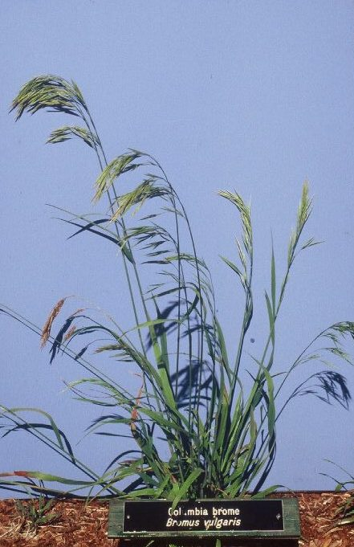

Dale Darris

USDA NRCS Corvallis PMC

**Alternate names:** Narrow-flowered brome is another common name.

**Uses:** Columbia brome is a native upland grass useful for erosion control and revegetation along shady streambanks, ravines, and roadsides. The species is also important for the restoration of moist to relatively dry understory woodland plant communities. The fibrous root system aids in soil retention especially on steeper, rocky, north facing slopes. Ranked high as palatable livestock forage, Columbia brome is valuable for grazing at mid to higher elevations in certain western ranges. It’s affinity for shade lends application to silvopastural systems (combined tree and forage production). Elk utilize it in spring and other ungulates presumably graze it as well. The seed and plants serve as food and cover for small mammals and birds.

# Description: Columbia brome is a cool season perennial bunchgrass that is short to medium lived depending on growing conditions. The base is loosely clumped and non-rhizomatous although rooting may (rarely) occur from lower nodes along the stems (culms). The culms are 45-120 cm tall and erect to spreading, often with hairy nodes (joints). Inflorescences (seedheads or panicles) are 8-22 cm long, spreading to drooping, typically with the slender, compressed spikelets (subunits of the seedhead) all hanging in the same direction. Leaves are course textured (5-12 mm wide), often hairy on at least one side, basal to part way up the stems, lax, and flat.

*Key to identification*: Despite the typical hairy nodes and uniform orientation of the drooping seedheads, Columbia brome is difficult to distinguish from three other native bromes that occur in the western US, often in similar habitats: fringed brome (*Bromus ciliatus*), Orcutt’s brome (*Bromus orcuttianus)*, and woodland or Chinook brome (*Bromus laevipes*). Refer to a botanical key for detailed descriptions of traits and proper identification. It should not be confused with false brome (*Brachypodium sylvaticum*), a weedy and invasive introduced grass that also grows in woodland situations. The spikelets of both species noticeably droop, but on Columbia brome they are clearly stalked (i.e. on short branchlets) and on false brome they are not.

**Adaptation:** Columbia brome is widely distributed in the western US and Canada from sea level to an elevation of 6500 ft. In the US it occurs from Washington south to California and west to Montana, Wyoming, and Utah. It strongly prefers shaded habitats including woodland edges and the floor of hardwood and coniferous forest types. Survival in open areas appears more limited to ravines, north facing slopes, seepage areas, and montane meadows.

Soil adaptation varies from volcanic ash to deep, moderately well and well drained sandy loams, loams, silts, and clays that are moderately acid to slightly alkaline (pH 5.4 to 7.9) with generally rich nutrient regimes. The species is found in disturbed environments such as along streams and in clearcuts, as well as in mature undisturbed forests. In natural settings, response to fire varies with litter dryness and intensity of burn, but is generally considered neutral in terms of regeneration. Prolonged smoldering can destroy plants. Tolerances to saline, flooded or saturated soil conditions are low.

**Commercial availability:** A few seed sources from Oregon and California are periodically for sale.

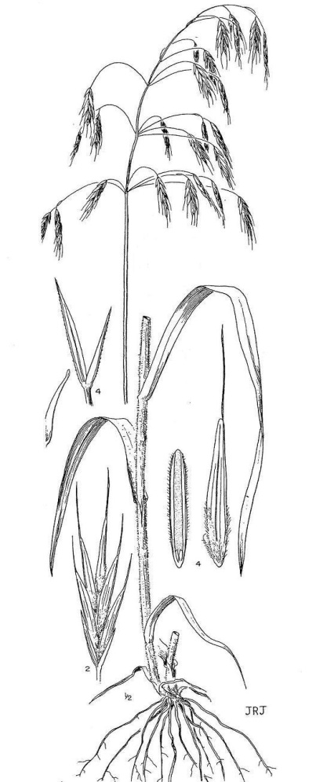

##### University of Washington Press, line drawing reprinted with permission

**Relative abundance in the wild:** Columbia brome is very common in both disturbed and undisturbed forest environments. Seed is relatively easy to hand collect but shatters (separates from the seedhead) readily at maturity.

**Limitations or environmental concerns:** This species can be initially slow to germinate and sometimes difficult to establish, especially on open, dry, sunny sites where it is maladapted. It is often difficult to grow for seed on open farmland where plants may appear stressed and die after one growing season. There are no known environmental concerns.

**Establishment:** Seed dormancy has not been reported for Columbia brome, but germination can be staggered or delayed for several weeks, especially if spring sown. Fall seeding in cool soils is recommended. No special physical conditioning of the seed is required for use in a drill or broadcast seeder, but removal of the awn (linear appendage) and minute hair from the seed improves seed flow in some equipment.

Establishment rate from seed is moderately fast after germination. There are approximately 95,000 (+/- 20%) seeds per pound with seed hulls intact and 108,000 seeds per pound with hulls removed (naked seed). Therefore, each 1 pound of live seed sown per acre is equivalent to approximately 2 to 2.5 live seeds per square foot. Sown alone, a suggested minimum seeding rate is 15-20 lbs of pure live seed (PLS) per acre for general revegetation.

When grown for seed, fields should be situated on the north side of tall windbreaks or in other wooded settings to receive partial shade. Good soil fertility and drainage are needed. Burning for post harvest residue management is not recommended at this time. Hulls often separate from the seed and seed may be damaged during mechanical harvest with a combine. Stands are typically variable and frequently short lived. Management requirements for livestock utilization are not well reported but may approach those of other native bromes provided there is partial shade.

Prepared By:

*Dale Darris*, USDA NRCS Plant Materials Center, Corvallis, Oregon.

Species Coordinator:

*Dale Darris*, USDA NRCS Plant Materials Center, Corvallis, Oregon.

Edited: 080917 jsp

For more information about this and other plants, please contact your local NRCS field office or Conservation District, and visit the PLANTS Web site<<http://plants.usda.gov>> or the Plant Materials Program Web site <<http://Plant-Materials.nrcs.usda.gov>>

*The U.S. Department of Agriculture (USDA) prohibits discrimination in all its programs and activities on the basis of race, color, national origin, sex, religion, age, disability, political beliefs, sexual orientation, and marital or family status. (Not all prohibited bases apply to all programs.) Persons with disabilities who require alternative means for communication of program information (Braille, large print, audiotape, etc.) should contact USDA's* [*TARGET Center*](http://www.usda.gov/oo/target.htm) *at 202-720-2600 (voice and TDD).*

*To file a complaint of discrimination write USDA, Director, Office of Civil Rights, Room 326-W, Whitten Building, 14th and Independence Avenue, SW, Washington, DC 20250-9410 or call 202-720-5964 (voice or TDD). USDA is an equal opportunity provider and employer.*

*Read about* [*Civil Rights at the Natural Resources Conservation Service*](http://www.nrcs.usda.gov/about/civilrights/)