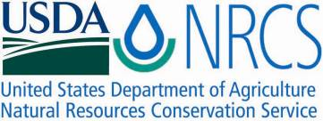

Plant Fact Sheet

# orange eye butterflybush

## Buddleja davidii Franch.

Plant Symbol = BUDA2

Contributed by: USDA NRCS Corvallis Plant Materials Center

### Orange eye butterflybush in bloom. Photo copyright G. C. Carr.

© G. D. Carr

### Caution: This plant may become invasive.

### Alternate Names

*Alternative common names:* Butterfly bush, orange eye, summer lilac, purple buddleja, red buddleja

*Alternative scientific names:* *Buddleia, Buddleja variabilis* Hemsl.

### Uses

*Ornamental:* Orange eye butterflybush has been used in the nursery trade for over a hundred years due to its pleasant weeping, grey-green foliage and fragrant, colorful blooms that attract butterflies, hummingbirds and other floral visitors. Because it can become invasive and crowd out desirable native vegetation, sterile varieties or hybrids should be chosen when installing new plantings.

### Status

Orange eye butterflybush is listed as a Class B noxious weed in Washington, and in Oregon is a list B designated weed, subject to quarantine. As of January 1, 2010, any plant listed as ‘butterfly bush’ is assumed to be *B. davidii* and is prohibited entry, transport, purchase, sale or propagation in the State of Oregon. Sterile varieties of *Buddleja* approved by the Oregon Dept. of Agriculture, including inter-specific hybrids, are not regulated and may be propagated and sold if labeled as follows: “Seedless Butterfly Bush*.” “*Produces less than 2% viable seed.” Please consult the PLANTS Web site and your State Department of Natural Resources for this plant’s current status (e.g., threatened or endangered species, state noxious status, and wetland indicator values).

### Weediness

This plant establishes readily from seed and stem fragments in disturbed or natural areas, especially riparian zones, where it can form dense thickets that outcompete native vegetation. Seed can be produced the first year, is spread easily by wind and water, and can remain viable in the seed bank for three to five years. Plants are difficult to remove once established as they will readily resprout from the root crown after the stems are cut. Please consult with your local NRCS Field Office, Cooperative Extension Service office, state natural resource, or state agriculture department regarding its status and use. Weed information is also available from the PLANTS Web site at [http://plants.usda.gov](http://plants.usda.gov/). Please consult the Related Web Sites on the Plant Profile for this species for further information.

### Description and Adaptation

Orange eye butterflybush is a non-native, deciduous to semi-evergreen shrub that grows 6–16 feet tall and 4–15 feet wide. The leaves are egg- to lance-shaped, up to 10 inches long, green above and grayish, soft-woolly below, growing oppositely on long, arching stems that are green when young and have peeling, gray-brown bark when older. Tiny, tubular, four-petaled flowers are arranged in large, cone-shaped clusters 3–18 inches long that bloom from late spring to first frost in fall. Flowers are generally purplish with a yellow to orange throat, though horticultural varieties range from white or yellow to pink and deep purple.

Butterflybush is hardy to -20°F (USDA zones 5–10) and prefers moist, well-drained soils in partial to full-sun, although it is fairly drought-tolerant once established. Roots generally don’t survive in saturated soil. Ornamental escapes establish on roadsides, railroad tracks, stream and river banks, dryland meadows, dunes, coastal forest edges and logged areas, surface mined lands, industrial yards and other disturbed areas.

Native to China, this shrub has been spread widely through the horticultural trade and become naturalized in many parts of North America, including the pacific northwest, northeast, Hawaii and Puerto Rico (see map below), as well as western Europe, southeastern Australia and New Zealand. For updated distribution, please consult the Plant Profile page for this species on the PLANTS Web site.

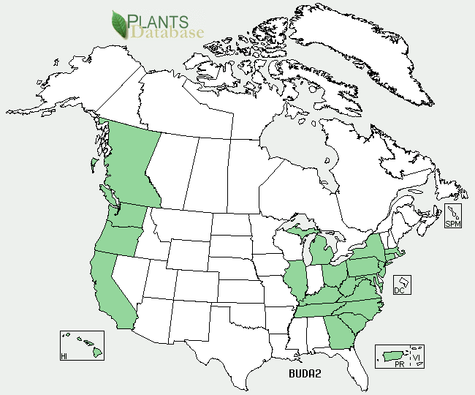

Orange eye butterflybush distribution from USDA-NRCS PLANTS Database.

### Establishment

Plants can be started easily in the spring from seed, container stock or cuttings. Plants should be given sufficient space in the garden as they grow rapidly and can shade out neighbors. They may need summer watering in drier climates the first couple of years, but most varieties are drought-hardy once established. There are approximately 143,000 seeds per pound.

### Management

In gardens and yards, flowers should be deadheaded before they produce fruits to prolong bloom and prevent seeds from establishing in undesirable areas. In warmer climates (USDA zones 8–10) where the shrubs don’t die back to the ground during winter, the weeping side branches should be pruned in the spring to encourage new growth and larger, more prolific blooms. In cold climates (USDA zones 5 and 6), mulch plants in the fall and cut back to about a foot high in late winter. Cut branches must be disposed of properly (burned or composted) to ensure they don’t sprout into new plants.

### Pests and Potential Problems

Orange eye butterflybush generally has few pests, but can be susceptible to spider mites, caterpillars, weevils, mullein moth, fungal leaf spot and dieback, especially during drought or stress.

### Environmental Concerns

Dense thickets of butterflybush can crowd out native vegetation and disrupt natural succession patterns on forests after logging or burns, and on riverbanks and sandbars following floods. Plants buried by up to 1.5 feet of fine sand in a flood can survive by sprouting new roots and shoots from buried stems, thus aiding their rapid recovery and dominance of early succession riparian communities.

### Control

Seedlings and small plants can be hand-picked or dug out, though this soil disturbance can also create sites for further invasion. To remove established shrubs, stems should be cut off at the base and disposed of properly, and then a general use herbicide such as glyphosate or triclopyr can be applied to the freshly-cut stump to prevent regrowth. Alternately, infested areas can be fenced and browsed by goats for 3-4 years to attain acceptable control as part of an integrated pest management program. Two biological control agents are being used on an experimental basis in New Zealand, but have not yet been tested or approved for use in the US: the weevil *Cleopus japonicas,* whose adults and larvae consume butterflybush leaves, and the stem boring beetle, *Mecyslobus erro.* Please contact your local agricultural extension specialist or county weed specialist to learn what works best in your area and how to use it safely. Always read label and safety instructions for each control method. Trade names and control measures appear in this document only to provide specific information. USDA NRCS does not guarantee or warranty the products and control methods named, and other products may be equally effective.

### Cultivars, Improved, and Selected Materials (and area of origin)

There are over a hundred *Buddleja* varieties or hybrids that are widely available from commercial sources. As of September 2011, the following sterile varieties were approved for sale and propagation in Oregon: Buddleja 'Asian Moon', 'Purple Haze', and 'Ice Chip' (formerly 'White Icing'); FLUTTERBY GRANDÉ™ Blueberry Cobbler Nectar Bush, Peach Cobbler Nectar Bush, Sweet Marmalade Nectar Bush, Tangerine Dream Nectar Bush, and Vanilla Nectar Bush; FLUTTERBY PETITE™ Snow White Nectar Bush; and FLUTTERBY™ Pink Nectar Bush. The following hybrids (between two or more *Buddleja* species) are not regulated in Oregon, and are assumed to be sterile, though their fertility has not been assessed: Buddleja 'Lilac Chip', 'Blue Chip', 'Miss Molly' and 'Miss Ruby'.

### Prepared By

*Anna Young-Mathews*

USDA-NRCS Plant Materials Center, Corvallis, Oregon

### Citation

Young-Mathews, A. 2011. Plant fact sheet for orange eye butterflybush (*Buddleja davidii)*. USDA-Natural Resources Conservation Service, Corvallis Plant Materials Center, Corvallis, OR.

Published September, 2011

Edited: [06Sept2011 jab]

For more information about this and other plants, please contact your local NRCS field office or Conservation District <<http://www.nrcs.usda.gov/>>, and visit the PLANTS Web site <[http://plants.usda.gov](http://plants.usda.gov/)> or the Plant Materials Program Web site <<http://plant-materials.nrcs.usda.gov>>

**USDA IS AN EQUAL OPPORTUNITY PROVIDER AND EMPLOYER**