|  |
| --- |
| Northern catalpa |
| *Catalpa speciosa* (Warder) Warder ex Englm. |
| Plant Symbol = CASP8 |

Contributed by: USDA NRCS Manhattan Plant Materials Center and Kansas State University Forestry Research

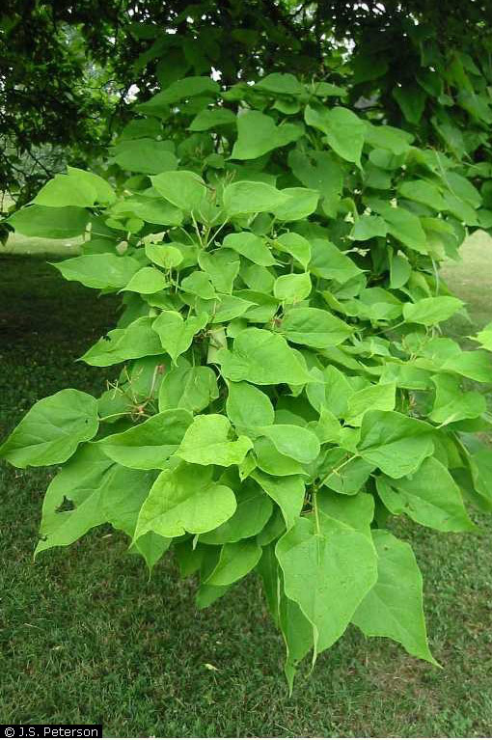

J.S. Peterson @ plants.usda.gov

Alternate Names

Hardy catalpa, western catalpa, Catawba, cigar tree, Indian bean tree, Indian cigar

Uses

Northern catalpa is primarily used today as a large ornamental shade tree. It is widely planted in urban areas as a street and lawn tree. Conservation uses include plantings in mined-land reclamation projects and shelterbelts.

Status

Please consult the PLANTS Web site and your State Department of Natural Resources for this plant’s current status (e.g. threatened or endangered species, state noxious status, and wetland indicator values).

Weediness

This plant may become weedy or invasive in some regions or habitats and may displace desirable vegetation if not properly managed. Please consult with your local NRCS Field Office, Cooperative Extension Service office, or state natural resource or agriculture department regarding its status and use. Weed information is also available from the PLANTS Web site at plants.usda.gov.

Description and Adaptation

A member of the Trumpet-creeper Family (Bignoniaceae), northern catalpa is a perennial deciduous tree which readily grows in USDA Hardiness Zones 4 to 8. The height at 20 years is about 20 feet. Catalpas prefer moist, deep, well drained soil, but adapts to dry or wet soils. The soil pH may range from 5.5 to 7.0. It prefers an open sunny space to partial shade. It is tall with an irregular, open-rounded to narrow-oval crown. This tree comes into leaf very late in the spring and it is one of the first to lose its leaves in the fall. Its longevity is about 60 years.

The tree bark ranges from scaly to ridged, to blocky plates. On young tree seedlings the bark is thin and easily damaged by impact, or rodents.

Twigs in winter have a unique identifying characteristic. They have sunken leaf scars which resemble suction cups. Their whorled arrangement of 3 scars per node is another trait easily identified.

Leaves are simple, large ovate to ovate-oblong, from 8 to 12 inches long, heart-shaped tropical looking without any lobes and are yellowish green in color. Leaves are generally opposite on large branches and often whorled in 3 on young stems. They turn an undistinguished yellow in the fall before dropping.

The flowers of catalpa are perfect. Flowering takes place in late spring to early summer. They occur as large clusters of showy, white, bell-shaped corollas of 5 lobes with ruffled edges and yellow, orange or purple interior spotting or streaking. Individual flowers are showy, tubular up to ½ inch broad. They are branched in about 10 inch clusters at the stem tips.

Seedpods are slender and green in the summer growing from 10 to 24 inches long, looking similar to an exaggerated green bean. They mature in the fall, turn dark brown, split open lengthwise to let seeds fall in the spring. The shape and color of the mature seedpod gives rise to the common name of cigar tree.

It has been extensively propagated for over 200 years. It can now be found in most states east of the Rocky Mountains and in Utah.

Establishment

When placed as an ornamental in a yard setting, care must be taken to ensure it is not too close to a building, fence, property line or septic system. Ample space should be provided to let it reach a mature height.

Management

The biggest management problem with a catalpa tree used as an ornamental is litter. It will drop a heavy load of flowers in the spring, then a plentiful supply of leaves in the fall and finally a lot of large seedpods in the winter.

Pests and Potential Problems

Larva of the catalpa sphinx caterpillar (*Ceratomia catalpae*) eats leaves. Almost complete defoliation may occur in some years.

Immature seeds in the pods are often destroyed by a small yellow grub, the larva of a gnat.

Brown leaf spots on leaves are often created by the fungi *Macrosporium catalpae*. Catalpa is also susceptible to the decay fungus *Polystictus versicolor*. Powdery mildew causes a white powdery coating on the leaves. When severe the leaves turn yellow and drop. Verticillum wilt will make the branches die, and can eventually kill trees. Catalpa midge (*Cecidomyia catalpae* Comstock) causes leaf spots, injures terminal buds and branch tips, as well as seeds in the pods.

Environmental Concerns

It is an invasive, weedy tree which escapes cultivation easily. The flowers, long seedpods and seeds fall down from spring through winter, and create a mess on the ground anywhere near the tree.

Cultivars, Improved, and Selected Materials (and area of origin)

There are two species of catalpa native to North America, northern catalpa (*Catalpa speciosa*) and southern catalpa (*Catalpa bignonioides*). They appear very similar but are two distinct species. One variety of *C. speciosa* has been documented: ‘Pulverulenta’ from Paul & Son.

Control

Please contact your local agricultural extension specialist or county weed specialist to learn what works best in your area and how to use it safely. Always read label and safety instructions for each control method. Trade names and control measures appear in this document only to provide specific information. USDA, NRCS does not guarantee or warranty the products and control methods named, and other products may be equally effective.

Prepared By:

*Dr. Wayne A. Geyer,* Kansas State University Forestry Division, Manhattan, Kansas

##### *Patrick J. Broyles,* Formerly USDA NRCS Manhattan Plant Materials Center Manhattan, Kansas

Species Coordinator:

##### *John Row,* USDA NRCS Manhattan Plant Materials Center Manhattan, Kansas

Edited: 27June05 rln; 01June 06 jsp; 081121 jsp

For more information about this and other plants, please contact your local NRCS field office or Conservation District, and visit the PLANTS Web site<<http://plants.usda.gov>> or the Plant Materials Program Web site <<http://Plant-Materials.nrcs.usda.gov>>

*The U.S. Department of Agriculture (USDA) prohibits discrimination in all its programs and activities on the basis of race, color, national origin, sex, religion, age, disability, political beliefs, sexual orientation, and marital or family status. (Not all prohibited bases apply to all programs.) Persons with disabilities who require alternative means for communication of program information (Braille, large print, audiotape, etc.) should contact USDA's* [*TARGET Center*](http://www.usda.gov/oo/target.htm) *at 202-720-2600 (voice and TDD).*

*To file a complaint of discrimination write USDA, Director, Office of Civil Rights, Room 326-W, Whitten Building, 14th and Independence Avenue, SW, Washington, DC 20250-9410 or call 202-720-5964 (voice or TDD). USDA is an equal opportunity provider and employer.*

*Read about* [*Civil Rights at the Natural Resources Conservation Service*](http://www.nrcs.usda.gov/about/civilrights/)*.*