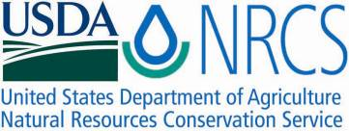

Plant Fact Sheet

# NEW JERSEY TEA

## Ceanothus americanus L.

### Plant Symbol = CEAM

#### Contributed by: USDA NRCS Manhattan Plant Materials Center

#### [Foliage and white flowers of New Jersey tea.](http://www.mobot.org/gardeninghelp/images/low/G820-0901020.jpg)

New Jersey tea in full flower from the PLANTS Database.

#### **Alternate Names** redroot, Indian tea, wild snowball, snowbrush, and soapbloom

#### **Uses**

*Wildlife:* Rabbit, elk and deer browse New Jersey tea and turkey and quail eat the fruit. The small flowers attract numerous insects, especially bees, wasps, flies, and beetles. Butterflies and moths visit the flowers occasionally. These insects collect nectar from the flowers, although bees may also collect pollen. The caterpillars of the butterfly *Celestina* *neglecta* (summer azure) and the skipper *Erynnis martialis* (Mottled Duskywing) feed on the flowers, flower buds, and fruit of a variety of small woody shrubs including New Jersey tea.

*Ethnobotanical:* Tribes of the Missouri River region used the leaves for tea and the roots for fuel on hunting trips. Tribes of the Great Lakes Bioregion ascribed great power to its treatment of bowel troubles. Although New Jersey tea was never listed in the U.S. Pharmacopeia, it was used by some physicians. New Jersey tea is a strong astringent (8 percent tannins) and contains an alkaloid that is mildly hypotensive. The leaves contain the flavonols afzelin, quercitrin, and rutin. It was used by colonists during the Revolutionary War as a substitute for tea even though the leaves contained no caffeine. Recently it was discovered that the roots contain a blood-clotting agent.

*Landscaping:* New Jersey tea is a pretty shrub that can be cultivated for its fragrant white flower clusters and leaves for tea. Horticulturists have stated that it should be grown more as an ornamental plant especially in droughty sites.

#### **Status**

Please consult the PLANTS Web site and your State Department of Natural Resources for this plant’s current status (e.g., threatened or endangered species, state noxious status, and wetland indicator values).

#### **Description and Adaptation**

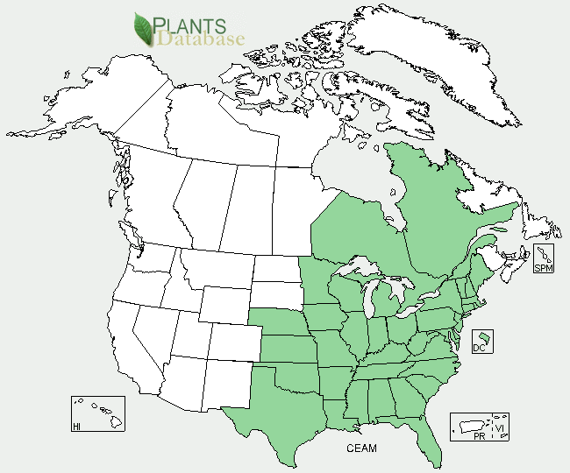

New Jersey tea distribution from USDA-NRCS PLANTS Database.

*General:* Buckthorn Family (Rhamnaceae). This shrubby, upright, deciduous, native perennial grows to approximately 3 feet in height. It will tiller at the base, sending up multiple stems. Its stems are light green and covered with fine white hairs which become woody with age in the absence of fire or browsing by wildlife. Leaves are alternate and broadly oblong-ovate, up to 3 inches long and 2 inches wide. The underside of the leaf is light green and covered with fine white hairs. The leaf margins are smooth to finely serrate, and slightly ciliate. The simple leaves have short petioles and three conspicuous palmate veins. From the axils of the upper leaves emerge long stalked clusters of numerous white flowers. These clusters of flowers are elongated and rounded. Each individual flower consists of a long slender tube terminated in five folded sepals. When the calyx opens five hatchet shaped petals with slender bases spread outward, while a large pistil and five stamens, with dark gray anthers emerge from the flower’s center. The flowers have a pleasant fragrance and bloom for about a month during early summer. Later, three small (1/4 inch) lobed fruits (Drupe) form, splitting into three carpels each containing a smooth coated, elliptical, brown seed. The root system consists of a stout, deeply anchored reddish taproot. Thus, the common name for New Jersey tea is red root.

For updated distribution, please consult the Plant Profile page for this species on the PLANTS Web site.

*Adaptation****:*** New Jersey tea is usually found on the sandy soils of open woodlands and prairies, and on rocky hillsides. It is fire adapted with top growth being typically killed by fire, but vigorous resprouting from the undamaged rootstock. It has the ability to slowly spread from seed production; however the seedling vigor is considered quite low.

Drought resistance is very good, under severe drought the leaves will become discolored and shrivel, but quickly revive when moisture returns.

**Establishment**

It can be propagated by root division in the fall, softwood cuttings forced in the greenhouse in spring, or by seed. Seed of New Jersey tea should be planted outside in the fall or early winter in a well drained soil site with full sun. Note that the plant does not require cold moist stratification, but spring plantings have been enhanced by submerging the seed in 180 degree Fahrenheit water the night before planting and allowing seeds to soak in the slowly cooling liquid. Since there are many mammalian herbivores that browse this species its establishment can be a challenge when there are large populations of these active browsing species about.

#### **Management**

Fire is a beneficial management tool in promoting the spread of this species. It has a high tolerance for drought and restricted water conditions. The plant cannot survive exposure to temperatures below negative 28 degrees Fahrenheit. New Jersey tea is listed as a threatened species in the state of Maine.

#### **Pests and Potential Problems**

Foliar disease is rarely a significant problem for this species; however it is susceptible to leaf spot and powdery mildew.

#### **Control**

Please contact your local agricultural extension specialist or county weed specialist to learn what works best in your area and how to use it safely. Always read label and safety instructions for each control method. Trade names and control measures appear in this document only to provide specific information. USDA NRCS does not guarantee or warranty the products and control methods named, and other products may be equally effective.

#### **Cultivars, Improved, and Selected Materials (and area of origin)**

The New Jersey tea is easily found in nurseries, garden stores and other plant dealers and distributors. It is native to the United States and has a moderate lifespan and a slow growth rate.

#### **Prepared By**

Richard L. Wynia, USDA-NRCS Manhattan Plant Materials Center, Manhattan, KS.

#### **Citation**

Wynia, R.L. 2010. Plant fact sheet for New Jersey tea (Ceanothus americanus). USDA-Natural Resources Conservation Service, Manhattan Plant Materials Center. Manhattan, KS 66502.

Published: September 2010

Edited: 04Aug2010rw

For more information about this and other plants, please contact your local NRCS field office or Conservation District <<http://www.nrcs.usda.gov/>>, and visit the PLANTS Web site <[http://plants.usda.gov](http://plants.usda.gov/)> or the Plant Materials Program Web site <<http://plant-materials.nrcs.usda.gov>>

**USDA IS AN EQUAL OPPORTUNITY PROVIDER AND EMPLOYER**