

Plant Fact Sheet

# Eastern Redbud

## Cercis canadensis L.

### Plant Symbol = CECA4

Contributed by: USDA NRCS East Texas Plant Materials Center.

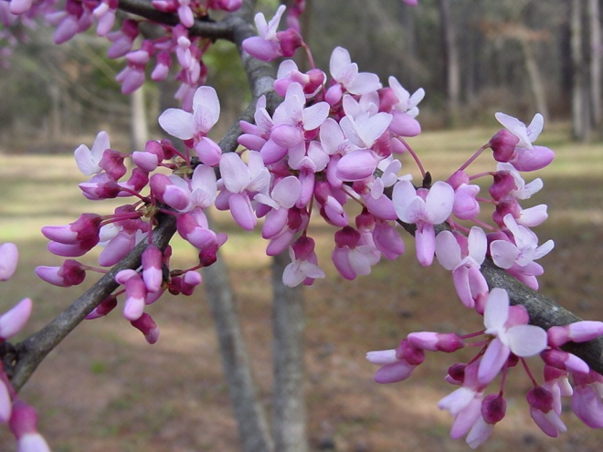 Melinda Brakie-USDA NRCS Plant Materials

#### **Alternate Names**

The alternate names for eastern redbud include Judas tree and redbud.

#### **Uses**

The Henry’s elfin butterfly (*Callophyrus henrici*) and hummingbirds utilize eastern redbud for nectar. Honeybees use the flowers for pollen.

#### Native Americans boiled the bark to make tea to treat whooping cough. Dysentery was treated using an astringent from the bark. The roots and inner bark were utilized for fevers, congestion, and vomiting. The flowers can be fried and eaten.

#### Whitetail deer browse the foliage and twigs during the spring and summer. Squirrels occasionally eat the buds, bark, and seed. Bobwhite quail and songbirds eat the seeds. However, for the animals which utilize eastern redbud, it is considered a less desirable or emergency food. Livestock will infrequently graze on the foliage and twigs.

#### **Status**

Please consult the PLANTS Web site and your State Department of Natural Resources for this plant’s current status (e.g., threatened or endangered species, state noxious status, and wetland indicator values).

**Description and Adaptation**

Eastern redbud is a native, perennial, deciduous tree which grows 15 to 30 feet tall and spreads 15 to 25 feet. Older trees generally resemble a vase shape. This tree is a member of Fabaceae or pea family. Eastern redbud is found throughout the lower Great Plains and eastern United States. For updated distribution, please consult the Plant Profile page for this species on the PLANTS Web site.

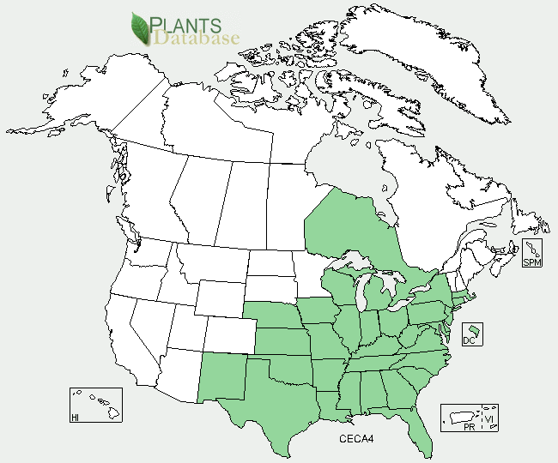

Eastern redbud distribution from USDA-NRCS PLANTS Database.

Eastern redbud is usually one of the first trees to bloom in spring. Pink to reddish purple flowers are grown on old twigs, branches, and trunks. Flowering occurs in March to May before leaf growth. After bloom, the leaves begin growing and gradually turn dark green. When mature, the alternately arranged leaves are about four inches long, four inches wide and heart shaped with prominent venation. The twigs are slender, spreading, zigzag with short or dark brown knotty spurs. Eastern redbud produces clusters of flat green pods (~3.5 inches long, ~0.5 inches wide) that change to brown when mature. Each pod contains four to ten small hard black or brown seeds.

#### Eastern redbud occurs as scattered trees or small populations. It is an understory species in open woods and is found on moist, loam or sandy soils in valleys or bottomlands. Usually this tree is more numerous on south facing slopes with more sunlight. Eastern redbud grows on a wide range of pH; however, it grows best on soils with a pH of 7.5 or above. It is not found on inundated sites, poorly aerated soils, or coarse sands. The tree is fire tolerant and root sprouts after fire.

#### **Establishment**

In fall, collect the mature pods before they open and release their seed or insects, particularly weevils, attack the seeds. Collect a large number to compensate for a high percentage of inferior seeds. Store air dried seeds in sealed glass jars or metal containers at 350 to 410F. Eastern redbud has a hard seed coat and dormancy. Scarify the seed coat by mechanical scarification, immersing in boiling water, or in concentrated sulfuric acid for approximately 30 minutes. After scarifying, stratify in moist sand for five to eight weeks at approximately 410F. The seeds can then be planted outdoors in the fall or stored for spring planting. In late April or early May, plant the treated seeds in a well prepared seedbed at a maximum depth of 0.2 inches. Very young seedlings which have sprouted around parent trees are easily moved when they are small.

#### **Management**

Eastern redbud develops a deep taproot that grows quickly the first few years under conducive conditions. Pruning the tree helps develop a strong structure.

#### **Pests and Potential Problems**

Three main disease effect eastern redbud: leaf anthracnose, (*Mycosphaerella cercidicola)*, Botryosphaeria canker, and verticillium wilt. Botryosphaeria canker produces stem and twig lesions and entire stands have been killed by the disease. Several species of wood borers attack the tree. The redbud leaffolder, grape leaffolder, and Japanese weevil feed on the leaves.

#### **Environmental Concerns**

The seed are dispersed by wind and animals.

#### **Cultivars, Improved, and Selected Materials (and area of origin)**

Commercially available cultivars of eastern redbud include; ‘Pink Charm’ and ‘Pinkbud’- pink flowers; ‘Purple Leaf’- foliage is purple when young; ‘Silver Cloud’- leaves variegated with white, ‘Flame’- double flowers and no seed pods, and ‘Forest Pansy’.

#### **Prepared By**

Melinda Brakie USDA-NRCS Plant Materials Center, Nacogdoches, Texas. August 2010

#### **Citation**

Brakie, Melinda. 2010. Plant fact sheet for eastern redbud (*Cercis canadensis*). USDA-Natural Resources Conservation Service, East Texas Plant Materials Center. Nacogdoches, TX 75964

Published August 2010

Edited:

For more information about this and other plants, please contact your local NRCS field office or Conservation District <<http://www.nrcs.usda.gov/>>, and visit the PLANTS Web site <[http://plants.usda.gov](http://plants.usda.gov/)> or the Plant Materials Program Web site <<http://plant-materials.nrcs.usda.gov>>

**USDA IS AN EQUAL OPPORTUNITY PROVIDER AND EMPLOYER**