|  |
| --- |
| showy partridge pea |
| *Chamaecrista fasiculata* (Michx.) Greene |
| Plant Symbol = CHFA2 |

Contributed by: USDA NRCS Plant Materials Program and the Manhattan Plant Materials Center, Manhattan, Kansas

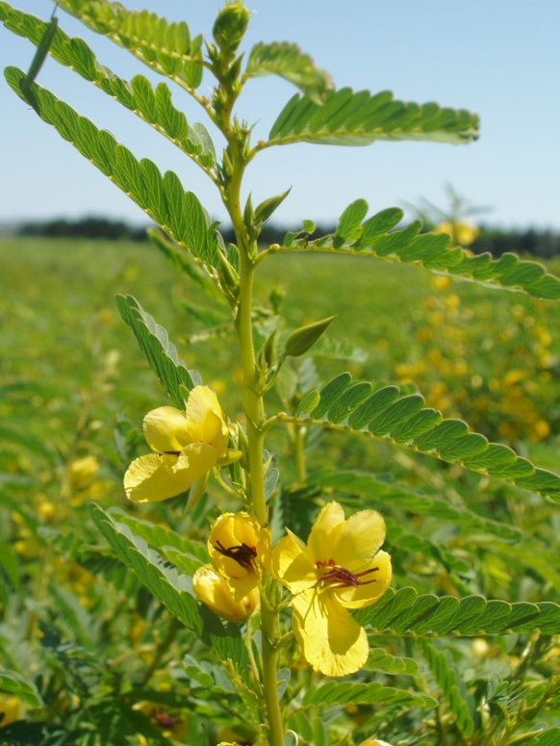

R. Alan Shadow, USDA NRCS East Texas Plant Materials Center

Alternate Names

*Cassia chamaecrista* L., *C. fasiculata* Michx., sleeping plant, prairie partridge pea, prairie senna, large-flowered sensitive-pea, dwarf cassia, partridge pea senna, locust weed, golden cassia

Uses

*Wildlife*: This plant provides food for birds. The seed is one of the major food items of northern bobwhite and quail because it remains in sound condition throughout the winter and early spring.

*Erosion control*: The plant can be used along road banks and stream banks to control erosion.

*Recreation and beautification*: The flowers of this plant can be used to beautify areas where wildflowers are planted. Partridge pea is commonly grown as an ornamental. The bright yellow flowers make it a popular choice for use in native gardens.

*Livestock Caution*: *Although partridge pea foliage is nutritious, it can be poisonous and should be considered potentially dangerous to cattle.*

Status

Please consult the PLANTS Web site and your State Department of Natural Resources for this plant’s current status (e.g. threatened or endangered species, state noxious status, and wetland indicator values).

Description

Showy partridge pea[*Chamaecrista fasciculata* (Michx.) Greene] is an annual erect legume plant that reaches a height of 1 to 3 feet. The leaves consist of 10 to 16 pairs of small, narrow leaflets that are somewhatdelicate to the touch. The showy yellow flowers, about 1 inch across, grow 2 to 4 together in clusters on the stem. Flowers normally bloom July-September. The fruit is a straight, narrow pod 1½ to 2½ inches long, which splits along 2 sutures as it dries; the pod sides spiral to expel the seeds some distance from the parent plant. The highest seed production has been obtained under 30% shade, followed in decreasing order by 55% shade, full sunlight, and dense shade.

Adaptation and Distribution

This plant grows on a wide range of soils that are slightly acid to moderately alkaline. However, it grows best on moderately lime, well drained soils. It is important to use an adapted strain to ensure that successful reseeding will occur.

Showy partridge pea is distributed throughout the Midwestern and eastern United States. For a current distribution map, please consult the Plant Profile page for this species on the PLANTS Website.

Establishment

Established stands should be disked lightly in the spring to expose mineral soil on which the seed can germinate. Drill seeds at 1/4 to 3/4 inch deep at a rate of 10 lbs/ac pure live seed. If the seed is broadcast, increase seeding rate and cover seed by lightly disking or by cultipacking. Planting should be conducted late winter (March) to late spring (May) while soil moisture is still high. Germination is improved by scarification of the seed prior to planting. Seed should also be inoculated with the correct species of *rhizobium* before planting. Fertilizer should be applied at the recommended rate, based on soil samples, at time of planting.

Management

Partridge pea usually reseeds but will gradually disappear without regular maintenance. Light disking to remove weeds, small brush, and old sod is necessary for healthy plantings or natural stands. In areas where prescribed burning is permitted, controlled fire is an excellent method for controlling unwanted vegetation. Fire or disking should be done in late winter for best results. Weeds can also be controlled during the growing season by mowing over the top of the partridge pea.

Pests and Potential Problems

No pests reported at this time. Some sources report that this species has invasive qualities. See the PLANTS Plant Profile for this species. *Although partridge pea foliage is nutritious, it can be poisonous and should be considered potentially dangerous to cattle.*

Cultivars, Improved, and Selected Materials (and area of origin)

‘Comanche’ (TX), ‘Riley’ (KS), and Lark Selection (AR), Comanche (cultivar) was released by the James E. ‘Bud’ Smith Plant Materials Center (PMC), Knox City, Texas, Riley (cultivar) was released by the Manhattan PMC, Manhattan, Kansas. Lark Selection is a selected class release from the Jamie L. Whitten PMC, Coffeeville, Mississippi.

Prepared By:

USDA NRCS Plant Materials Program and John M. Row, Plant Materials Center, Manhattan, Kansas

##### Species Coordinator:

*Morris J. Houck*, USDA NRCS, Alexandria, Louisiana

Edited: 01Feb2002 JLK; 01jun06 jsp; 070820 jsp

For more information about this and other plants, please contact your local NRCS field office or Conservation District, and visit the PLANTS Web site<<http://plants.usda.gov>> or the Plant Materials Program Web site <<http://Plant-Materials.nrcs.usda.gov>>

*The U.S. Department of Agriculture (USDA) prohibits discrimination in all its programs and activities on the basis of race, color, national origin, sex, religion, age, disability, political beliefs, sexual orientation, and marital or family status. (Not all prohibited bases apply to all programs.) Persons with disabilities who require alternative means for communication of program information (Braille, large print, audiotape, etc.) should contact USDA's* [*TARGET Center*](http://www.usda.gov/oo/target.htm) *at 202-720-2600 (voice and TDD).*

*To file a complaint of discrimination write USDA, Director, Office of Civil Rights, Room 326-W, Whitten Building, 14th and Independence Avenue, SW, Washington, DC 20250-9410 or call 202-720-5964 (voice or TDD). USDA is an equal opportunity provider and employer.*

*Read about* [*Civil Rights at the Natural Resources Conservation Service*](http://www.nrcs.usda.gov/about/civilrights/)*.*