

Plant Fact Sheet

**FREMONT’S LEATHER FLOWER**

***Clematis fremontii* S. Wats.**

Plant Symbol = CLFR

Contributed by: USDA NRCS Plant Materials Center, Manhattan, Kansas

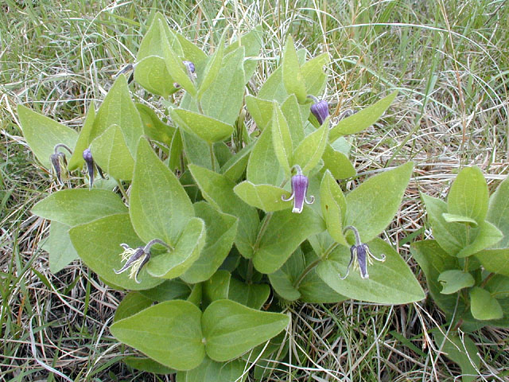 Mike Haddock, Kansas State University

Fremont’s leather flower was named for Gen. John C. Frémont, U.S. Army Corps of Topographical Engineers, and famous explorer of the American West, who first cataloged this plant in the 1840s.

**Alternate Names**

Fremont’s clematis, Fremont’s crowsfoot, Fremont’s leather-plant, leatherplant, rattleweed

**Uses**

*Ornamental*: Fremont’s leather flower has potential as a garden plant with its unique, showy, bell or urn-shaped flowers, ornamental fruit clusters, interesting texture and long period of attractiveness. It may be planted in large groups and is an attractive addition to rock gardens, border fronts, native plant gardens, prairies or meadows. Fremont’s leather flower combines well with other native herbaceous spring bloomers, such as pasque flower and prairie smoke. The dried plants, with fruit clusters and foliage intact have potential for dried arrangements.

**Status**

CAUTION!! Described as one of our rarest plants, Fremont’s leather flower is protected in Missouri. Please consult the PLANTS Web site and your State Department of Natural Resources for this plant’s Plant Materials

current status (e.g. threatened or endangered species, state noxious status, and wetland indicator values).

**Description and Adaptation**

An herbaceous perennial, non-climbing, shrubby-type clematis, with broad ovate leathery green leaves to 5 inches long with parallel veins, appearing alternate, simple, and sessile, on erect stems 12 to 18 inches tall, arising from a stout caudex bearing many fibrous roots.

Thick, non-spreading, often recurved sepals form an inch-long solitary bell-shaped purple to white flower nodding on a slender stalk atop the foliage. Blooming occurs late April into June, giving rise to large clusters of achenes each tipped with a long, curled style. The achenes and foliage turn brown in the fall and persist into the winter.

Large cluster of achenes

Mike Haddock, Kansas State University

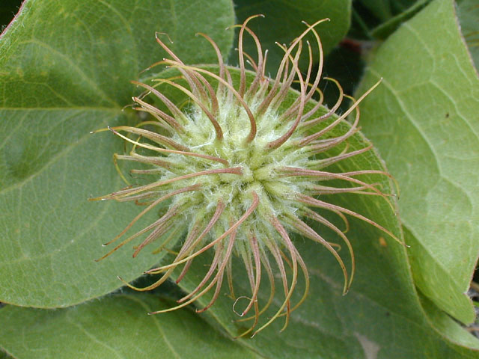

Fremont’s leather flower thrives in full sun on a lean alkaline soil. Although this species naturally occurs on rocky prairie sites such as Fort Hays Limestone and Smoky Hill Chalk, and on limestone glades in the eastern Ozark region, it has been found to be a hardy, very easy to grow, long lived garden plant given full sun to part shade and rich, well drained soil. This species is adapted to the 20 to 24 inch precipitation zone. *Distribution*: Fremont’s leather flower is limited in distribution to north central Kansas, south central Nebraska and the eastern Ozark region of Missouri. A recent discovery from Tennessee near Chattanooga in 2006 and a nearby Georgia population has been reported. For current distribution, please consult the Plant Profile page for this species on the PLANTS Web site.

*Habitat*: Fremont’s leather flower is native to limestone prairies and dolomite glades.

**Establishment**

Seed may be sown following a three month cold-moist stratification period. The seeds are slow to germinate and may lay in the soil medium a month before germinating.

**Pests and Potential Problems**

None known

**Environmental Concerns**

None

**Seeds and Plant Production**

There are approximately 35,290 seeds per pound. Plants grown from seed take two to three years to reach maturity and begin flowering.

**Cultivars, Improved, and Selected Materials (and area of origin)** none known

Contact your local Natural Resources Conservation Service (formerly Soil Conservation Service) office for more information. Look in the phone book under “United States Government.” The Natural Resources Conservation Service will be listed under the subheading “Department of Agriculture.”

**Prepared By and Species Coordinator**

*John M. Row,* USDA NRCS Plant Materials Center, Manhattan, Kansas

### Citation

Row, J. 2009. Plant fact sheet for Fremont’s leather flower (Clematis fremontii S. Watson*)*. USDA-Natural Resources Conservation Service, Kansas Plant Materials Center, Manhattan, Kansas 66502

Published July, 2009

Edited: 090611 jsp

For more information about this and other plants, please contact your local NRCS field office or Conservation District <<http://www.nrcs.usda.gov/>>, and visit the PLANTS Web site <[http://plants.usda.gov](http://plants.usda.gov/)> or the Plant Materials Program Web site <<http://plant-materials.nrcs.usda.gov>>

**USDA IS AN EQUAL OPPORTUNITY PROVIDER AND EMPLOYER**