

Plant Fact Sheet

# california hazelnut

## Corylus cornuta Marsh. var. californica (A. DC.) Sharp

Plant Symbol = COCOC

Contributed by: USDA NRCS Corvallis Plant Materials Center

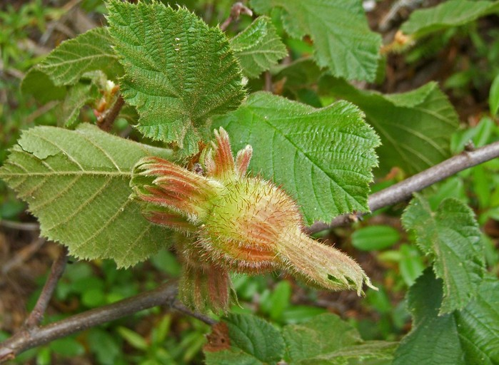

© 2008 Neal Kramer

### Alternative Names

*Alternative common names:* California hazel, California filbert, beaked hazelnut, western beaked hazel

*Alternative scientific names:* *Corylus californica* (A. DC.) Rose, *Corylus cornuta* ssp. *californica* (A. DC.) E. Murray

### Uses

*Wildlife*: California hazelnut is used in hedgerow, riparian and wildlife habitat plantings to provide cover and food. The nuts are eaten by many animals including squirrels, chipmunks, jays, grouse and pheasant. Plants may be browsed by mule deer and domestic livestock.

*Landscaping*: California hazelnut can be incorporated into garden plantings or woodland parks. It is the first native shrub to come into bloom in the spring, with attractive yellow catkins hanging from the bare branches, and its leaves turn bright yellow in the fall. The Oregon Department of Agriculture currently has restrictions on the import and sale of all *Corylus* species within the state in order to control the spread of Eastern filbert blight (EFB). California hazelnut is resistant to EFB, but check to see if a ban is in effect in your area prior to planting.

*Ethnobotanic*: Many Native American tribes of the Pacific Northwest and California used the nuts as a food source, picking them in late summer to early autumn, storing until fully ripe, and then roasting or eating them raw. The nuts were also pounded into cakes containing berries, meat, or animal fat, or boiled to extract the oil, which was used as flavoring. The nuts’ milk was used to cure coughs and colds, to heal cuts, and as an astringent. Roots were used to make a bluish dye. The wood was fashioned into arrows, fishing traps, hooks, and spoons, and the long, flexible shoots were twisted into rope or used for basketry. Plants were burned to the ground periodically (about every five years) to maintain productivity. The nuts were also used as a trade item among tribes because of their sporadic distribution.

### Status

California hazelnut is listed as a facultative upland species in Oregon and Washington, meaning it usually occurs in non-wetlands, but is occasionally found in wetlands. Please consult the PLANTS Web site and your State Department of Natural Resources for this plant’s current status (e.g., threatened or endangered species, state noxious status, and wetland indicator values).

### Description and Adaptation

Birch family (Betulaceae): Native, deciduous shrubs or small trees growing 3 to 50 feet tall and forming thickets; main stems straight, with spreading, ascending branches, and light brown twigs that are often glandular-hairy when young. Leaves are simple, alternate, often velvety-hairy, paler below than above, nearly round to ovate, 1.6-4 inches long, with

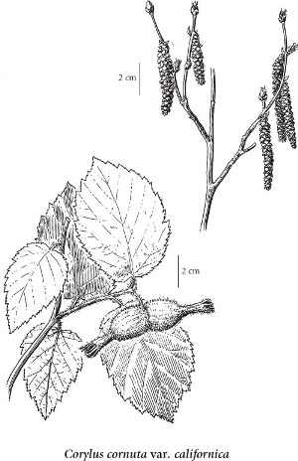doubly toothed margins. Male and female flowers are separate, but both types are present on each plant. Male flowers are numerous in long, hanging stalks (catkins) 2-3 inches long, in clusters of 2 or 3 near branch tips, appearing in the fall but opening early the following spring (Jan.-Mar.) before leaves develop. Female flowers are several in a scaly bud, tiny and inconspicuous, with only bright red stigma and styles protruding from the otherwise gray-brown buds near the end of the twigs. Fruit is a hard-shelled, acorn-like nut ½ - ¾ inch in diameter, completely concealed by two leafy, coarsely toothed, husk-like bracts fused at the tip and forming an extended tubular beak. California hazelnut typically has glandular hairs on twigs and petioles and has a shorter husk beak (beak length usually less than twice nut length), whereas the eastern beaked hazelnut (*C. cornuta* var. *cornuta*) lacks glandular hairs on twigs and petioles and has a longer beak (two times or more nut length). , . The European hazelnut (*C. avellana*) can generally be distinguished from beaked hazelnuts by the exposed nuts in the involucral bracts (husks), although newer varieties of hazelnuts are being interbred with the native hazelnuts and will show intermediate traits.

Reprinted with permission of University of Washington Press.

California hazelnut does well in full sun to full shade, and prefers moist but well-drained, loamy, acid soils with plenty of organic matter; it tolerates clay but not saturated soils. Plants are winter hardy to 0°F, and sprout readily from the root crown after top-kill by fire or other disturbance. It typically occupies damp rocky slopes and stream banks in the understory of coniferous or mixed hardwood forests at elevations up to 8000 feet in zones with mean annual precipitation of 14 to 100 inches. Distribution ranges from western British Columbia, Washington and Oregon to California (see map below). For updated distribution, please consult the Plant Profile page for this species on the PLANTS Web site.

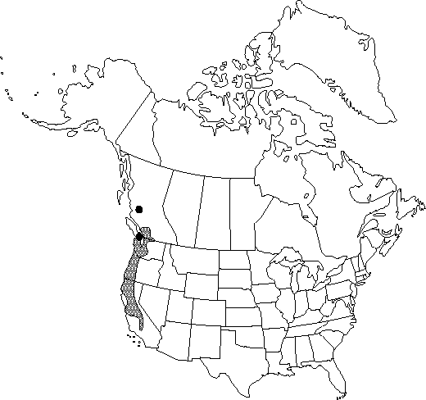

California hazelnut distribution map courtesy of the Flora of North America Association.

### Establishment

Propagation is easiest from seed, but seeds must be harvested early, just before they ripen and while husks are still a bit green (Jul. to Oct. depending on location), or squirrels will harvest the entire crop. Allow the nuts to ripen and dry before sowing; husks will turn brown and can be left on or removed before planting. Sow nuts about 1 inch deep outdoors in the fall, or cold stratify for 2-3 months to break seed dormancy prior to spring sowing. There are approximately 410 seeds per pound, and seed viability is about one year. Plants can also be vegetatively propagated by transplanting suckers from existing plants in late winter or early spring, or layering in the fall by nicking a branch, then bending and burying the nick until roots form. In an irrigated sandy loam nursery bed rooting trial, hardwood cutting rooting success was about 60% regardless of treatment with Wood’s rooting compound (WRC). In a related trial, hardwood cuttings showed poorer performance, with only 27% rooting on a greenhouse mist bench (perlite), 9% rooting on a moderately well-drained silt loam farm field, and no rooting in an artificial pond, again with no significant effect of WRC. Results may vary by climate.

### Management

California hazelnut may need to be watered during the first year or two, but requires little management once established. Optional pruning to remove suckers and enhance the shape for landscape plantings should be done in the winter when plants are dormant.

### Pests and Potential Problems

Eastern filbert blight, caused by the fungus *Anisogramma anomala,* is a growing problem for commercial filbert orchards in the Pacific Northwest because of susceptible cultivars of the European species *C. avellana* (common filbert) and *C. maxima* (giant filbert). Although the native California hazelnut is resistant to EFB, at this time the import and sale of all *Corylus* species is under a Control Area Order in Oregon as a precaution to prevent spreading the disease.

### Environmental Concerns

California hazelnut is sometimes treated with herbicides in commercially managed forests to reduce interference with establishment and growth of conifer seedlings.

### Cultivars, Improved, and Selected Materials (and area of origin)

There are no improved cultivars of California hazelnut, but seed and container plants are sometimes available from commercial sources in Washington and California.

### Prepared By

*Anna Young-Mathews*

Corvallis Plant Materials Center, Corvallis, Oregon

### Citation

Young-Mathews, A. 2011. Plant fact sheet for California hazelnut (*Corylus cornuta* var*. californica)*. USDA-Natural Resources Conservation Service, Corvallis Plant Materials Center, Corvallis, OR.

Published September 2011

Edited: [13Aug2011 dcd; 24Aug2011 klp; 06Sep2011 jab, 07Nov2011 aym]

For more information about this and other plants, please contact your local NRCS field office or Conservation District <<http://www.nrcs.usda.gov/>>, and visit the PLANTS Web site <[http://plants.usda.gov](http://plants.usda.gov/)> or the Plant Materials Program Web site <<http://plant-materials.nrcs.usda.gov>>

**USDA IS AN EQUAL OPPORTUNITY PROVIDER AND EMPLOYER**