|  |
| --- |
| sweetfern |
| *Comptonia peregrina* L. |
| Plant Symbol = COPE80 |

Contributed by: USDA NRCS Plant Materials Program

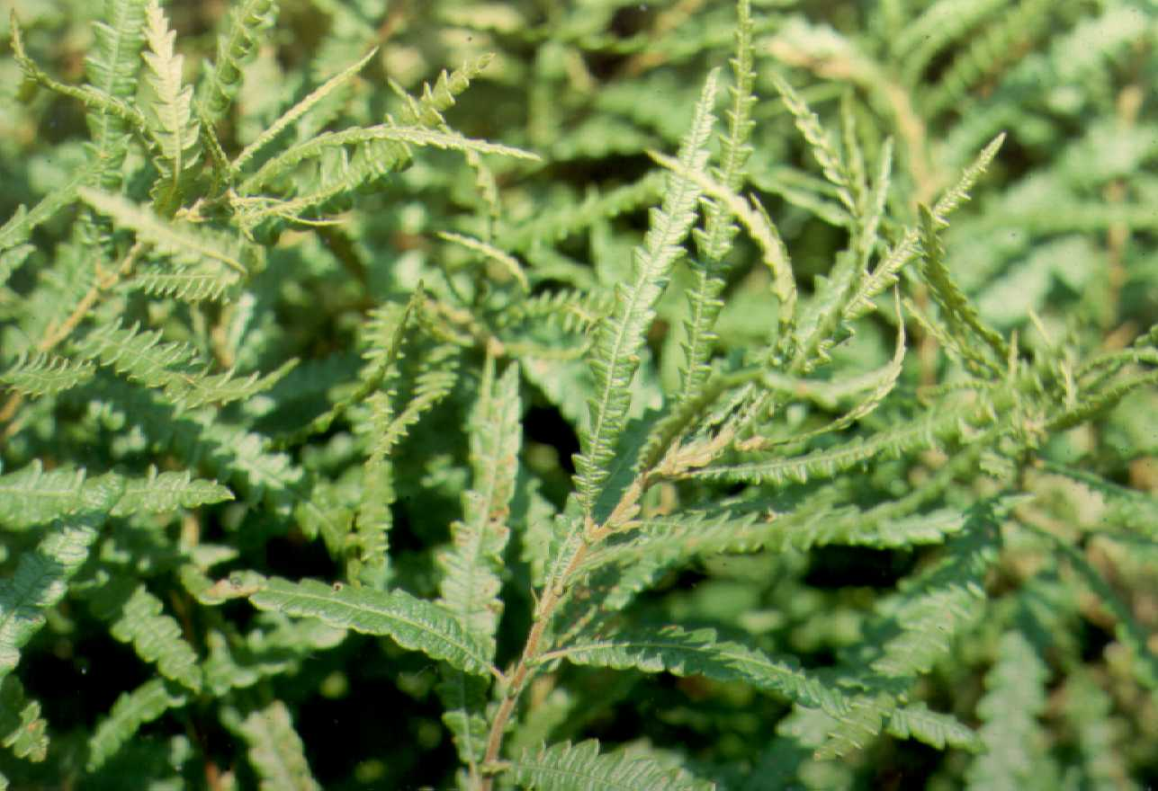

USDA NRCS National Plant Materials Center

Beltsville, MD

**Alternate Names**

*Comptonia peregrina* (L.) Coult. var. *aspleniifolia* (L.) Fern., *Myrica aspleniifolia* L., *Myrica peregrina* (L.) Kuntze

Uses

This nitrogen-fixing plant is used primarily as a ground cover for erosion control and species diversity in sterile, sandy soils. The abundant underground stems, or rhizomes, makes it especially suited to stabilizing steep, sandy banks. It makes a pleasing companion plant in a coastal setting with the low growing junipers, rugosa rose, bayberry, and beach plum.

Status

Please consult the PLANTS Web site and your State Department of Natural Resources for this plant’s current status (e.g. threatened or endangered species, state noxious status, and wetland indicator values). It is considered threatened or endangered in several states.

Description

Bayberry Family (Myricaceae). Sweetfern is a low, loosely branched, mat-forming shrub, 1-3 feet high, with sweet-scented, fern like leaves. The alternate, hair-covered leaves are 2-5 inches long and taper at each end. There is an occasional compound leaf form variation. The leaf blades are deeply cut into 20 or more rounded lobes, dark green above, paler and hair-covered beneath and on the midrib and margin above. Resinous glands cover both surfaces. Leaves are very aromatic when crushed. The flowers are small, inconspicuous catkins that bloom during April and May. Flowers of one or both sexes can be produced on an individual plant. The male catkins are rather long and cylindrical; the female catkins are short and rounded. In winter, the male catkins are prominent and erect. The female catkins become bur-like at maturity and are 1/2 inch in diameter. The seeds are nutlets that mature in August and become available in September and October. About four seeds are found in each fruit. Each seed is about 1/4 inch long, olive brown in color, and shiny.

Adaptation and Distribution

Sweetfern does especially well in open, sterile, sandy soils of woodlands, clearings, and pastures. It prefers acidic soils over limestone soils.

Sweetfern is distributed throughout northeastern United States. For a current distribution map, please consult the Plant Profile page for this species on the PLANTS Website.

Establishment

Some nurseries offer wild collected clumps, but it is best established using nursery-grown, containerized plants. Losses of plants from the wild can be considerable. One or two year old liner material is also acceptable.

Management

Little management is needed if planted in an appropriate site. Sweetfern does not tolerate shading well, so removing competing vegetation is important.

Cultivars, Improved, and Selected Materials (and area of origin)

No known varieties of sweetfern exist. Plants are available at nurseries in the Northeast that specialize in coastal plants.

Prepared By & Species Coordinator:

USDA NRCS Northeast Plant Materials Program

Edited: 01Feb2002 JLK; 01jun06 jsp

For more information about this and other plants, please contact your local NRCS field office or Conservation District, and visit the PLANTS Web site<<http://plants.usda.gov>> or the Plant Materials Program Web site <<http://Plant-Materials.nrcs.usda.gov>>

*The U.S. Department of Agriculture (USDA) prohibits discrimination in all its programs and activities on the basis of race, color, national origin, sex, religion, age, disability, political beliefs, sexual orientation, and marital or family status. (Not all prohibited bases apply to all programs.) Persons with disabilities who require alternative means for communication of program information (Braille, large print, audiotape, etc.) should contact USDA's* [*TARGET Center*](http://www.usda.gov/oo/target.htm) *at 202-720-2600 (voice and TDD).*

*To file a complaint of discrimination write USDA, Director, Office of Civil Rights, Room 326-W, Whitten Building, 14th and Independence Avenue, SW, Washington, DC 20250-9410 or call 202-720-5964 (voice or TDD). USDA is an equal opportunity provider and employer.*

*Read about* [*Civil Rights at the Natural Resources Convervation Service*](http://www.nrcs.usda.gov/about/civilrights/)*.*