

Plant Fact Sheet

# Kansas Hawthorn

## Crataegus coccinioides Ashe

### Plant Symbol = CRCO2

#### Contributed by: USDA NRCS Plant Materials Center Manhattan, Kansas

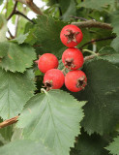 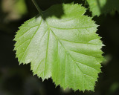 Figures 1 and 2: Example of fruit and leaf of Kansas hawthorn. Photographer Bob Walker pbase.com web site

#### **Alternate Names:** red hawthorn and Eggert thorn

#### **Uses**

*Erosion Control*: Planted to stabilize a variety of sites due to its tolerance of various soils and climatic conditions. Used in shelterbelts and to stabilize areas from wind and water erosion.

*Timber*: Since it is a rather small tree the lumber is of no commercial value except to fashion tool handles and other small items.

*Aesthetics:* Produces an excellent small specimen tree in a landscape or provides shrub border or screen along a property line. It is tolerant of atmospheric pollutants and performs admirably in urban settings. Foliage turns red to bright orange in the fall. Bright red round fruit is also an attractive attribute of this plant.

*Wildlife:* It provides excellent cover and protected nesting sites for small birds. In general, the fruits of this species are eaten by birds, rodents and other small mammals. White-tail deer browse young twigs and foliage.

#### **Status**

Please consult the PLANTS Web site and your State Department of Natural Resources for this plant’s current status (e.g., threatened or endangered species, state noxious status, and wetland indicator values).

#### **Description and Adaptation**

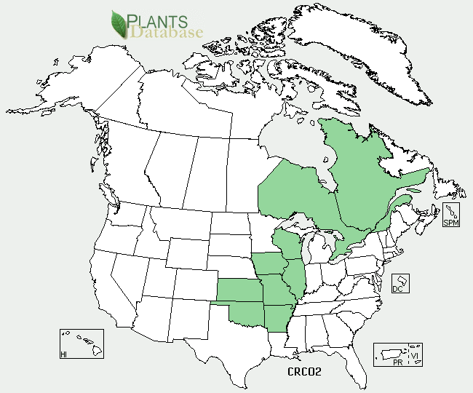

Kansas hawthorn distribution from USDA-NRCS PLANTS Database.

*General:* A spiny large shrub or small tree that is reported to be up to 20 feet tall. However, a specimen tree planted in the Brooklyn Botanical Garden in 1912 is officially recognized as the biggest tree of its species on record in the state of New York. The tree topped out at 31 feet tall and has a 36 inch basal circumference. Leaves are alternate, simple, broadly ovate 2.4 to 3.0 inches long and 2.0 to 2.4 inches wide, pubescent when young, turning glabrous with age, dull dark green above, paler beneath, base variable, apex acute, margin serrate or doubly serrate with several shallow lobes above the middle. The bark is dark brown and scaly. The twigs are lustrous brown, glabrous with many spines up to two inches long. Flowers are white and produced in flat topped inflorescences, termed corymbs, of 5 to 7 flowers. The flowers have five petals and styles and 20 stamens with rose colored anthers. Fruits are pomes that are nearly globe shaped and bright red at maturity, each contains five seeds or nutlets.

*Adaptation:* Kansas hawthorn is best adapted to dry uplands on limestone hillsides. While it can succeed in partial shade and various soil types it prefers full sun and well drained loamy soils.

*Distribution:* Kansas hawthorn grows from southern Illinois and Missouri to eastern Kansas and Oklahoma and into Arkansas. This species is uncommon in Oklahoma.

For updated distribution, please consult the Plant Profile page for this species on the PLANTS Web site.

#### **Establishment**

Kansas hawthorn can be propagated either by seed or grafting. Successful propagation from seed is the best alternative, but will require several intermediate steps such as acid scarification, warm stratification and cold moist stratification of the seed units to induce germination. This proposed series of treatments may be necessary due to the fact that *Crataegus* species possess what is termed double dormancy. Thus it is necessary to overcome two separate types of dormancy in order for the species to successfully germinate. No precise germination protocols have been worked out for Kansas hawthorn since it is considered a minor species with limited commercial value.

Grafting onto seedling stock of *Crataegus oxyacantha* or *Crataegus monogyna* is best performed in the winter or early spring.

#### **Management**

Pruning should be accomplished in the winter or early spring in order to maintain a strong central leader. Pruning should remove weak branches to allow light to penetrate the tree and root suckers or sprouts should be removed as needed. Seedlings should not be kept in a nursery situation for more than a year to reduce damage to the strong tap root system.

#### **Pests and Potential Problems:** The most common disease problems of hawthorn are rust, fireblight and leaf spot. Rust and leaf spot are caused by fungi and fireblight is a bacterial disease. Cedar – hawthorn rust is a particularly troubling problem in landscapes where Juniper species are planted near hawthorn species. The disease requires both plant species to complete its life cycle and the hawthorn species is devastated with foliage destruction to the point that the plants may be severely defoliated by late in the growing season. This combination of plant species should not be used in the same landscape planting.

Insect pests are not a serious problem on Kansas hawthorn, but may cause leaf and fruit damage on the tree.

#### **Cultivars, Improved, and Selected Materials (and area of origin)**

Consult local nurseries to choose the right cultivar for your intended use of the plant material.

#### **Prepared By:** Richard L. Wynia, USDA-NRCS Plant Materials Center, Manhattan, KS.

#### **Citation**

Wynia, R.L. 2010. Plant fact sheet for Kansas hawthorn (*Crataegus coccinioides)*. USDA-Natural Resources Conservation Service, Manhattan Plant Materials Center, Manhattan, KS 66502

Published *:* October 2009

Edited: [e.g., 08Sep2009 rg, 08Sep2009 jfh; 17Sep2009 jfe]

For more information about this and other plants, please contact your local NRCS field office or Conservation District <<http://www.nrcs.usda.gov/>>, and visit the PLANTS Web site <[http://plants.usda.gov](http://plants.usda.gov/)> or the Plant Materials Program Web site <<http://plant-materials.nrcs.usda.gov>>

**USDA IS AN EQUAL OPPORTUNITY PROVIDER AND EMPLOYER**