|  |
| --- |
| White Prairie Clover |
| *Dalea candida* Michx. ex Willd. |
| Plant Symbol = DACA7 |

Contributed by: USDA NRCS Manhattan Plant Materials Center, Manhattan, Kansas

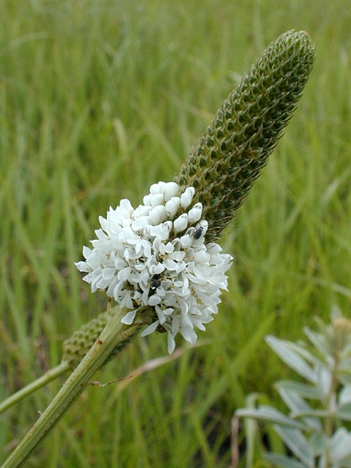

Mike Haddock, Kansas wildflowers and Grasses, KSU Library Website

Alternate Names

Slender white prairie clover, prairie clover and

Bloka (Lakota).

**Uses**

This leguminous forb produces palatable and nutritious forage for all classes of livestock and is an important browse species for antelope, deer, elk, and upland game birds, particularly sharp-tail grouse. Plains pocket gophers utilize the taproots and numerous birds and rodents eat the seed. This species will decrease and disappear under persistent overgrazing. It has an important ecological role in native grasslands, because of its nitrogen fixing characteristic. This native legume can be used as the forb component in reclamation of drastically disturbed lands, range renovation and prairie restoration projects. It is also a potentially useful plant for roadside and rest area beautification, park plantings and recreational garden natural area plantings. Native Americans used the plant for both food and medicine. The Lakota chewed the roots for its pleasant, sweet taste, and they made tea from dry leaves. Other Great Plains Indians bruised the leaves and steeped them in water for application to fresh wounds. The Pawnees called the plant broom weed because they bundled the tough stems together to make a broom for sweeping their lodges.

**Status**

Please consult the PLANTS Web site and your State Department of Natural Resources for this plant’s current status (e.g. threatened or endangered species, state noxious status, and wetland indicator values).

Description and Adaptation

*General*: Legume family (Fabaceae). White prairie clover is an attractive landscape plant that has fine textured leaves and grows 2 to 3 feet tall in small clumps. The stems tend to be single with a few upright branches near the top. The stems are ridged or ribbed longitudinally. The bright green, alternately attached leaves are pinnately compound with an odd number (usually 5 to 9) of narrow leaflets. The leaflets have glandular dots on their lower surface that can be seen with magnification. Flowering occurs from early to mid-June to July or August in Kansas. The small white flowers are packed into dense cylindrical spikes (3/8 to 2 1/8 inches) on the terminal ends of stems. The flowers are much simplified from the typical pea-like flowers of the legume family with most petals being reduced except for a single banner petal. The first flowers to open are at the bottom of the spike and progress upward toward the tip. Pollination is accomplished by numerous insects ranging from wasps to bumble bees. The fruit is a thin-walled pod (legume) approximately 1/8 of an inch long containing a single seed (rarely two). The greenish-brown seed is asymmetrically kidney shaped and a little more than 1/16 inch long.

This species is found growing primarily on well drained sandy, gravelly, and silt type soils, rarely on clay or lowland sites. It occurs on sites that receive 10 to 18 inches of precipitation. Thus it would be found growing most commonly in mid to short grass prairie plant communities. It has been observed as a pioneer species on disturbed shallow soils or gravel.

*Distribution*: Please consult the Plant Profile page for this species on the PLANTS Web site.

Establishment

White prairie clover is easy to propagate by seed. Scarification will improve total germination and speed of germination. Mechanical scarification using sandpaper or a laboratory scarifier is acceptable. White prairie clover should be planted on a prepared, weed free, firm seedbed. The seedbed should be firm enough to allow planting at a ¼ to ½ inch depth. Full seeding rate is 4 pounds per acre; however, this species will normally be planted as a minor component in a native seed mixture at a rate of .5 pound per acre or less. Seeding of the forb component in alternate rows or cross planting with the grass component will ensure better forb establishment and stand longevity. Early spring seeding will produce the best results. The processed seed of Antelope Germplasm has 278,000 seeds per pound. With any planting containing forb and shrub species, broadleaf weed species can become a problem.

Management

Weed management during the first year establishment of native forbs is essential to produce a healthy stand. Mowing at a height that will not affect white prairie clover seedlings is one method of reducing weed competition. White prairie clover has good relative forage quality, but suffers from having relatively low forage yield when compared to other native legume species. White prairie clover should improve forage digestibility when planted in pasture situations with native warm season grasses. Native legumes such as white prairie clover fix nitrogen from the atmosphere and make it available to grass species planted in association with it.

Pests and Potential Problems

Rabbits prefer the foliage of this plant and can damage young plantings of this species. Plains pocket gophers can damage the tap root of this species. White prairie clover is a food plant for the larvae stage of the isola blue butterfly *Hemiagus isola*. White prairie clover was discovered to be a host for *Megacyllene angulifera* in Carbon County, Montana. Investigation of plant damage revealed 10 per cent of the root had extensive injury from the feeding of the cerambycid larvae. Plant Pathologists at Kansas State University found that the rust species *Uropyxis* *petalostemonis* had an increased incidence of disease on white prairie clover that had been irrigated. The rust disease had a profound effect on the relative fitness and fecundity of the white clover population on the Konza Prairie Biological Station.

Environmental Concerns

White prairie clover should not cause any environmental concerns since it does not spread aggressively by seed or vegetative means.

Cultivars, Improved, and Selected Materials (and area of origin)

Antelope Germplasm is a tested class release of slender white prairie clover from the North Dakota and Montana Plant Materials Centers (PMC). It was originally collected in 1947 in Stark County, North Dakota southwest of Dickinson. This collection was first evaluated as NDL-56 in Mandan, North Dakota Soil Conservation Service Nursery. The germplasm was sent to Montana in 1960 and compared to other white prairie clover accessions. It was released cooperatively in 2000 by the two PMC’s. G1 seed is produced by the Bridger PMC and made available to commercial growers through the Foundation Seed Stock programs in Montana and Wyoming. Only a single generation (G2) beyond G1 is recognized in commercial production.

Prepared By and Species Coordinator:

Richard Wynia, USDA NRCS Plant Materials Center, Manhattan, Kansas

Edited: 080229 jsp

For more information about this and other plants, please contact your local NRCS field office or Conservation District, and visit the PLANTS Web site<<http://plants.usda.gov>> or the Plant Materials Program Web site <<http://Plant-Materials.nrcs.usda.gov>>

*The U.S. Department of Agriculture (USDA) prohibits discrimination in all its programs and activities on the basis of race, color, national origin, sex, religion, age, disability, political beliefs, sexual orientation, and marital or family status. (Not all prohibited bases apply to all programs.) Persons with disabilities who require alternative means for communication of program information (Braille, large print, audiotape, etc.) should contact USDA's* [*TARGET Center*](http://www.usda.gov/oo/target.htm) *at 202-720-2600 (voice and TDD).*

*To file a complaint of discrimination write USDA, Director, Office of Civil Rights, Room 326-W, Whitten Building, 14th and Independence Avenue, SW, Washington, DC 20250-9410 or call 202-720-5964 (voice or TDD). USDA is an equal opportunitprovider and employer.*

*Read about* [*Civil Rights at the Natural Resources Conservation Service*](http://www.nrcs.usda.gov/about/civilrights/)*.*