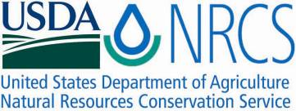

Plant Fact Sheet

Western Prairie Clover

*Dalea ornata* (Douglas) Eaton & Wright

Plant Symbol = DAOR2

Contributed by: USDA NRCS Plant Materials Center, Pullman, Washington

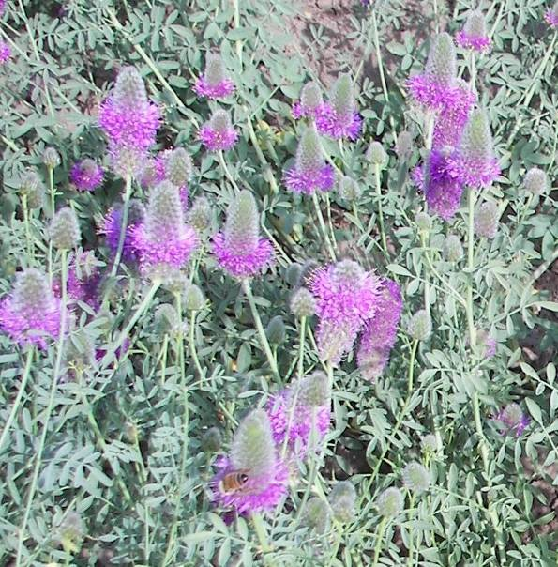

Kishor Bhattarai, Utah State University

### Alternate Names

Alternative common names: Blue Mountain prairie clover, showy prairie clover, ornate dalea

Alternative scientific names: Petalostemon ornatus Douglas ex. Hook, Petalostemon ornatum Douglas, Kuhnistera ornata (Douglas) Kuntze, Petalostemon lagopus Rydb., Petalostemon ornatum forma pallidus H. St. John

### Uses

Rangeland revegetation: Western prairie clover can be used in seeding mixes for diversification and revegetation of rangelands.

Forage: Western prairie clover is a non-toxic legume and has the potential for increasing forage production and quality (Bhattarai et al. 2009).

Pollinator habitat: Dalea ornata attracts native bee fauna as well as managed agricultural pollinators.

### *Beautification*: This plant is an excellent choice for beautification of roadsides, rest areas and parks.

### Status

Please consult the PLANTS Web site and your State Department of Natural Resources for this plant’s current status (e.g., threatened or endangered species, state noxious status, and wetland indicator values).

### Description and Adaptation

*General*: Legume family (Fabaceae). Western prairie clover is a perennial, herbaceous North American legume that grows to 12 – 24 inches in height. It has a cluster of stems that arise from a taproot. Dried stems are also usually present from previous years. Leaves are alternate and odd-pinnate, comprised of 5 – 7 oval shaped leaflets. Leaves and stems are dotted with tiny glands. Flowers occur in dense, cylinder-shaped spikes, are light pink to purple in color and have 5 petals. The flowers bloom upward along the spike May – July. Seedpods are closed and contain 1 or 2 seeds.

*Distribution*: Western prairie clover is native to southeastern Washington, western Idaho, eastern Oregon, northern California and northwestern Nevada. It is relatively uncommon.

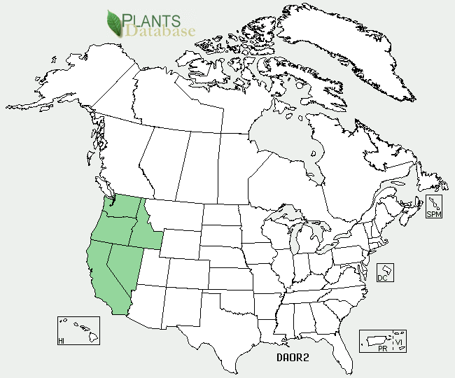

Western prairie clover distribution from USDA-NRCS PLANTS Database

For updated distribution, please consult the Plant Profile page for this species on the PLANTS Web site.

*Habitat*: Western prairie clover is found in sagebrush-steppe habitats in the southern Columbia Plateau, the Blue Mountains and the northern Great Basin. It is adapted to low to moderate elevations and is characteristic of soft clay and sandy soils derived from weathering of basalt and volcanic ash (Barneby 1977).

### Establishment

To establish a planting, the seed must first be scarified using sandpaper or a laboratory scarifying device. Seed also can be scarified by soaking in 98% sulfuric acid, rinsed with water and air-dried. The seed should be planted with a drill into a prepared, firm, weed-free seed bed at a depth of ¼ - ½ inch and at a rate of 4 – 5 pounds Pure Live Seed (PLS) per acre. If the seed is planted in a mix, the seeding rate should be adjusted according to the proportion of the mix. If the seed is broadcast, the seeding rate should be doubled. To improve the plant's ability to establish and fix nitrogen, the seed should be inoculated with the proper *Rhizobium* bacteria strain prior to planting.

### Management

In all native forb plantings, weeds must be managed for several years to ensure successful establishment. Integrated Pest Management (IPM) techniques such as herbicide use and mowing could be used.

### Pests and Potential Problems

Seedlings of *Dalea ornata* may be damaged by rodents and insects.

### Environmental Concerns

This plant does not appear to spread aggressively by seed or vegetative means.

### Cultivars, Improved, and Selected Materials (and area of origin)

None

References

Barneby, R.C. 1977. Daleae imagines. Memoirs of the New York Botanical Garden 27:1-892.

Bhattarai, K., B.S. Bushman, D.A. Johnson and J.G. Carman. 2009. Characterization of the population structures in the wildland collections of *Dalea ornata* and *D. searlsiae* from the western U.S. Society for Range Management 62nd Annual Meeting, Alberquerque, NM, 2009. Paper No. 1000-6. [Online]. Available at

<http://www.srmmeetings.org/pdf_Abstracts/pstrA1000_Ecology/1000_6.pdf> (Accessed 29 October 2009). USDA-ARS, Logan, UT.

**Burke Museum of Natural History and Culture. [Online]. Available at** <http://biology.burke.washington.edu/herbarium/imagecollection.php?Genus=Dalea&Species=ornata>**. (Accessed 29 Oct 2009). University of Washington, Seattle, WA.**

Davis, R.J. 1952. Flora of Idaho. W.M.C. Brown Company, Dubuque, IA.

Hitchcock, C.L. and A. Cronquist. 1973. Flora of the Pacific Northwest. University of Washington Press, Seattle, WA.

USDA-ARS. 2009. Improved Plant Genetic Resources for Pastures and Rangelands in the Temperate Semiarid Regions of the Western U.S. 2009 Annual Report. [Online]. Available at <http://afrsweb.usda.gov/research/projects/projects.htm?ACCN_NO=412652> (Accessed 29 Oct 2009). USDA-ARS, Logan, UT.

### Prepared By

*Pamela Scheinost*, USDA NRCS Plant Materials Center, Pullman, Washington

*Douglas A. Johnson*, USDA ARS Forage and Range Research Laboratory, Logan, Utah

*James H. Cane*, USDA ARS Pollinating Insects Research Unit, Logan, Utah

### Citation

Scheinost, P., D.A. Johnson and J.H. Cane. 2009. Plant fact sheet for western prairie clover (*Dalea ornata*). USDA-Natural Resources Conservation Service, Pullman Plant Materials Center. Pullman, WA.

Published November 2009

Edited: 13nov2009 jhc; 13nov2009 daj;17 nov2009ps; 20Nov2009 jb; 3Dec2009 ps

For more information about this and other plants, please contact your local NRCS field office or Conservation District <<http://www.nrcs.usda.gov/>>, and visit the PLANTS Web site <[http://plants.usda.gov](http://plants.usda.gov/)> or the Plant Materials Program Web site <<http://plant-materials.nrcs.usda.gov>>

**USDA IS AN EQUAL OPPORTUNITY PROVIDER AND EMPLOYER**