|  |
| --- |
| Illinois Bundleflower |
| *Desmanthus illinoensis* (Michx.) MacM. ex B.L. Robins. & Fern. |
| Plant Symbol = DEIL |

Contributed by: USDA NRCS Plant Materials Center, Manhattan, Kansas

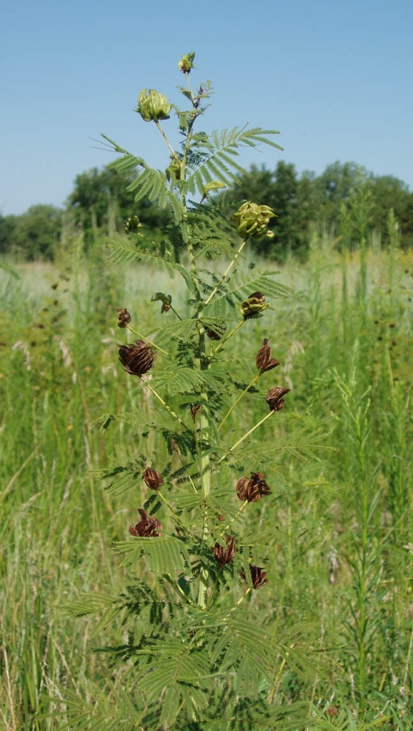

R. Alan Shadow

East Texas Plant Materials Center, Nacogdoches, Texas

Alternate Names: False sensitive plant, Illinois mimosa, and Illinois desmanthus.

Uses: It is frequently used in range revegetation projects. It is recommended for use in range seedings and for wildlife food and cover. Illinois bundleflower was a minor plant for use by Native American tribes. It is being studied as a potential human grain crop by an independent, self-funded non-profit research and educational organization based in Kansas.

Status

Please consult the PLANTS Web site and your State Department of Natural Resources for this plant’s current status (e.g. threatened or endangered species, state noxious status, and wetland indicator values).

Description and Adaptation

This species is a member of the legume family (Fabaceae). It is a warm season, herbaceous, perennial leguminous forb. Multiple stems grow from a woody caudex which is in turn attached to the deep tap root system of this species. The erect stems are smooth, angular, and grooved. The plant stands 1.5 to 4.25 feet tall when mature. Its doubly compound leaves are attached to the stems in an alternate arrangement. Leaves are sensitive to external stimulation such as sunlight or touch which causes the leaflets to fold inward, thus giving the plant the common name false sensitive plant. The white flowers contain five sepals, petals and stamens and are borne in “powder puff” globose heads. The self pollinated flowers produce clustered flat scythe-shaped pods each about 1 to 1 1/2 inches long and containing two to six seeds. The pods generally split open at maturity and the brown seeds are expelled or at least in a position to be scattered by wind or wildlife.

Illinois bundleflower plants are most often found in prairie remnants, sloughs, woodland edges or disturbed areas. The plant thrives on medium textured soils and is tolerant of most soil types except heavy clays and exceptionally coarse sands. It grows more vigorously and is more abundant in a 20 inch or greater rainfall zone. Good drought tolerance can be expected in open communities with reduced levels of competition. Bundleflower is normally found growing in association with tall warm-season grasses.

Establishment

It is easily established from commercially available seed. Bundleflower may be seeded alone at a depth of ½ inch on heavier moister soils or up to 1 inch deep on dryer sandier soil types. Planting into a prepared seed bed with mulch would increase the chance of establishment. Planting in the early to mid spring time would provide optimum moisture conditions for the seedlings. Broadcast planting would require a 50 to 100 percent increase in the amount of seed used. To maximize germination a seed scarification process should be preformed on the seed prior to planting. The seed should also be inoculated with the correct inoculant to cause nodulation of the plants root system.

Management

Planting a mixture of legumes and grass will generally increase the crude protein concentration of the harvested forage. However, forage samples containing Illinois bundleflower showed lower dry matter digestibility than grass samples alone. This lowering of digestibility may be due to the tannin content of the legume or its high lignin content. Forage yields produced in Minnesota indicated bundleflower may be a viable mid-summer forage candidate in that state, but winter survival might be a concern.

Pests and Potential Problems

Rabbits, rodents, grasshoppers, and leafhoppers selectively attack legumes, especially at the seedling stage of growth. Reports indicate that fungal leaf spot diseases and seed eating insects are a problem with this species.

Environmental Concerns

There were no environmental concerns expressed about this leguminous, native perennial prairie plant. It is compatible and competitive with climax grasses of the tall grass prairie.

Cultivars, Improved, and Selected Materials (and area of origin)

‘Sabine’ Illinois bundleflower is a cooperative cultivar release by the USDA NRCS Knox City Plant Materials Center, Texas Parks and Wildlife Department, and the Texas Agricultural Experiment Station. Sabine was collected from a native population near Crystal Beach, Texas. Foundation seed is available from the Foundation Seed Service, Vernon, Texas.

Reno Germplasm Illinois bundleflower is a Tested class release by the Manhattan Plant Materials Center in Manhattan, Kansas. Reno originated for seed collected from native plants growing near Lake Cheney in Reno County, Kansas. Generation 2 seed, equivalent to foundation seed, is available from the USDA NRCS Plant Materials Center, Manhattan, Kansas.

Prepared By and Species Coordinator:

Richard Wynia, USDA NRCS Manhattan Plant Materials Center, Manhattan, Kansas

Edited: 071218 jsp

For more information about this and other plants, please contact your local NRCS field office or Conservation District, and visit the PLANTS Web site<<http://plants.usda.gov>> or the Plant Materials Program Web site <<http://Plant-Materials.nrcs.usda.gov>>

*The U.S. Department of Agriculture (USDA) prohibits discrimination in all its programs and activities on the basis of race, color, national origin, sex, religion, age, disability, political beliefs, sexual orientation, and marital or family status. (Not all prohibited bases apply to all programs.) Persons with disabilities who require alternative means for communication of program information (Braille, large print, audiotape, etc.) should contact USDA's* [*TARGET Center*](http://www.usda.gov/oo/target.htm) *at 202-720-2600 (voice and TDD).*

*To file a complaint of discrimination write USDA, Director, Office of Civil Rights, Room 326-W, Whitten Building, 14th and Independence Avenue, SW, Washington, DC 20250-9410 or call 202-720-5964 (voice or TDD). USDA is an equal opportunity provider and employer.*

*Read about* [*Civil Rights at the Natural Resources Conservation Service*](http://www.nrcs.usda.gov/about/civilrights/)*.*