

Plant Fact Sheet

|  |
| --- |
| Panicledleaf Ticktrefoil |
| *Desmodium paniculatum (L.) DC.* |
| Plant Symbol = DEPA6 |

Contributed by: USDA, NRCS, Norman A. Berg National Plant Materials Center, Beltsville, MD

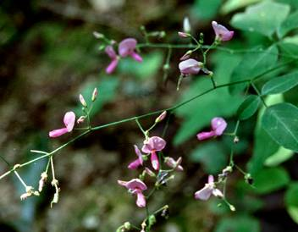

Photo by Rick Mark [rick.mark@comcast.net](rick.mark@comcast.net%20) image used with permission

Alternate Names

Panicled Tick Trefoil

Uses

*Ethnobotanical:* The Houma Indians of Louisiana used an infusion of the roots in whiskey to treat weakness and cramps.

*Landscaping and wildlife:* Panicledleaf Ticktrefoil attracts birds and is a good grazing and browsing plant for livestock. Panicledleaf Ticktrefoil enriches the soil through nitrogen fixation. Long-tongued bumblebees (*Bombus impatien* and *Bombus pensylvanica* ) collect pollen from the flowers. Other long tongued bee pollinators include leaf-cutting bees (*Megachile brevis brevis, Megachile mendica*, and *Megachile petulans* ), and digger bees (*Melissodes bimaculata bimaculata* ). Short tongued bee pollinators include: sweat bees (*Nomia nortoni nortoni*) and Campus bees (*Calliopsis andreniformis*). The caterpillars of several skippers feed on the leaves: Hoary Edge *(Achalarus lyciades)*, Silver-Spotted Skipper (*Epargyreus clarus)*, Southern Cloudywing (*Thorybes bathyllus)*, and Northern Cloudywing (*Thorybes pylades)*. The caterpillars of the butterfly Eastern Tailed Blue (*Everes comyntas)* also feed on the foliage, while the caterpillars of the butterfly Gray Hairstreak (*Strymon melinus*) eat the flowers and developing seedpods. Other insect feeders include many kinds of beetles, and some species of thrips, aphids, moth caterpillars, and stinkbugs. The seeds are eaten by some upland gamebirds (Bobwhite Quail, Wild Turkey) and small rodents (White-Footed Mouse, Deer Mouse), while the foliage is readily eaten by White-Tailed Deer and other hoofed mammalian herbivores. The Cottontail Rabbit also consumes the foliage.

Status

Please consult the PLANTS Web site and your State Department of Natural Resources for this plant’s current status (e.g. threatened or endangered species, state noxious status, and wetland indicator values).

Description and Adaptation

Panicledleaf Ticktrefoil is a native, perennial, wildflower that grows up to 3 feet tall. The genus *Desmodium*: originates from Greek meaning "long branch or chain," probably from the shape and attachment of the seedpods. The central stem is green with clover-like, oblong, multiple green leaflets proceeding singly up the stem. The showy purple flowers appear in late summer and grow arranged on a stem maturing from the bottom upwards. In early fall, the flowers produce leguminous seed pods approximately ⅛ inch long. Panicledleaf Ticktrefoil plants have a single crown. This wildflower is a pioneer species that prefers some disturbance from wildfires, selective logging, and others causes. The sticky seedpods cling to the fur of animals and the clothing of humans and are carried to new locations.

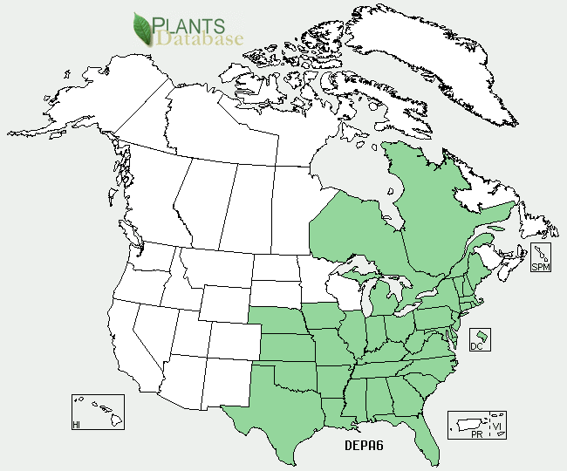

Figure Panicledleaf Ticktrefoil distribution from USDA-NRCS PLANTS Database.

For updated distribution, please consult the Plant Profile page for this species on the PLANTS Web site.

Panicledleaf Ticktrefoil grows in upland habitats such as forests and savannahs. It prefers coarse to medium textured, well drained soils, growing from Maine south to Florida and east to Texas and Nebraska.

Establishment

Gather seeds in the fall and dry them in paper bags for 1 – 2 weeks. Sow seeds directly in fall and plant a cover crop of a cool season annual grass over the seedbed to protect seed over the winter. If seeds are to be propagated in a container, stratify them for approximately 3 months at 34o to 38o F. Scarify the seeds before planting by rubbing them with sandpaper and inoculate them with a *Desmodium*-specific inoculant. Cover seeds lightly with a vermiculite/perlite mixture and keep air temperature at approximately 65o F until seeds have germinated.

Management

Panicledleaf Ticktrefoil grows in partial shade and prefers neutral to slightly acidic soil, fine to medium textured soil.

Pests and Potential Problems

No known pests or potential problems at this time.

Environmental Concerns

No concerns at this time.

Cultivars, Improved, and Selected Materials (and area of origin)

There are no recommended cultivars or selected materials at this time.

Prepared By: Samantha Kirk and Shawn Belt, NRCS, National Plant Materials Center, Beltsville, MD

**Citation**

Kirk, S. and Belt, S. 2009. Plant fact sheet for Panicledleaf Ticktrefoil **(***Desmodium paniculatum***),** USDA-Natural Resources Conservation Service, Norman A. Berg National Plant Materials Center, Beltsville, 20705**.**

Published: January 2010

Edited: (10-Nov-2009 SMK, 12 Dec -2009 SVB, 16-Dec 2009 JW, Dec 16-2009RG)

For more information about this and other plants, please contact your local NRCS field office or Conservation District <<http://www.nrcs.usda.gov/>>, and visit the PLANTS Web site <[http://plants.usda.gov](http://plants.usda.gov/)> or the Plant Materials Program Web site <<http://plant-materials.nrcs.usda.gov>>.

**USDA IS AN EQUAL OPPORTUNITY PROVIDER AND EMPLOYER**