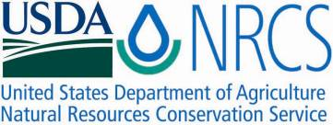

Plant Fact Sheet

# SALTGRASS

# Distichlis spicata (L.) Greene

Plant Symbol = DISP

Contributed by: USDA NRCS Cape May Plant Materials Center

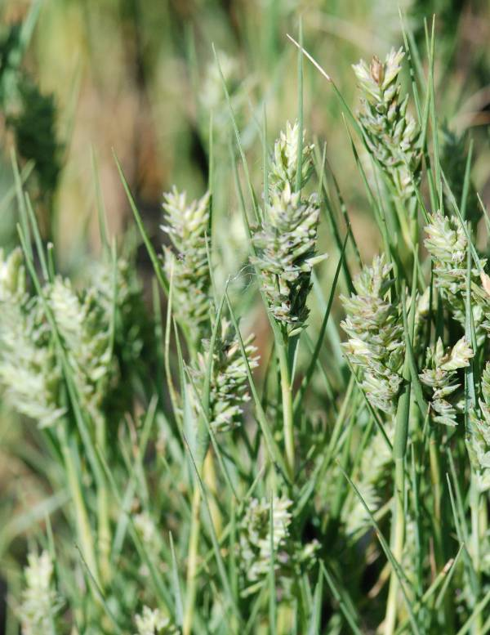 Photo by William Skaradek USDA NRCS

Alternate Names

Inland saltgrass, seashore saltgrass, spike grass and alkali grass.

Uses

*Livestock*: Under favorable soil and moisture conditions, studies have shown Saltgrass favorable for pastures irrigated with saline water. The total dry matter yields were 9081 kg/ha with a total protein production of 1300 kg/ha. Saltgrass is grazed by both cattle and horses and it has a forage value of fair to good because it remains green when most other grasses are dry during the drought periods and it is resistant to grazing and trampling. It is cropped both when green and in the dry state; however, it is most commonly used the winter for livestock feed. Saltgrass along the Atlantic coast was the primary source of hay for the early colonists.

Wildlife: Saltgrass is a larval foodplant for the Wandering Skipper (Panoquina panoquinoides errans) butterfly. It is also an important food in the diet of waterfowl and the Florida salt marsh vole (*Microtus pennsylvanicus dukecampbelli*), which is on the Endangered and Threatened Species List of Southeastern United States. Ducks are reported to occasionally eat the dried seeds and controlled burning provides tender forages for wild geese.

*Distichlis spicata* is significant in the salt marshes, which provide nesting grounds for birds, fish and larvae of many species of marine invertebrate animals. As salt marsh plants decompose, their stored nutrients provide a steady source of food for clams, crabs, and fish.

*Wetland Restoration*: The thick entangled roots of salt marsh plants acts as a guard between the ocean and the shore protecting the land from pollutants and other chemicals associated with runoff water. It is particularly useful in saline/alkaline wetlands.

*Medicine*: Saltgrass is a respiratory allergenic plant that is offered by Miles Pharmaceutical and used by Florida physicians to treat respiratory allergies.

*Spice*: Indians that inhabited California used saltgrass as a seasoning. They collected the salt crystals by threshing the blades. The seasoning provided is gray-green and said to have tasted like a salty dill pickle.

Status

Please consult the PLANTS Web site and your State Department of Natural Resources for this plant’s current status (e.g. threatened or endangered species, state noxious status, and wetland indicator values).

Description

Saltgrass is a native perennial from 15” to 35” in height. It forms dense mats with rhizomes and sometimes stolons. It is a dioecious species with male and female reproductive parts on separate plants.

It is widespread and in the eastern United States is most commonly found along estuaries and the troughs of back dune areas along the shorelines.

*Distribution*: Please consult the Plant Profile page for this species on the PLANTS Web site.

Establishment

*Adaptation*: Saltgrass is found in saline areas, brackish marshes, and in salt flats along the coasts of the Atlantic and Pacific Oceans, the Gulf of Mexico and the along the coast of South America. It inhabits upper/high marsh (irregularly flooded) areas, in which the water levels vary between 2 inches above the soil surface and 6 inches below the soil surface. It is also commonly present in the dry West, where it is one of the most drought-tolerant species. Saltgrass is located in both organic alkaline and in saline soils. It is found in planting zones 7,8,9,and 10. Distichlis spicata can be found in flower from June to October. The inflorescence is yellowish in color, turning straw brown as it dries.

*General*: It may be propagated by seeds, which are produced many times in a growing season and are dispersed by wind and water. It is easier and more often propagated by its extensively creeping underground rhizomes.

*Rhizomes*: Saltgrass can be established by seeds or by rhizome cuttings. If using rhizome cuttings, they must not dry out. They may be stored up to 28 days. It is recommended that the rhizomes be stored in a temperature range of 35-50° F and in 60-75% relative humidity. Rhizomes are can be planted any time of the year at a depth of 1-2 inches. However, rhizomes sprout better at 77-86° F.

*Seeds*: Saltgrass seeds demand more than rhizomes to sprout. The seeds need moist soil, low alkalinity and high temperatures. Although many seeds are produced, only a small percentage of those seeds may germinate naturally.

Management

Saltgrass can be managed by burning between September 1 and February 1 biannually, when the water level exceeds the soil surface. Following burning, four inches of re-growth should be obtained before grazing is allowed. Water control systems may need to be installed to maintain correct water levels to avoid prolong inundation, which kills saltgrass. Cattle walkways are usually installed to make the forage more accessible.

Pests and Potential Problems

Saltgrass is the alternate host for the red rust (*Puccinia aristidae*, also known as *Puccinia subnitens*) that infects spinach. Although the red rust disease is difficult for shippers to detect, it grows rapidly during transit. Since little is known about this disease, there are no recommended control techniques. Saltgrass eradication has been the only method used so far because the pathogen cannotcomplete its life cycle without this alternate host plant.

Cultivars, Improved, and Selected Materials (and area of origin)

**‘LK517f saltgrass’** is a California native, perennial, warm season grass with extensive creeping, yellowish, scaly rhizomes forming large colonies.

Establishment should be in late spring using rhizomes or plugs planted on one-foot centers. Irrigation water should be applied the first summer to ensure stand establishment. LK517f is used for riparian restoration and bank and shoreline stabilization.

Contact your local Natural Resources Conservation Service (formerly Soil Conservation Service) office for more information. Look in the phone book under ”United States Government.” The Natural Resources Conservation Service will be listed under the subheading “Department of Agriculture.”

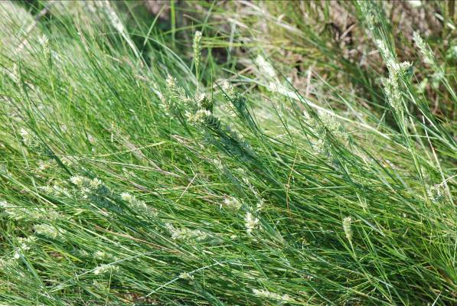 Photo by William Skaradek depicting low growing, matted growth form.

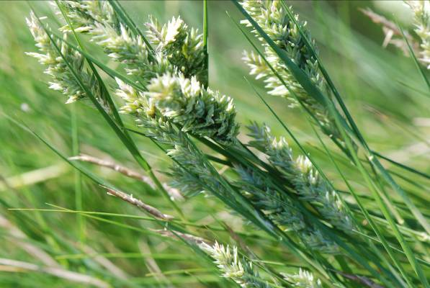 Photo by William Skaradek depicting the groups of seed heads.

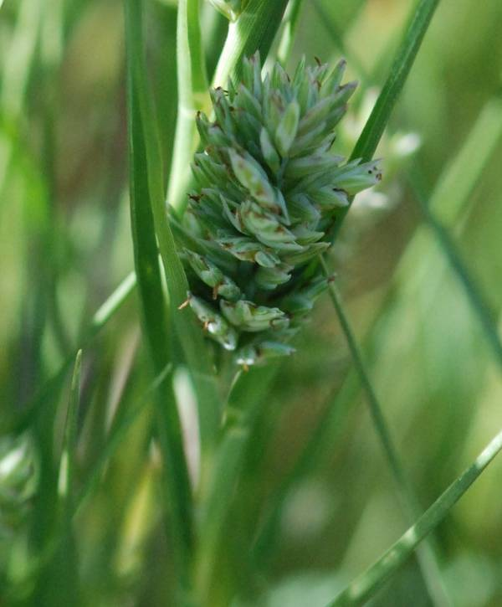

Photo of seed head close-up by William Skaradek

Prepared By:

William Skaradek

USDA NRCS and

Christopher Miller

USDA NRCS Cape May Plant Materials Center

Species Coordinator:

Christopher Miller

**Published:** June 2010

**Edited:**

Robert Glennon

James Henson

Mark Skinner

For more information about this and other plants, please contact your local NRCS field office or Conservation District <<http://www.nrcs.usda.gov/>>, and visit the PLANTS Web site <[http://plants.usda.gov](http://plants.usda.gov/)> or the Plant Materials Program Web site <<http://plant-materials.nrcs.usda.gov>>

**USDA IS AN EQUAL OPPORTUNITY PROVIDER AND EMPLOYER**