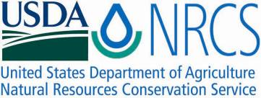

Plant Fact Sheet

# hOpbush

*Dodonaea viscosa* (L.) Jacq*.*

Plant Symbol = DOVI

Contributed by: Hoolehua Plant Materials Center

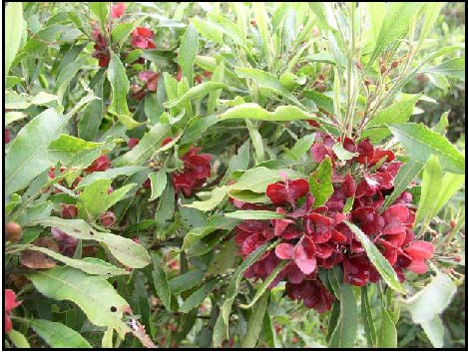David Duvauchelle

USDA NRCS 2004

**Alternate Names**

Aalii, lampuaye, togovao, hopseed bush, and varnish-leaf.

**Uses**

***Conservation:*** The fibrous spreading root system, rapid growth, and spreading canopy make *D. viscosa* an effective soil stabilizer which is particularly useful in controlling gully and coastal dune erosion. It is drought-tolerant and has the ability to withstand wildfires. *D. viscosa* shrubs are somewhat shade tolerant and suitable for riparian and restoration projects. They are also very wind hardy and useful as an in-field windbreak system.

***Landscape:*** *D. viscosa* is an aesthetically pleasing plant. It has lush green foliage and deep red capsules that make it pleasing to the eye. *D. viscosa* may be used as a hedge, specimen plant, or maybe a small patio tree. It is ideal for xeriscape gardens.

***Cultural:*** In Hawaii, its bright colored capsules were woven into lei and also used dye. The wood was used for house timbers and for making weapons. Medicinally, the leaves were crushed and applied to treat rashes.

**Status**

Please consult the PLANTS Web site and your State Department of Natural Resources for this plant’s current status (e.g. threatened or endangered species, state noxious status, and wetland indicator values).

**Description and Adaptation**

*Dodonaea viscosa* is a shrub or sometimes a small tree ranging in height from 6-25 feet. Its long and slender leaves have margins that are usually wavy or crinkled. Plants usually bloom in the early part of the year and seed before summer. The flowers are fairly small and the female flowers develop into papery capsules that may be red, pink, green, yellow, or tan. Seeds are roundish, black and very small; about 1/16 inch wide. There are about 84,200 seeds per pound. *D. viscosa* is adapted to a wide range of habitats, from sea-level to nearly 8,000 feet and tolerating annual rainfall of 12-98 inches. *D. viscosa* is found throughout the tropical regions of the world including Arizona, California, Florida, Hawaii, and Puerto Rico.

*Distribution*: Please consult the Plant Profile page for this species on the PLANTS Web site.

**Establishment**

It is recommended that *D. viscosa* be propagated in a shade house with 50 percent shade, after the last frost. To aid in germination, seeds can be soaked overnight in hot tap water or scarified. Seeds are planted ¼ inch deep in a sterile medium and irrigated daily. Dibble tubes are recommended. Germination should occur within 10 days. Fertilizer can be applied to seedlings at four weeks after germination. After four months, seedlings should be exposed to direct sunlight and allowed to adjust to the new environment. The seedlings should be ready for planting into the field after one month of exposure to direct sunlight. Some advantageous attributes of *D. viscosa,* if considering it for conservation use, are that it takes well in any kind of soil and it tolerates ocean winds and also dry dessert heat. Water regularly to establish the plant, but once it is established it requires very little water.

**Management**

Trials at the Hoolehua PMC suggest that *D. viscosa* can be planted in single rows at 1-3 foot spacing or six-foot-staggered double rows, to serve as in-field windbreaks or visual screens. With very light watering D. viscosa will remain a smaller 6-8ft shrub. On the other hand, it may attain heights above 15ft if more water is available. Mulch paper or some other sort of mulching is recommended to aid with weed suppression. It tolerates regular pruning very well if a uniform hedge is desired. It is an ideal plant for conservation because it requires very little effort to manage.

**Pests and Potential Problems**

In Hawaii a virus known as‘*Dodonaea* yellows’, characterized by stunted yellow leaves, distortion of leaf margins, severe internodal elongation of branches and twigs, and eventual death of infected tissue, possibly including the entire plant. Flowering and fruiting may be diminished or absent on symptomatic branches. Entire plants may be affected, or the symptoms may occur on individual branches of otherwise normal appearing plants.

Sooty mold, ants, scales, and some leaf-eating insects were also observed on adult shrubs and are thought to reduce plant vigor.

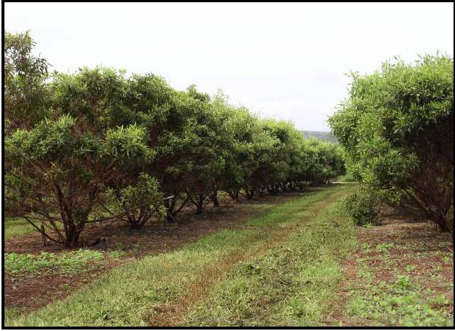*The photo above shows ‘a‘ali‘i being cultivated for seed.*

David Duvauchelle

USDA NRCS 2005

**Environmental Concerns**

None are known at this time.

**Cultivars, Improved, and Selected Materials (and area of origin)**

Kamiloloa Germplasm Aalii Source Identified Class of Natural Germaplasm (Hawaii).

**Prepared By:**

David Duvauchelle - Natural Resource Specialist

USDA NRCS Plant Materials Center

Hoolehua, Hawaii

### Citation

Duvauchelle, D. 2009 Plant fact sheet for hop bush (Dodonaea viscosa (L.) Jacq. *)*. USDA-Natural Resources Conservation Service, Hawaii Plant Materials Center, Hoolehua, HI 96729.

Published November, 2009

Edited:

For more information about this and other plants, please contact your local NRCS field office or Conservation District <<http://www.nrcs.usda.gov/>>, and visit the PLANTS Web site <[http://plants.usda.gov](http://plants.usda.gov/)> or the Plant Materials Program Web site <<http://plant-materials.nrcs.usda.gov>>

**USDA IS AN EQUAL OPPORTUNITY PROVIDER AND EMPLOYER**