|  |
| --- |
| Eastern purple coneflower |
| *Echinacea purpurea* (L.) Moench |
| Plant Symbol = ECPU |

Contributed by: USDA NRCS East Texas Plant Materials Center

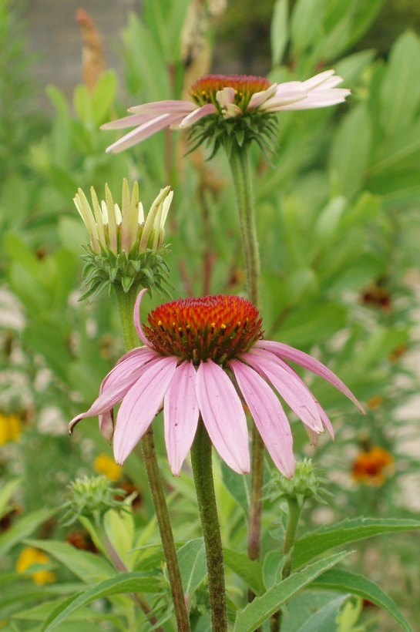 R. Alan Shadow

USDA NRCS East Texas Plant Materials Center

Alternate Names

Echinacea, snakeroot, Kansas snakeroot, broad-leaved purple coneflower, scurvy root, Indian head, comb flower, black susans, and hedge hog

Uses

*Ethnobotanic*: Eastern purple coneflower was one of the most important medicinal plants used by Native Americans. It was used by many tribes throughout North America to treat a variety of ailments. It was used as a pain reliever, anti inflammatory, a treatment for toothaches, coughs, colds, and sore throats. It was also used as an antidote for various forms of poisonings, including snake bite. Portions of this plant were used to dress wounds and treat infections. It has been used to soothe gastrointestinal troubles in man and horses. Early pioneers were quick to pick up on healing properties of this species, probably from contact with Native Americans as they traveled west, across the plains.

Modern medicine has also seen potential benefits associate with this plant species. Studies have shown eastern purple coneflower to be an immune system booster. It has also shown activity against bacterial and viral infections. Chemical compounds extracted from Echinacea have even shown inhibitory effects against certain forms of cancer.

Echinacea is a very popular herbal remedy today, and can be found easily in heath food stores. It is most commonly used to treat the common cold and flu. However, some scientists debate its effectiveness for such use. It should be noted that herbal remedies can interfere with some prescription medication. Allergic reactions have occurred in some individuals. It is recommended that a healthcare professional be consulted before use of such products.

*Landscaping*: Eastern purple coneflower is a popular plant in home gardens and is often grown for its showy flowers. It can be used in pots, as accents in flower beds, or as borders. It can also be used in wildflower mixes for roadside beautification and prairie restoration.

*Wildlife*: Eastern purple coneflower will attract insects and butterflies when in bloom, and song birds, particularly Goldfinches, are fond of its seed in the fall.

Status

Please consult the PLANTS Web site and your State Department of Natural Resources for this plant’s current status (e.g. threatened or endangered species, state noxious status, and wetland indicator values).

Description and Adaptation

Asteraceae Family. Eastern purple coneflower is an erect, long lived, perennial herb that grows one to three feet in height, and produces a woody rhizome. It has a very distinctive flower with reddish-purple petals. The petals may be pink or white in some rare instances. There is a characteristic “cone” at the center of the flower, from which its name is derived. Echinacea is rooted in the Greek word for hedge hog, echinos, in reference to the spiky appearance of the cone. The stems are rough and have small hairs along their entire length. The leaves are alternate, simple, and ovate. Seeds are produced in the cone much like that of a sunflower, and are small, dark, 4 sided achenes. Eastern purple coneflower typically blooms May through June.

Eastern purple coneflower can be found throughout most of the eastern and central United States. It can be found as far west as Colorado and north to Wisconsin, Michigan, and New York. It is not present in the extreme north east, and becomes increasingly rare as its range extends westward, past Missouri.

This plant prefers full sun, and has a low tolerance of drought conditions. It will grow in a wide range of soil textures, and prefers a pH between 6.5 and 7.2. It will not tolerate water logging, and is most commonly associated with open, upland sites.

Establishment

Seed should be sown in a well prepared, firm, weed free, seedbed at a depth of ⅛ to ¼ inch. If broadcast seeding, a light drag or cultipacker should be used to cover to the seed. Cold stratification of the seed is reportedly not necessary; however, most sources note that it does improve germination. Cold stratification can be achieved by storing the seed in moist conditions in a cooler or refrigerator for 2 months, or by planting in the fall.

If a solid stand of plants is desired, broadcast seeding at a rate of 12-15 pounds of seed per acre should be used. For 36 inch rows, a seeding rate of 3 to 5 pounds per acre will be adequate. In wildflower mixes up to 1 pound of seed per acre may be used.

For home applications seed may be germinated in flats, and transplanted into pots or flower gardens. Mature plants may also be divided when dormant and transplanted. This process is done by splitting the dormant crowns into smaller units, and transplanting to desired locations. The rhizomes and roots are very susceptible to drying during the process. They should be transplanted immediately after splitting.

Management

Echinacea does not compete well with other plants. Competition from weeds should be controlled by mechanical or chemical methods. Chemical control can be achieved by application of pre and post-emergent herbicides. (Please read all warnings and labels before making applications and follow the manufacturer’s directions.) Mechanical control can be achieved by mowing above the tops of young plants or cultivation between plants.

In general, fertilizer application is not necessary as eastern purple coneflower has low fertility needs. In newly established fields, fertilization will increase weed competition and reduce stands. Fertilization should be used sparingly in fields that have been established for 3-4 years.

Pests and Potential Problems

There are no known pests or potential problems associated with this species.

Environmental Concerns

Due to its popularity as an herbal remedy, this species is becoming increasingly rare in its natural habitat. Over harvest from the wild has drastically reduced plant numbers throughout much of its range.

Cultivars, Improved, and Selected Materials (and area of origin)

There are no releases for this species from the USDA NRCS Plant Materials Program available at this time. However, commercial material is readily available to the public though nurseries and seed companies. Improved, ornamental varieties include:

King, Bright Star, Razzmatazz, Orange Meadow Bright, Mango Meadow Bright, Doppleganger, Ruby Giant, Kim’s Knee High Sombrero, Alba, Bright Star Leuchste, Crimson Star, Magnus, Ovation, Springbrook’s Crimson Star, Talent, Thompson and Morgan Hybrids, White Flower Farm Strain, White Lustre, and White Swan.

Prepared By & Species Coordinator: R. Alan Shadow, East Texas Plant Materials Center, Nacogdoches, Texas

Edited: 071217 jsp

For more information about this and other plants, please contact your local NRCS field office or Conservation District, and visit the PLANTS Web site<<http://plants.usda.gov>> or the Plant Materials Program Web site <<http://Plant-Materials.nrcs.usda.gov>>

*The U.S. Department of Agriculture (USDA) prohibits discrimination in all its programs and activities on the basis of race, color, national origin, sex, religion, age, disability, political beliefs, sexual orientation, and marital or family status. (Not all prohibited bases apply to all programs.) Persons with disabilities who require alternative means for communication of program information (Braille, large print, audiotape, etc.) should contact USDA's* [*TARGET Center*](http://www.usda.gov/oo/target.htm) *at 202-720-2600 (voice and TDD).*

*To file a complaint of discrimination write USDA, Director, Office of Civil Rights, Room 326-W, Whitten Building, 14th and Independence Avenue, SW, Washington, DC 20250-9410 or call 202-720-5964 (voice or TDD). USDA is an equal opportunity provider and employer.*

*Read about* [*Civil Rights at the Natural Resources Conservation Service*](http://www.nrcs.usda.gov/about/civilrights/)*.*