

Plant Fact Sheet

# COMMON spikerush

***Eleocharis palustris* (L.) Roem. & Schult.**

Plant Symbol = ELPA3

*Contributed by*: USDA NRCS Idaho Plant Materials Program

### *common spikerush*

### Common spikerush. Derek Tilley, USDA-NRCS.

### Alternate Names

*Common Alternate Names:* creeping spikerush

*Scientific Alternate Names: E. calva; E. smallii;*

### Uses

*Wildlife and Livestock*: Common spikerush has moderately high protein content in the spring and good digestibility. The tops are heavily grazed by both livestock and big game animals, especially after the seeds have ripened. It produces nesting cover for waterfowl and ducks eat the seeds and geese graze the shoots.

### *Conservation Uses*: This species has utility for erosion control, constructed wetland system applications, wildlife food and cover, wetland creation and restoration, and for increasing plant diversity in wetland and riparian communities. Its dense root mass makes this species an excellent choice for soil stabilization in riparian and wetland sites. The rhizomes also form a matrix for many beneficial bacteria making this plant an excellent choice for wastewater treatment.

### Status

Please consult the PLANTS Web site and your State Department of Natural Resources for this plant’s current status (e.g., threatened or endangered species, state noxious status, and wetland indicator values).

### Description and Adaptation

### *General*: Rush Family (Cyperaceae). Common spikerush is a perennial, heavily rhizomatous wetland plant. It has a dense root mass that extends deeper that 40 cm (16 in) in the soil profile. The stems are singular or in small clusters and it will continue to grow to keep the seedheads out of the water if the water rises slowly. The stems are upright, round, and may reach 1.2 m (4 ft) in height (height is dependent on the depth of water in the growing environment). The leaves are reduced to sheaths clustered at the base of the stems. The flowers are borne in a terminal spikelet, 1 flower per scale with 2 stigmas. Plants typically flower from June through September. The seeds are yellow to brown lenticular achenes, 1.5-2.5 mm (0.06-0.1 in) long including tubercle, and subtended by up to 8 bristles. The seed ripens in late August to October. Seeds are held tightly in the seed head for a long period of time.

Common spikerush is a pioneering wetland obligate species that populates mud flats very quickly as the water draws down. It can grow in areas that are flooded in the spring and saturated in the fall. Common spikerush can grow in flooded conditions where the water is up to one meter deep for most of the growing season. It grows on fine texture soils in neutral to alkaline or saline conditions.

Common spikerush spreads rapidly by rhizomes and occasionally seed and will spread into areas with water that is too deep for seedling establishment. Common spikerush will develop a thick root mass that is resistant to compaction and erosion; however, its roots grow less deeply than Nebraska sedge (*Carex nebrascensis*). Bacterial associates of common spikerush can fix atmospheric nitrogen and make it available to other plants in the wetland community.

Common spikerush grows on sites that are either permanently or seasonally flooded. The plants can grow and thrive in permanent water up to 1 m deep or they can survive in areas where the water table drops to 30 cm (12 in) below the surface late in the season. Common Spikerush grows in areas that can be totally inundated for up to 3-4 months.

*Distribution*: Common spikerush is found from the West Coast of the US, east to the Upper Peninsula of Michigan, and south to Louisiana. For current distribution, please consult the Plant Profile page for this species on the PLANTS Web site.

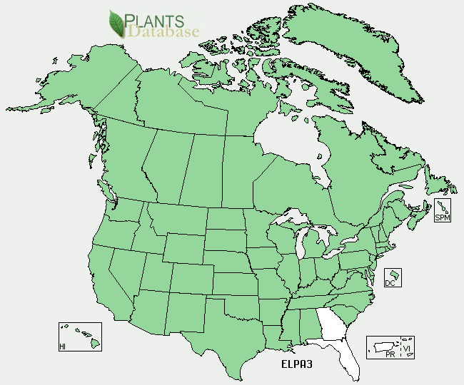

*Common spikerush distribution from USDA-NRCS PLANTS Database.*

*Habitat*: Common spikerush grows in wet meadows, irrigation ditches, springs, seepage areas, freshwater marshes, rivers, and along lakeshores. It has a broad elevational range from 0 10,000 ft and will thus be found associated with a wide assortment of plant species.

### Establishment

Planting plugs (either from the greenhouse or wild transplants) is the surest way to establish a new stand of this species. Plug spacing of 30-45 cm (12-18 in) will fill in within one growing season. The soil should be kept saturated. Allow no more than 8 cm (3 in) of standing water at any time during the first growing season. Fluctuating water levels during the establishment year will speed the spread of the plants. Water levels should be managed to enhance rhizome spread.

### Management

When plants are established, standing water should be no deeper than 1 m (3 ft) and should fluctuate throughout the growing season. If deeper water levels are desirable, increase the depth slowly over the course of the growing season. This species can tolerate periods of drought and total inundation. Water levels can be managed to enhance or reduce spread as well as control terrestrial weeds.

### Pests and Potential Problems

Few insect or disease problems have been encountered in the greenhouse. Aphids will feed on the stems, but little or no damage has been noted and the vigor of the plant has not been affected.

### Environmental Concerns

Common spikerush is native to North America. It can spread under favorable conditions but does not pose any environmental concern to native plant communities.

### Cultivars, Improved, and Selected Materials (and area of origin)

### There are no cultivars, improved, or selected materials of common spikerush. Common wildland collected seed is available from commercial sources.

### Prepared By

### Derek Tilley, USDA NRCS Plant Materials Center, Aberdeen, ID

Loren St. John, USDA NRCS Plant Materials Center, Aberdeen, ID

### 

### Citation

Tilley, D., and L. St. John. 2012. Plant Guide for common spikerush (*Eleocharis palustris)*. USDA-Natural Resources Conservation Service, Aberdeen Plant Materials Center. Aberdeen, Idaho 83210.

Published January 2013

Edited: 17dec2012djt; 17dec2012ls

For more information about this and other plants, please contact your local NRCS field office or Conservation District <<http://www.nrcs.usda.gov/>>, and visit the PLANTS Web site <[http://plants.usda.gov](http://plants.usda.gov/)> or the Plant Materials Program Web site <<http://plant-materials.nrcs.usda.gov>>

**USDA IS AN EQUAL OPPORTUNITY PROVIDER AND EMPLOYER**