

Plant Fact Sheet

# snake river wheatgrass

## Elymus wawawaiensis J. Carlson & Barkworth

Plant Symbol = ELWA2

Contributed by: USDA NRCS Idaho PM Program

### *Snake River Wheatgrass. Dr. Tom Jones, USDA, ARS, Logan, UT*

**Snake River wheatgrass. Tom Jones, USDA-ARS.**

### Uses

*Grazing/rangeland/wildlife*: Snake River wheatgrass is palatable to all classes of livestock and wildlife. It is a preferred feed in spring when protein levels can be as high as 20 percent. Protein levels decrease to about 4 percent as the grass matures in early to mid summer.

*Erosion control/reclamation*: Snake River wheatgrass is very drought tolerant, and is adapted to stabilization of disturbed soils. It is very compatible with slower developing native bunchgrass species, but does not compete well with aggressive introduced grasses. Its drought tolerance, extensive root system and fair to good seedling vigor, make this species ideal for reclamation in areas receiving 10 to 20 inches annual precipitation. This grass can be used in urban areas where irrigation water is limited to stabilize ditch banks, dikes, and roadsides as a component of a native mix.

### Status

Please consult the PLANTS Web site and your State Department of Natural Resources for this plant’s current status (e.g., threatened or endangered species, state noxious status, and wetland indicator values).

### Description and Adaptation

Snake River wheatgrass is a long-lived, perennial, cool-season native bunchgrass with an extensive root system with strong tillers. Mature plants reach a height of approximately 36 inches. Snake River wheatgrass is similar in appearance to bluebunch wheatgrass and can be distinguished by floral and vegetative characters.

The natural distribution of Snake River wheatgrass is limited to eastern Oregon, eastern Washington, and west central to northern Idaho, but it is widely used as a surrogate for bluebunch wheatgrass for restoration, reclamation, and rehabilitation of rangelands in the Columbia Plateau, Northern Basin and Range, Central Basin and Range, and Snake River Plain. For a current distribution map, consult the Plant Profile page for this species on the PLANTS Website.

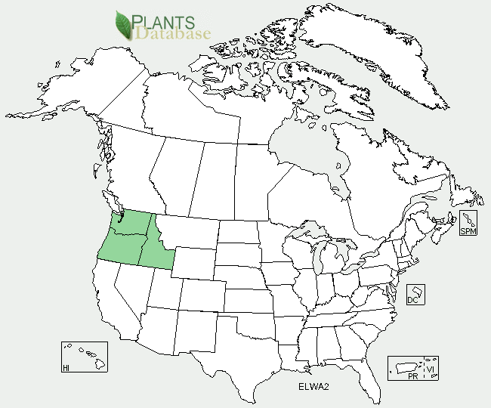

Snake River wheatgrass distribution from USDA-NRCS PLANTS Database.

Snake River wheatgrass does best on medium to coarse-textured soils, but can be found on heavy to coarse-textured soils over 10 inches deep, including fairly sandy sites. It tolerates weakly saline conditions, but does not grow on acidic sites. It is cold tolerant, moderately shade tolerant, and very tolerant of fire. It is intolerant of high water tables, and periods of extended inundation.

Snake River wheatgrass is most abundant in 8 to 20 inch annual precipitation areas at elevations from 500 to 10,000 feet. It performs best with 10 to 20 inches of annual precipitation but can establish with as little as 7 inches and tolerate up to 35 inches on very well-drained soils. It is a major component of native plant communities and generally occupies 20 to 60 percent of the overall composition by weight of the community.

### Establishment

This species should be seeded with a drill at a depth of 1/2 inch or less on medium-textured soils, 1/4 inch on fine-textured soils and 3/4 inch or less on coarse-textured soils. The single species seeding rate is 8 pounds Pure Live Seed (PLS)/ac. If used as a component of a mix, adjust to percent of mix desired. For broadcast plantings, mined lands, and other harsh critical areas, the seeding rate should be doubled. Seedlings are significantly weaker than crested wheatgrass and a clean firm weed free seedbed is required for establishment.

Seed in very early spring on heavy to medium- textured soils and in late fall on medium to light- textured soils. Late summer (August to mid- September) seeding is not recommended unless irrigation is available. Dormant fall seedings will pre-chill seed and improve germination. Snake River wheatgrass establishes fairly quickly compared to other native grasses. Stands should be given up to 3 years to ensure establishment. It is compatible with other native species and can be used in seeding mixtures. It should not be seeded with competitive introduced species. Stands may require weed-control measures during establishment.

### Management

Stands of Snake River wheatgrass should not be grazed for two to three growing seasons. Six inches of new growth should be attained in spring before grazing is allowed in established stands. The growing point of Snake River wheatgrass is fairly high and stands can be easily overgrazed. Spring grazing should occur no more than one out of three years and no more than 40 percent utilization should occur during rapid growth. Heavy early-spring grazing is especially damaging, and grazing should be delayed until new seedheads are emerging about halfway from the boot or protecting leaf. No more than 60 percent utilization should occur after seed ripens. Snake River wheatgrass is not suited to hay production and is best suited to rangeland, critical area stabilization, and cropland retirement type uses.

### Environmental Concerns

Snake River wheatgrass is long lived and spreads primarily via seed. It is not considered a "weedy" or invasive species, but can spread into adjoining vegetative communities under ideal conditions. It is known to cross with bluebunch wheatgrass, thickspike wheatgrass, quackgrass, and bottlebrush squirreltail. These interspecific hybrids generally exhibit low fertility and do not dominate a site or crowd out non-hybrid plants.

### Cultivars, Improved, and Selected Materials (and area of origin)

‘Discovery’ was developed from four accessions that were found to have improved vigor in comparison to Secar. The populations used to generate Discovery trace to materials collected in Whitman and Asotin counties in southeastern Washington and Idaho County in central Idaho. Discovery was released in 2008, and Breeder seed is maintained by the USDA-ARS Forage and Range Research Laboratory, Logan, UT. Foundation, Registered and Certified seed is available to commercial growers through the Utah Crop Improvement Association.

'Secar' is the original cultivar release of Snake River wheatgrass. It was originally released as a bluebunch wheatgrass, but was later determined it to be Snake River wheatgrass. The original collection site for Secar is the Snake River Gorge near Lewiston, Idaho. The Idaho- Oregon, Montana, and Wyoming AES, Washington Agriculture Research Center, and Pullman Plant Materials Center released Secar in 1980. Certified seed is available and Breeder seed is maintained by Pullman PMC. Foundation seed is available through the Washington State Crop Improvement Association.

### Prepared By

### Derek Tilley, USDA NRCS Plant Materials Center, Aberdeen, ID

Loren St. John, USDA NRCS Plant Materials Center, Aberdeen, ID

### 

### Citation

Tilley, D. and L. St. John. 2012. Plant Fact Sheet for Snake River wheatgrass (*Elymus wawawaiensis*). USDA-Natural Resources Conservation Service, Aberdeen Plant Materials Center. Aberdeen, Idaho 83210.

Published January 2013

Edited: 17dec2012djt; 18dec2012; 10Jan2013jab

For more information about this and other plants, please contact your local NRCS field office or Conservation District <<http://www.nrcs.usda.gov/>>, and visit the PLANTS Web site <[http://plants.usda.gov](http://plants.usda.gov/)> or the Plant Materials Program Web site <<http://plant-materials.nrcs.usda.gov>>

.

**USDA IS AN EQUAL OPPORTUNITY PROVIDER AND EMPLOYER**