|  |
| --- |
| weeping lovegrass |
| *Eragrostis curvula* (Schrad.) Nees |
| Plant Symbol = ERCU2 |

Contributed by: USDA NRCS Plant Materials Program

Uses

*Erosion control*: Weeping lovegrass is used as a temporary cover for erosion control purposes. On surface mine spoil, it provides almost immediate cover on steep outer slopes where spoil is rather acidic and of low fertility.

*Crops*: Weeping lovegrass is used as a nurse crop when seeding sericea lespedeza, coastal panic grass, or switchgrass. When seeding black locust or bristly locust, it serves as a companion species.

Status

Please consult the PLANTS Web site and your State Department of Natural Resources for this plant’s current status (e.g. threatened or endangered species, state noxious status, and wetland indicator values).

Description

*Eragrostis curvula* (Schrad.) Nees, weeping lovegrass, is a rapidly growing warm-season bunchgrass that was introduced into the U. S. from East Africa. The many long, narrow leaves emerging from a tight tuft are pendulous, with the tips almost touching the ground.The drooping leaf characteristic gives riseto the name “weeping” lovegrass. Leaf height is rarely above 12 inches. The seed heads are open panicles, reaching a height of 30 to 40 inches and containing numerous small, fine seeds.

Adaptation

Weeping lovegrass prefers a light-textured, well-drained soil, and will thrive on soils of low fertility. Climatic conditions determine its range of adaptation. Low winter temperatures will prevent regrowth and cause the grass to act as an annual or a short-lived perennial.

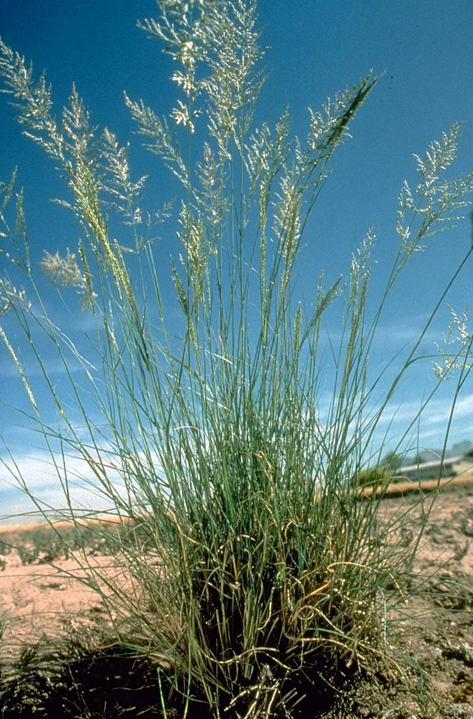

USDA NRCS National Plant Materials Center

Beltsville, MD

Weeping lovegrass is distributed throughout the southern United States. For a current distribution map, please consult the Plant Profile page for this species on the PLANTS Website.

Establishment

This grass is easy to establish by seed. Seed alone at a rate of 3 to 5 pounds per acre, or 1 to 2 pounds per acre in mixtures with other species. Seeds will germinate quickly and plant growth is rapid. The seed is extremely fine, requiring mechanical seeding equipment to have small seed attachments. If seeded with a ‘hand’ cyclone seeder, the lovegrass seed should be mixed with a diluent or a carrier (cornmeal, sand, or fine sawdust) for uniform distribution of seed. Do not cover seed more than 1/2 to 1 inch on sandy soils; 1/4 inch is sufficient on silt loams. Cultipacking soil before seeding is helpful.

Sites too steep or stony for use of mechanical equipment can be seeded without soil scarification. Broadcast seeding by air or use of hydroseeders is successful if seeding rates are increased to compensate for poor seedbed. Where possible, the soil should be scarified and firmed.

Normally, weeping lovegrass can be planted after danger of severe frost is over, and anytime throughout the summer with success. Lime and fertilizer needs are similar to that for tall fescue and ryegrass when used for temporary cover.

Management

Because of its short duration, there is no managementrequired for weeping lovegrass. It is palatable to livestock and should be protected where this possibility exists.

Pests and Potential Problems

There are no serious pests of weeping lovegrass.

Cultivars, Improved, and Selected Materials (and area of origin)

‘A-67’, ‘Ermelo’, and ‘Morpa’. Seed is commercially available from most of the large seed companies**.**

Prepared By & Species Coordinator:

USDA NRCS Plant Materials Program

Edited: 01Feb2002 JLK; 06jun06 jsp

For more information about this and other plants, please contact your local NRCS field office or Conservation District, and visit the PLANTS Web site<<http://plants.usda.gov>> or the Plant Materials Program Web site <<http://Plant-Materials.nrcs.usda.gov>>

*The U.S. Department of Agriculture (USDA) prohibits discrimination in all its programs and activities on the basis of race, color, national origin, sex, religion, age, disability, political beliefs, sexual orientation, and marital or family status. (Not all prohibited bases apply to all programs.) Persons with disabilities who require alternative means for communication of program information (Braille, large print, audiotape, etc.) should contact USDA's* [*TARGET Center*](http://www.usda.gov/oo/target.htm) *at 202-720-2600 (voice and TDD).*

*To file a complaint of discrimination write USDA, Director, Office of Civil Rights, Room 326-W, Whitten Building, 14th and Independence Avenue, SW, Washington, DC 20250-9410 or call 202-720-5964 (voice or TDD). USDA is an equal opportunity provider and employer.*

*Read about* [*Civil Rights at the Natural Resources Convervation Service*](http://www.nrcs.usda.gov/about/civilrights/)*.*