

Plant Fact Sheet

# RUBBER RABBITBRUSH

***Ericameria nauseosa* (Pallas ex Pursh) G.L. Nesom & Baird**

Plant Symbol = ERNA10

Contributed by: USDA NRCS Plant Materials Center, Pullman Washington

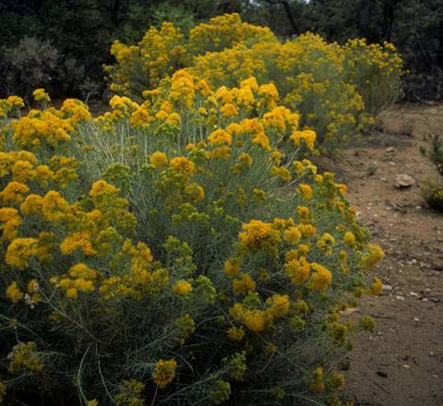

Sally and Andy Wasowski, Lady Bird Johnson Wildflower Center, www.wildflower.org

**Alternate Names**

Grey rabbitbrush, golden rabbitbrush, chamiso blanco, *Chrysothamnus nauseosus* (Pallas ex Pursh) Britton, *Chrysocoma nauseosa* Pallas ex Pursh, *Bigelovia nauseosa* Gray

**Uses**

*Forage:* Rubber rabbitbrush has marginal value for livestock but is an important browse species for wildlife during the winter months.

*Wildlife habitat:* Small mammals and birds such as jackrabbits and sage grouse utilize rubber rabbitbrush for cover.

*Pollinator habitat*: Rubber rabbitbrush attracts a wide array of native insects, including butterflies and small bees. It is one the few native plant species in the Intermountain West that provides habitat for pollinators during the late summer and fall months.

*Range revegetation, erosion control and mine reclamation:* Rubber rabbitbrush produces deep roots, heavy litter and abundant seed. It grows rapidly and is able to establish on severe sites.

*Ethnobotanical:* Native Americans used rubber rabbitbrush for baskets, yellow dye, chewing gum, tea, cough syrup, and to treat chest pains. During World War II the plant was studied as a substitute for commercial rubber, and currently it is a small commercial rubber source.

*Ornamental*: Rubber rabbitbrush is a desirable plant for low maintenance and sustainable landscaping.

**Status**

Consult the PLANTS Web site and your State Department of Natural Resources for this plant’s current status (e.g., threatened or endangered species, state noxious status, and wetland indicator values).

**Description and Adaptation**

*General*: Composite family (Asteraceae). Rubber rabbitbrush is a native, perennial, warm-season shrub that grows to 1 to 8 feet tall. It has a rounded crown with stems originating from its base. Stems and leaves are covered with dense white hairs. Leaves are 0.75 to 2.75 inches long, 0.02 to 0.12 inches wide, alternate, linear to spatula shaped with entire margins. Flowers are yellow, tubular, 0.25 to 0.4 inch long, arranged in terminal, rounded clusters. Flowers begin bloom late July – October. Inflorescences and seed bracts often persist through winter. Seeds are achenes with pappus and are wind disseminated. Reproduction is primarily by seeds and epicormic buds.

The species is taxonomically complex, and is divided into two subspecies and 22 varieties (ecotypes). The 22 ecotypes exhibit a great deal of variability in morphological characteristics and chemical composition.

*Distribution*: *Ericameria naseosa* is present in New York and all Great Plains and western states in the United States, and in the Canadian provinces of Alberta, Saskatchewan, and British Columbia. For current distribution, please consult the Plant Profile page for this species on the PLANTS Web site.

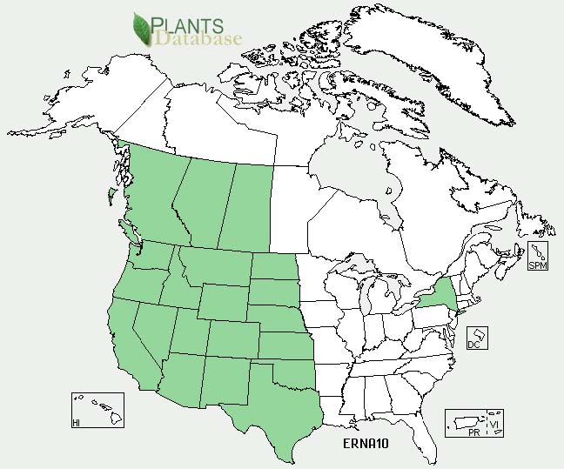Rubber rabbitbrush distribution from USDA-NRCS PLANTS Database.

*Habitat*: Rubber rabbitbrush inhabits dry, open areas on plains, valley bottoms, foothills and mountains. It is associated with many habitat types (Tirmenstein 1999).

**Establishment**

Rubber rabbitbrush can be established by transplanting seedlings, or drilling or broadcasting seed. Planting can be done in spring or fall, on prepared or unprepared seedbeds (Tirmenstein 1999). Rubber rabbitbrush should be seeded in a mixture with forbs and grasses at a rate of 0.025 lb Pure Live Seed (PLS) per acre. This rate should be doubled if the seed is broadcast.

**Management**

To control invasive weeds while minimizing damage to rubber rabbitbrush, an application of chlosulfuron can be effective (Enloe et al. 2009).

**Environmental Concerns**

Although rubber rabbitbrush may appear to dominate a plant community soon after disturbance, it is not overly competitive (McArthur 1979) and is eventually replaced with other vegetation as the community matures.

**Cultivars, Improved, and Selected Materials (and area of origin)**

None

**References**

Enloe, S.F., A. Kniss, M. Ferrell, J. Lafantasie, and S.D. Aagard. 2009. Black greasewood (*Sarcobatus vermiculatus*), gray rabbitbrush (*Ericameria nauseosa*), and perennial grass response to chlorsulfuron and metsulfuron. Invasive Plant Sci. and Manage. 2:247-252.

McArthur, E.D. and J.R. Taylor. 2004. *Chrysothamnus nauseosus* (Pallas ex Pursh) Britton, Asteraceae. *In* J.K. Francis [ed.] Wildland shrubs of the United States and its territories: thamnic descriptions: vol 1. USDA Forest Service General Tech. Rep. IITF- GTR-26. Fort Collins, CO.

Tirmenstein, D. 1999. *Chrysothamnus nauseosus*. In: Fire Effects Information System. [Online] Available at http://www.fs.fed.us/database/feis/. (accessed 15 Dec 2009). USDA Forest Service, Rocky Mountain Res. Sta., Fire Sci. Lab.

**Prepared By**

*Pamela L. Scheinost*, USDA NRCS Plant Materials Center, Pullman, Washington

*Joe Scianna*, USDA NRCS Plant Materials Center, Bridger, Montana

*Daniel G. Ogle,* USDA NRCS State Office, Boise, Idaho

**Citation**

Scheinost, P.L., J. Scianna, D.G. Ogle. 2010. Plant fact sheet for rubber rabbitbrush (*Ericameria nauseosa*). USDA-Natural Resources Conservation Service, Pullman Plant Materials Center, Pullman, WA.

Published March, 2010

Edited: 05Jan2010 dgo; 05Jan2010 js; 06Jan2010 pls; 04Feb2010 jb

For more information about this and other plants, please contact your local NRCS field office or Conservation District <<http://www.nrcs.usda.gov/>>, and visit the PLANTS Web site <[http://plants.usda.gov](http://plants.usda.gov/)> or the Plant Materials Program Web site <<http://plant-materials.nrcs.usda.gov>>

**USDA IS AN EQUAL OPPORTUNITY PROVIDER AND EMPLOYER**