

Plant Fact Sheet

# sulphur-flower buckwheat

## Eriogonum umbellatum Torr.

Plant Symbol = ERUM

*Contributed by: USDA NRCS Plant Materials Center, Corvallis, Oregon*

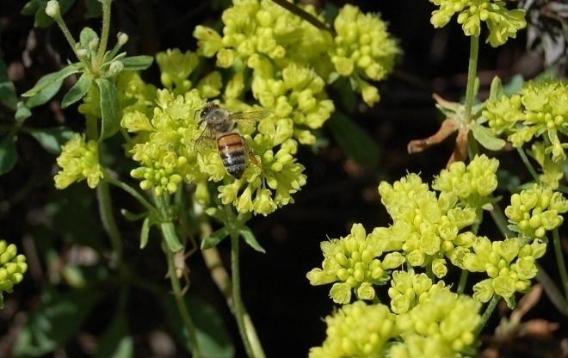

Photo by A. Young-Mathews, California Plant Materials Center, 2009

### Alternative Names

*Alternate Common Names:* Sulphur flower, buckwheat bush, sulfur buckwheat, sulfur flower buckwheat, sulphur wild buckwheat, slender buckwheat

*Alternate Scientific Names:* There are 20 to 40 recognized botanical varieties of *Eriogonum umbellatum,* many of which intergrade across their ranges.

### Uses

*Wildlife & Livestock*: The seeds are an important food source for many species of birds and small mammals. Quail, sage-grouse, deer and mountain sheep eat the leaves, and insects found on the plants are an important food source for sage-grouse chicks. The plants are rated as having medium palatability for browse animals, but low palatability for grazing animals, with low protein content.

*Pollinators*: Sulphur-flower buckwheat attracts a wide variety of bees and other native pollinators. It is a larval host and nectar source for lupine blue butterfly (*Plebejus lupini)*. The cythera metalmark butterfly (*Apodemia mormo cythera*) and the Rocky Mountain dotted-blue (*Euphilotes ancilla*) are also found in association with a few varieties of sulphur-flower. Bees produce a strong, dark honey from the nectar.

*Restoration:* Sulphur-flower buckwheat can be included in seed mixes for restoration of native plant communities on dry, rocky slopes and other sites where the species is adapted.

*Landscaping*: Sulphur-flower buckwheat can be used for environmental enhancement, erosion control and foundation plantings around homes. Plants withstand sun, heat, drought, and wind, making them ideal for dry sunny slopes. The showy flowers and seed heads, and compact growth habit make this plant a good choice for rock gardens.

*Ethnobotany*: Tribes throughout western North America traditionally used different parts of the sulphur-flower buckwheat plant to treat a variety of ailments. The Klamath used a poultice of the leaves to soothe burns. The Cheyenne made a tea from powdered stems and flowers that was used as a gynecological aid for lengthy menses. The Paiute and Shoshone made a poultice of mashed leaves, and sometimes roots, to treat lameness or rheumatism, and took a hot decoction of roots for colds or stomachaches. The Kayenta Navajo used the plant as a fumigant or to induce vomiting for gastrointestinal ailments. The Kawaiisu used the mashed flowers as a salve for gonorrheal sores.

### Status

Please consult the PLANTS Web site and your State Department of Natural Resources for this plant’s current status (e.g., threatened or endangered species, state noxious status, and wetland indicator values).

### Description and Adaptation

Sulphur-flower buckwheat is a native, low-growing, woody perennial in the buckwheat family (Polygonaceae). The plant typically forms low, broad mats with individual clumps ranging from 4 inches to 2 ft (but up to 4 ft) tall and wide. Leaves are basal, 1 inch long, and softly wooly or hairless. Flower stems are 3 to 16 inches tall and topped by umbel-shaped clusters of tiny flowers. Flowers range from sulfur yellow to orange or reddish, sometimes turning rusty orange-red with age. Floral displays can color entire slopes starting in June at lower elevations and continue into September or October at higher elevations.

Sulphur-flower buckwheat is usually found in dry, open, rocky sites with shallow, sandy soils, especially on sunny slopes and ridges. This species typically grows in regions that receive from 8 to 18 inches annual precipitation, which may come in the form of winter rain/snow or summer monsoons. This plant grows best in full sun on well-drained, sandy or gravelly soils with low fertility, but will sometimes tolerate saturated soils and light shade. It has high drought, salinity and carbonate tolerance, and grows in soils ranging from a pH of 6.5 to 9.0.

Sulphur-flower buckwheat is native to western mountainous regions of North America at elevations of 700 to 12,000 feet. It is found from western Canada south to California and east into Colorado and New Mexico. For current distribution, please consult the Plant Profile page for this species on the PLANTS Web site.

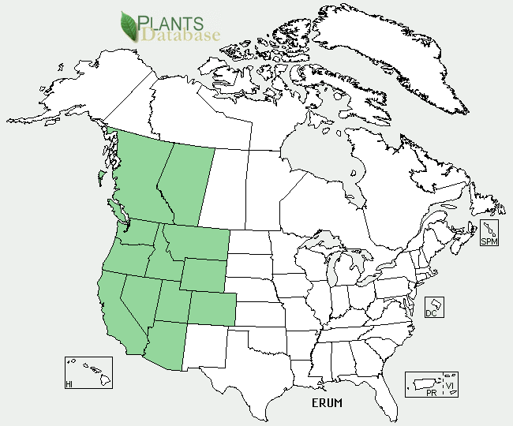

Sulphur-flower buckwheat distribution from USDA-NRCS PLANTS Database.

### Establishment and Seed Production

For most uses, sulphur-flower buckwheat can be established by direct seeding or transplanting plugs or container stock. Select a sunny, well-drained planting site and maintain good weed control, especially of annual grasses, during the first year of establishment. The recommended single-species broadcast seeding rate is 8 to 10 pounds per acre, but the rate should be adjusted depending on the species mix and site conditions. There are 100,000 to 200,000 seeds per pound, so a seeding rate of one pound per acre will result in about 2 to 5 seeds per square foot. Seeds should be raked in to a depth of about ¼ inch. Seeds are dormant, and usually require 8 to 12 weeks (but as many as 24 weeks) of cold, moist stratification in order to germinate, depending on the elevation and climate of the original collection. Dormancy is broken naturally by fall sowing if locally-adapted germplasm is used. Alternately, seeds can be cold stratified by placing them in a fine mesh bag buried in moist peat moss or sand in a ventilated container at 34 to 37°F and planted out in the early spring.

For seed production prepare a weed-free, smooth, firm, level seedbed for planting. At the Corvallis Plant Materials Center, fields are direct sown in the fall at a depth of ¼ inch and a rate of 10–12 pounds per acre (50 seeds per square foot) in rows 18–24 inches apart, unless wider row spacing is needed for between row cultivation. Weeds are controlled by row tillage, hand removal, and spot treatments with a nonselective herbicide. Production fields can also be established in the fall to early spring from container stock transplanted into weed mat to reduce the need for weed management. Plants do not produce seed until their second growing season and do not reach full production until year three, but can remain productive for ten to twenty years.

Seeds are mature when the petals and sepals become dry and papery (June to July in California and Oregon). Seed does not shatter easily and will remain on the plant for a few weeks following maturation. Small plots are harvested by hand with rice knives, while larger plots can be harvested with a seed stripper. Seeds are brittle and can be damaged easily when using threshers or combines. Use a hammermill or a gentle brush machine to break the seeds from the stalks and bracts, followed by a small air-screen machine to remove chaff and weed seeds. Seed yields vary from 150 to 700 pounds per acre.

### Management

Weeds should be controlled and irrigation may be necessary in the first year, but plants are drought tolerant once they are established. Plants can be pruned back after flowering to promote a denser, more compact plant.

### Pests and Potential Problems

Plants are relatively free from disease and pest problems, but are susceptible to root and crown rot when grown on poorly drained soils.

### Environmental Concerns

There are no known environmental concerns associated with sulphur-flower buckwheat.

### Cultivars, Improved, and Selected Materials (and area of origin)

Sulphur-flower buckwheat seeds and container plants are readily available from commercial sources. ‘Sierra’ (California) is a cultivar that was developed for erosion control and landscaping on dry, rocky slopes and droughty sites. This cultivar is adapted to the dry Sierra Nevada foothills and mountains where soils and slopes limit competition.

### Prepared By

### *Annie Young-Mathews,* Conservation Agronomist

### USDA NRCS Corvallis Plant Materials Center, Oregon

### Citation

Young-Mathews, A. 2012. Plant fact sheet for sulphur-flower buckwheat (*Eriogonum umbellatum)*. USDA-Natural Resources Conservation Service, Plant Materials Center, Corvallis, OR.

Published October 2012

Edited: 26Apr2012 dcd; 18May2012 jab; 29Aug2012 gm

For more information about this and other plants, please contact your local NRCS field office or Conservation District <<http://www.nrcs.usda.gov/>>, and visit the PLANTS Web site <[http://plants.usda.gov](http://plants.usda.gov/)> or the Plant Materials Program Web site <<http://plant-materials.nrcs.usda.gov>>

**USDA IS AN EQUAL OPPORTUNITY PROVIDER AND EMPLOYER**