

Plant Fact Sheet

# KAWELU

***Eragrostis variabilis* (Gaud.) Steud.**

Plant Symbol = ERVA

Contributed by: USDA NRCS Pacific Islands Area Plant Materials Program

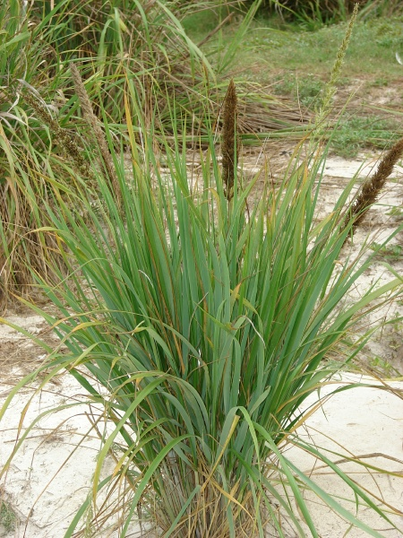

Forest and Kim Starr, USGS. Kawelu on Aviary Seep West Beach Sand Island, Midway Atoll.

Alternate Names

‘emoloa, kalamalo, variable lovegrass

**Uses**

*Conservation*: This species is used for erosion control, ecosystem restoration, and wildlife food and cover. Kawelu is one of the dominant species on Laysan and Lisianski islands and Pearl and Hermes Atoll where it is widely used by seabirds for nesting and foraging. On Laysan, the endemic and endangered Laysan Finch nests almost exclusively in kawelu and eats the seeds. Kawelu also provides important breeding habitat for the endangered Laysan Duck and several species of indigenous seabirds and terrestrial arthropods. On Pearl and Hermes Atoll, kawelu provides cover for noio (brown noddy), wedge-tailed shearwaters, and koa’e’ula (red-tailed tropic bird).

*Cultural*: The native Hawaiians used kawelu for thatching their houses as an alternative to piligrass (*Heteropogon contortus*). It is used to enhance cultural sites. Kawelu is referred to in poems, songs, and hula chants. Kawelu is a hula step that signifies the waving of grass.

*Ornamental*: Kawelu is an attractive bunchgrass that can be used as an accent plant and for other landscape uses. Individual plants look like small, light green fountains. This is especially true for the type from the Northwestern Hawaiian Islands.

**Status**

Please consult the PLANTS Web site and your State Department of Natural Resources for this plant’s current status (e.g. threatened or endangered species, state noxious status, and wetland indicator values).

**Description and Adaptation**

Kawelu is a variable, tufted, short-lived perennial grass. The stems or culms are erect, smooth, and 1 to 3 or more feet tall. There is considerable variation in length of leaves and flowering panicles. The leaf blades are flat at the base and rolled inward at the upper part. Leaves are 0.50 to 0.60 inch wide and up to 32 inches long. The flowering heads or panicles are narrow and range from 8 to 16 inches long. They are either somewhat open or dense and spike-like, with branches strongly upright to spreading. The oval seeds (caryopsis) are .03 to .06 inch long with minute grooves. They are dark reddish brown. There are approximately 3,136,000 seeds per pound.

Kawelu is an endemic that occurs in the Hawaiian Islands on sand dunes, grasslands, open sites in dry forests, and exposed slopes and ridges or cliffs from sea level to approximately 3,700 feet. It is found in the Northwestern Hawaiian Islands on the atolls of Kure, Midway, and Pearl and Hermes and the islands of Lisianski, Laysan, and Nihoa. It occurs naturally on the main islands of Hawaii, Kauai, Lanai, Maui, Molokai, and Oahu. It grows naturally in areas that receive approximately 40 to 100 inches of rainfall annually. It can be established in lower rainfall areas, but may not perpetuate itself.

There is a distinct difference in growth habit between plants from the Northwestern Hawaiian Islands and those found on the main islands. Kawelu plants from the Northwestern Hawaiian Islands are more upright and fountain-like as shown by the image taken on Aviary Seep West Beach Sand Island, Midway Atoll. The plant type in the image taken on Kanaha Beach, Maui, is typical of kawelu plants from the main islands. Kawelu seeds collected on Laysan and Midway were planted at the NRCS Hoolehua Plant Materials Center on Molokai. The resulting plants had the characteristic growth habit described for kawelu plants from the Northwestern Hawaiian Islands.

**Distribution**

Please consult the Plant Profile page for this species on the PLANTS Web site.

**Establishment**

This grass is easily established by seed. Broadcast seed at the rate of 3 to 5 pounds pure live seed (PLS) per acre.

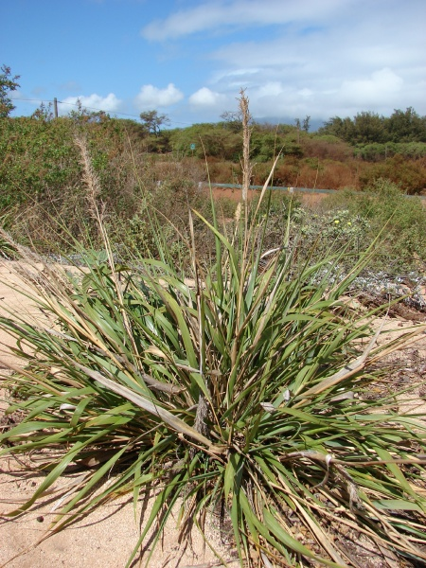

Forest and Kim Starr, USGS. Kawelu on Kanaha Beach, Maui.

Seeds will germinate quickly and the plants will develop fairly rapidly. The seedbed should be weed-free.

Plants may be propagated in the nursery and transplanted to the field. Use a sterile well-drained medium. Kawelu seedlings are susceptible to damping-off. Good sanitation practices are important. Fungicide seed treatments may be necessary. Applications of a time release fertilizer will enhance growth, enabling the seedlings to grow beyond the stagewhere they are susceptible to damping-off. The seedlings should be ready for planting on site within 3 to 4 months.

**Management**

No management is required for kawelu when planted in its natural range of adaptation for rainfall, elevation, and soil type. Plantings made on degraded sites may need additional fertilizer, irrigation, and other inputs as appropriate.

**Pests and Potential Problems**

There are no known pests that are detrimental to the life cycle of kawelu. Adult plants are susceptible to a leaf disease.

**Cultivars, Improved, and Selected Materials (and area of origin)**

Kahoolawe Germplasm Kawelu is a source identified release of a naturally occurring kawelu germplasm and has been unaltered.

**Prepared By:** *Robert J. Joy*, USDA NRCS Plant Materials Center, Hoolehua, Hawaii

### Citation

Joy, R. 2009. Plant fact sheet for kawelu (Eragrostis variabilis (Gaudich.) Steud.*)*. USDA-Natural Resources Conservation Service, Hawaii Plant Materials Center, Hoolehua, HI 96729.

Published October, 2009

Edited: 090616 jsp

For more information about this and other plants, please contact your local NRCS field office or Conservation District <<http://www.nrcs.usda.gov/>>, and visit the PLANTS Web site <[http://plants.usda.gov](http://plants.usda.gov/)> or the Plant Materials Program Web site <<http://plant-materials.nrcs.usda.gov>>

**USDA IS AN EQUAL OPPORTUNITY PROVIDER AND EMPLOYER**