

Plant Fact Sheet

# Flat-Top Goldentop

## Euthamia graminifolia (L.) Nutt.

Plant Symbol = EUGR5

*Contributed by:* USDA NRCS Cape May Plant Materials Center

Photograph of the many-branched, yellow-flowered inflorescence of the flat-top goldentop. 
The thin, grass-like leaves surround the many small flowerheads giving the plant a bushy appearance. 



Thomas G. Barnes @ USDA-NRCS PLANTS Database / Barnes, T.G., and S.W. Francis. 2004. Wildflowers and ferns of Kentucky. University Press of Kentucky.

**Alternative Names**

*Common Alternate Names:* bushy, common, fragrant, grass-leaved, or flat-topped goldenrod

*Scientific Alternate Names:*

*Solidago graminifolia* (L.) Salisb.

*Solidago lanceolata* L.

*Chrysocoma graminifolia* L.

**Uses**

*Wildlife Use:*Flat-top goldentop provides a nectar source for pollinators and is well-suited for use in pollinator restoration. Preliminary observation found that flat-top goldentop attracted 13 different species of Hymenoptera and Lepidoptera in Cape May, New Jersey. The European honey bee (*Apis mellifera*),common buckeye (*Junonia coenia*), and eastern carpenter bee (*Xylocopa virginica*) were most frequently observed visiting the flower.

The wildlife value of this species is considered low; nevertheless, songbirds such as the American goldfinch (*Carduelis tristis*) and the swamp sparrow (*Melospiza georgiana*) feed on the seeds (Hilty, 2002). Deer and rabbit enjoy browsing the plant.

The flower attracts the goldenrod soldier beetle (*Chauliognathus pensylvanicus*) and black blister beetle (*Epicauta pensylvanica*). The goldenrod soldier beetle larvae are beneficial insects known to feed on aphids, maggots, caterpillars, and grasshopper eggs; while the adults help to pollinate plants(Trigg, 2005). Black blister beetles produce cantharidin, a poisonous substance that may poison animals that graze the plant (Marlin, n.d.). Please refer to Hilty (2002b) for a complete list of insects that visit this plant.

**Status**

*E. graminifolia* is a native, facultative wetland plant that usually occurs in wetlands (67–99%) but is occasionally found in non-wetlands. Please consult the PLANTS Web site and your State Department of Natural Resources for this plant’s current status (e.g., threatened or endangered species, state noxious status, and wetland indicator values)

**Weediness**

This plant may become weedy or invasive in some regions or habitats and may displace desirable vegetation if not properly managed. Please consult with your local NRCS Field Office, Cooperative Extension Service office, state natural resource, or state agriculture department regarding its status and use. Weed information is also available from the PLANTS Web site at [http://plants.usda.gov](http://plants.usda.gov/). Please consult the Related Web Sites on the Plant Profile for this species for further information.

### Description and Adaptation

*Description*: Flat-top goldentop is an upright, erect, native perennial with a many-branched inflorescence. It is an herb of the Asteraceae family whose species name means “grass-leaf”. It grows to 3–6 ft in height with a 1–2 ft spread. The upper ½ of the plant appears bushy due to its branched stems and grass-like, narrow to linear, alternate leaves. It grows from a long-slender rhizome.

The stalk-less 2–4 in long leaves taper to a long point, and narrow towards the stem. The leaf has 3–5 nerves underneath and is minutely rough-pubescent along nerves and margins. There are a few resinous dots on the underside of the leaf. The lower leaves are deciduous early in plant’s life cycle and the upper leaves are reduced towards the inflorescence. The leaves omit a scent when crushed.

The primary stalk supporting the flower cluster is winged and pubescent with hairs lying flat on the wing margins. The flower heads are 2–2.5 in high, are arranged in dense, stalk-less, small flat-topped clusters of 20–35 flowers with small rays. It has pale to bright yellow flowers that bloom in the late summer or early fall. The outer flowers of the cluster open first. The flower heads are cone-shaped and attached at the pointed end. The whorl of small leaves beneath the flower is ovoid to bell-shaped. The obtuse or rounded, yellow bracts around the flower are somewhat sticky. These overlapping bracts are 3.1 mm long and occasionally have green tips. The .02 in (.5 mm) long seed is a hard, pubescent, one-seeded, indehiscent white nutlet. The seed is attached to hair-like bristles (pappus). The receptacle is finely fringed.

*E. graminifolia* var. *graminifolia* is distinguished by its relatively narrow leaves that are 11–20 times as long as wide (Gleason and Cronquist, 1963). *E. graminifolia* var. *hirtipes* is the hybrid of *E. graminifolia* and *E. caroliniana* (Fernald, 1950), and is distinguished by its relatively broad, hairy leaf blades and few-flowered head.

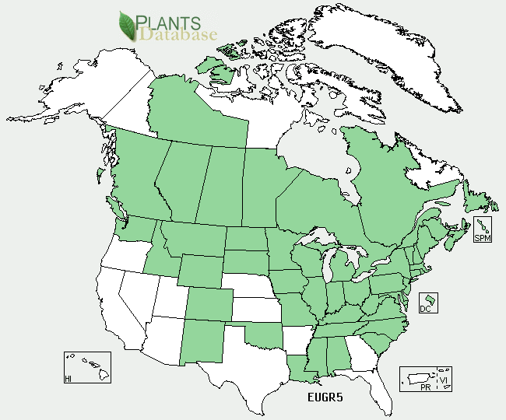

*Flat-top goldentop distribution from USDA-NRCS PLANTS Database.*

*Adaptation:* Flat-top goldentop can be found in moist, open ground; meadows; prairies; roadsides; ditches; inter-dunal flats; exposed lakes; conifer swamps; lowland forests; calcareous seeps; and sandy moist shorelines. It is tolerant of poor, gravelly, sandy, or dry soils and once established, can tolerate droughty conditions. It is also found in shaded wood edges or sunny fields and clearings. For updated distribution, please consult the Plant Profile page for this species on the PLANTS Web site.

**Establishment**

Seed can be sown year-round in a greenhouse that is at least 65°F. The recommended planting is three seeds per 2 in plug, watered regularly. It can also be sown outdoors from seed in the fall or sow the seed in a coldframe. *E. graminifolia* is a prolific rhizomatous perennial that spreads aggressively through vegetative reproduction. When growing from vegetative material divide rootball (rhizomatous clumps) while plant is dormant. Cuttings should be kept in the greenhouse at least 3 months to allow for ample root and shoot development. When transplanted into field, plant on 1.5–2 ft centers.

Unwanted seed dispersal from wind can be prevented by the development of a vegetative curtain or buffer with native shrubs, vines, or understory trees.

**Management**

Adding nitrogen will increase plant size, including an increase of stem height, number of leaves, and stem diameter. *E. graminifolia* seems to have a delayed response to nitrogen, and may store access N over winter in its rhizomes. Adding N has been shown to increase the density of stems in the second year after fertilization, thereby eliminating other plant species and reducing community diversity.

### Pests and Potential Problems

Allelopathic chemical properties have been found in root and leaf extracts of flat-top goldentop and may interfere with the growth of other species. Leaf leachates tend to interfere with seed germination while root leachates negatively affect the root growth of competing plants. Crops such as radish and lettuce are susceptible to allelopathic competition and should not be grown in the same area. Maples have also been negatively affected by similar *Solidago* species.

**Environmental Concerns**

Due to rhizomatous growth, *E. graminifolia* is somewhat aggressive. This plant may become a noxious weed so is perhaps not a good choice for more formal gardens unless controlled with a complimentary buffer planting. It is not as aggressive as *S. Canadensis* or *S. rugosa*. *E. graminifolia* is considered invasive in Europe.

### Control

Please contact your local agricultural extension specialist or county weed specialist to learn what works best in your area and how to use it safely. Always read label and safety instructions for each control method.

**Prepared By:** *Christopher M. Sheahan*. USDA-NRCS, Cape May Plant Materials Center, Cape May, NJ.

**Citation:** Sheahan, C.M. 2012. Fact sheet forflat-top goldentop (*Euthamia graminifolia*). USDA-NRCS, Cape May Plant Materials Center. Cape May, NJ. 08210.

Published July 2012

Edited:

For more information about this and other plants, please contact your local NRCS field office or Conservation District <<http://www.nrcs.usda.gov/>>, and visit the PLANTS Web site <[http://plants.usda.gov](http://plants.usda.gov/)> or the Plant Materials Program Web site <<http://plant-materials.nrcs.usda.gov>>

**USDA IS AN EQUAL OPPORTUNITY PROVIDER AND EMPLOYER**