

Plant Fact Sheet

# Penland's eutrema

## Eutrema penlandii Rollins

Plant Symbol = EUPE10

*Contributed by*: USDA NRCS Colorado Plant Materials Program

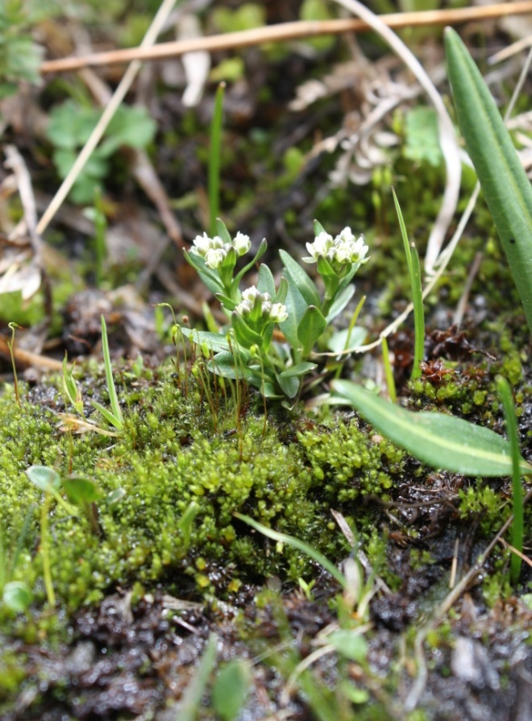

Figure1: Penland’s eutrema, *Eutrema penlandii*. Photo USFWS,

Alicia Langton July 2010.

### Alternative Names

Scientific name: *Eutrema edwardsii ssp. Penlandii*, Weber 1985).

### Common name: Penland Alpine fen mustard,

Mosquito range mustard.

### Uses

### Many mustard family plant species have known food value (cabbage, broccoli, kohlrabi, kale, etc.), in fact, Wasabi, *Eutrema japonica,* is a commonly recognized member of the *Eutrema* genus in Asia.

### Penland’s eutrema is browsed by alpine wildlife.

### Status

Penland’s eutrema was designated as endangered by the U.S. Fish and Wildlife Service (USFWS) in 1993.

The NatureServe conservation status rank, an international effort which ranks species on their “global” status, ranks Penland’s eutrema as G1/S1- critically imperiled globally and in Colorado.

Penland’s eutrema is only one of two species of *Eutrema* in North America and the only one in the lower 48 states.

Please consult the PLANTS Web site and your State Department of Natural Resources for this plant’s current status (e.g., threatened or endangered species, state noxious status, and wetland indicator values).

### Description and Adaptation

*General*: Mustard family (Brassicaceae). Penland’s eutrema is a diminutive herbaceous perennial plant that grows from a taproot . Plants grow up to 6 inches (15 cm) in height with one to several spreading erect stems (Figure 1). Basal leaves are heart-shaped with rounded tips. Several white, four-petalled flowers top each stem. The leaves and fruit are without hairs (glabrous) and stalked which distinguishes this species from many other small types of mustard that grow in the area such as *Draba* (whitlow-grass). Flowering occurs June to August and even into September, depending on the site and snow melt. Fruits of Penland’s eutrema are the characteristic mustard family siliques; they are diamond-shaped in cross-section and turn purple-black when mature which also distinguishes the plant from other look-alikes.

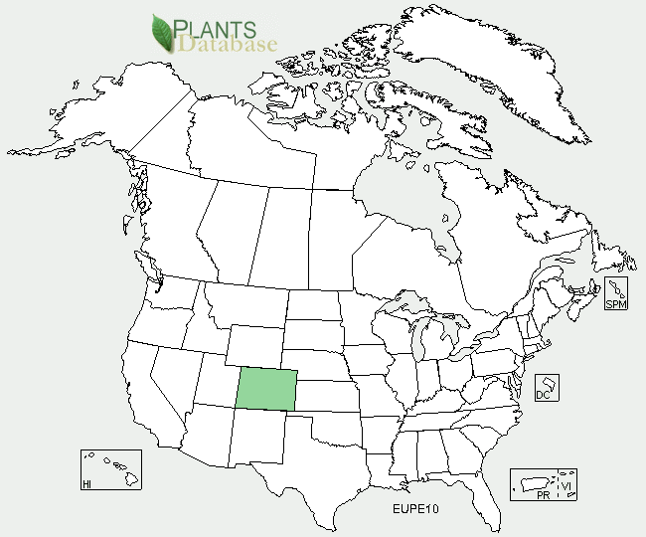

Penland’s eutrema distribution from USDA-NRCS PLANTS Database.

*Distribution*: *Eutrema penlandii* is a narrow endemic known only to occur in the Mosquito mountain range of Colorado in Lake, Park, and Summit counties. Range-wide distribution reaches 18 miles from north to south and approximately 10 miles east to west, encompassing roughly 200 acres of occupied habitat. This species is thought to be an ice-age relic with its closest relative, *E. edwardsii,* found in the Canadian Arctic Archipelago. Approximately 40% of the existing known populations and habitat for Penland’s Eutrema occurs on private land. Please consult the USFWS website at www.fws.gov, for more information. For current distribution, please consult the Plant Profile page for this species on the PLANTS Web site.

*Habitat*: Penland’s eutrema is an alpine tundra species that grows above treeline in association with many species of moss, forbs, and graminoids in alpine meadow habitat. It occurs in wetlands with perennial water flow from snowmelt, at 11,800 -13,100 ft. in elevation. Penland’s eutrema generally grows on the leeward, south and east-facing, flat to gently sloping benches with steep walls that provide some protection from snow-melting winds. The annual precipitation is 30-40 inches. Penland’s eutrema is known to frequently occur in association with a variety of alpine tundra species including: white marsh marigold (*Caltha leptosepala*), water sedge (*Carex aquatilis*), mountain sedge (*Carex scopulorum),* Bering chickweed (*Cerastium beeringianum*), alpine spring beauty (*Claytonia megarhiza*), tufted hairgrass (*Deschampsia cespitosa*), Ross avens (*Geum rossii*), elephanthead (*Pedicularis groenlandica*), arctic bluegrass (*Poa arctica*), America bistort (*Polygonum bistortoides),* alpine bistort (*Polygonum viviparum*), King’s crown (*Rhodiola integrifolia*), Rose crown (*Rhodiola rhodantha*), diamondleaf saxifrage (*Saxifraga rhomboidea*), and alpine meadow rue (*Thalictrum alpinum*). The Mosquito Range includes thirteen other rare plant species, of which, two are known only from the range.

**Adaptation**

Penland’s eutrema is adapted to grow in the Mosquito Range in central Colorado, where a unique set of habitat conditions exist. An arctic circumpolar species, Penland’s eutrema is separated from its closest relative *E. edwardsii*, which occurs in the Canadian Arctic Archipelago by over 1000 miles to the north.

For updated distribution, please consult the Plant Profile page for this species on the PLANTS Web site.

### Establishment

### Depending on snow-melt, Penland’s eutrema produces mature fruits from late-July into August and into September. Penland’s eutrema produces from seed with no means of vegetative reproduction. Little else is known about the reproduction, pollinators, or seed dispersal at this time.

### Management

Primary threats to Penland’s eutremaappear to be from habitat loss through recreation (off-highway vehicle use, camping, and hiking), alterations to hydrology, mining impacts, and climate.

### Pests and Potential Problems

Currently there are no known pests affecting the growth and vigor of Penland’s eutrema. Associated threats may include the introduction of non-native invasive plant species from hikers and campers as recreational use numbers continue to increase annually of this popular recreation area that constitutes the only habitat of Penland’s eutrema. Impacts of herbivory from pikas and rodents have been noted by researchers. However, Penland’s mustard has evolved some tolerance to grazing and wildlife usage. For instance, a taproot growth form enables re-sprouting after grazing. Interestingly, to date, the main non-native constituent in Penland’s mustard habitat is dandelion, *Taraxacon officinales*, another tap-rooted species.

### Environmental Concerns

### Hydrology is the most fragile aspect of the habitat affecting Penland’s eutrema. Any activity that directly or indirectly alters the surface or ground water supply and alters the wetland habitat required by this species could pose a significant threat. On a larger scale, climate change could potentially threaten this and other alpine species since there are no upward elevation to which the species may migrate.

### Cultivars, Improved, and Selected Materials (and area of origin)

N/A

**Prepared By**:

*Christine Taliga*; Plant Materials Specialist, USDA NRCS Colorado State Office, Denver, Colorado.

*Gina Glenne*; Botanist USFWS, Mountain-Prairie Region, Grand Junction, Colorado.

### Citation

Taliga, Christine E. and Gina Glenne, 2012. Plant Fact Sheet for Penland’s eutrema (*Eutrema penlandii)*. USDA-Natural Resources Conservation Service, Colorado State Office. Denver, 80225-0426.

Published *September 2012*

Edited: 19Sep2012jab

For more information about this and other plants, please contact your local NRCS field office or Conservation District <<http://www.nrcs.usda.gov/>>, and visit the PLANTS Web site <[http://plants.usda.gov](http://plants.usda.gov/)> or the Plant Materials Program Web site <<http://plant-materials.nrcs.usda.gov>>.

**USDA IS AN EQUAL OPPORTUNITY PROVIDER AND EMPLOYER**