|  |
| --- |
| California fescue |
| *Festuca californica* Vasey |
| Plant Symbol = FECA |

*Contributed by: USDA NRCS Plant Materials Center, Corvallis, Oregon*

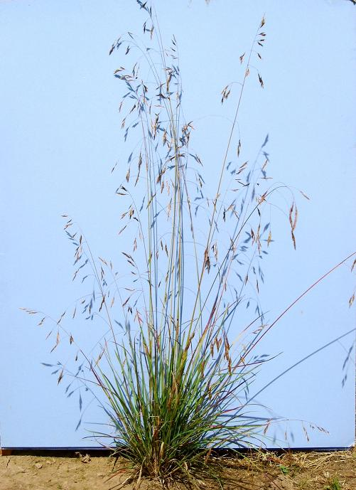

**Alternate names:** A close relative is Parish’s California fescue, *Festuca parishii* or *Festuca californica* var*. parishii*.

**Uses:** California fescue is a native grass useful for the restoration of upland plant communities, especially oak savanna, open woodlands, and prairies in Oregon and California. Its deep roots make it a good candidate for erosion control on slopes. The species often persists throughout the year with evergreen foliage in milder environments. Tightly clumped bases and non-aggressive growth habit suggest compatibility with forbs. Other possible uses are revegetation of disturbed areas and wildlife food and cover. Palatability is medium for all classes of ungulates. The species attracts certain butterflies and many native birds eat the seeds. As a tall grass with thick chalky blue to green foliage, California fescue is increasingly appreciated for its ornamental and environmental landscape value.

# Description: California fescue is a native, cool season perennial bunchgrass that is intermediate to long lived. The base is tightly clumped and the culms (stems) are tall and erect, growing to a height of 60-140 cm. Inflorescences (flowers or panicles) are 10-30 cm long, open and sparsely branched. Branches usually occur in pairs. Leaves are medium textured (2-4 mm wide), primarily basal, stiff, sometimes purple tinged, flat or rolled, firm, and rough to the touch. Plants are typically grayish blue to green and lack horizontal rooting systems. This species flowers anytime between March and July, depending on elevation, population, or locale.

*Key to identification*: California fescue is coarser textured and usually taller than other native fescues, but might be confused with tall fescue (*Schedonorus phoenix,* synonym *Festuca arundinacea*), which is widely introduced in the region. However, compared to California fescue, the leaves of tall fescue are wider (4-10 mm vs. 2-4 mm) and have prominent or clasping auricles (lobes at the base of the leaf blades). Parish’s fescue is smaller, but otherwise very similar to California fescue.

**Adaptation:** California fescue is found in large parts of Oregon and California; its range includes the Coast Ranges, foothills, and valleys from Clackamas County, Oregon, to San Luis Obispo County, California. The species also occurs in the Cascade Range from Clackamas County south into California and in the north and central Sierra Nevada. Elevation range is from sea level to 6500 ft. in the mountains. Its relative, Parish’s California fescue, is confined to the San Bernardino Mountains of California.

California fescue plants become hardy at a young age and, once established, are tough survivors. Adapted to a variety of conditions, the species tolerates sun to intermediate shade and semi-drought, as well as moist soil along stream banks. However, it is most frequent in the dappled shade, along the borders of woods, and on north facing slopes. Other habitats include oak savanna, the understory of mixed conifer-hardwood forests, chaparral, and serpentine soils (soils toxic to many plants due to high levels magnesium and iron silicates and other minerals). Preferred soils are medium to fine textured with a pH of 5.7 to 7.5. In one study, the species was rated tolerant to salt spray and moderately tolerant to soil salinity, similar to many other grasses including introduced tall fescue.

**Commercial availability:** A few seed sources are sometimes for sale in Oregon and California. Several cultivars with exceptional foliage are found in the horticultural trade, but they are vegetatively propagated or have a narrow gene base and are not recommended for restoration.

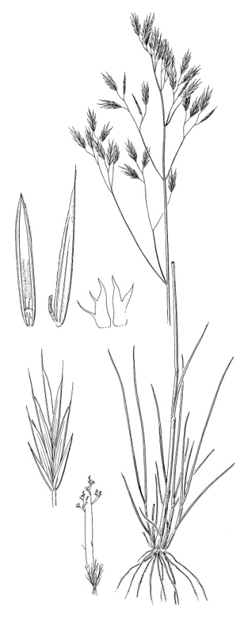

##### Line drawing reprinted with permission,

University of Washington Press

**Relative abundance in the wild:** California fescue has become rare in the Willamette Valley. Often hard to find, it is an excellent candidate for species reintroduction. This grass is relatively common in Southwest Oregon and parts of California.

**Limitations or environmental concerns:** This species is initially slow to germinate and sometimes difficult to establish, especially with competition. Seed set is low in some years which may be the result interference in pollination from rains during early spring flowering. There are no known environmental concerns.

**Establishment:** California fescue appears to have minor seed dormancy, at least in some populations. Others report no dormancy, but two weeks of cold moist chilling (stratification treatment) can result in more uniform and quicker germination. Spring sowing of untreated seed can have staggered germination; seedlings may emerge over a period of two to eight weeks. Therefore, fall planting when soil temperatures are cooler is highly recommended. No special physical conditioning of the seed is required for using a drill or broadcast seeder. While slow to establish, seedlings become hardy plants. . There are approximately 224,000 (+/- 20%) seeds per pound with hulls intact. Each 1 pound of seed sown per acre is equivalent to approximately 5 seeds per square foot. Sown alone, a suggested minimum seeding rate is 10 lbs of pure live seed (PLS) per acre for general revegetation. In seed mixes, fast germinating and quick establishing grasses should be kept to a low percentage.

Some practitioners prefer container plants of California fescue because of spotty or variable establishment from seed. It is easily propagated vegetatively by division of the crown. California fescue is presumed to have some tolerance to fire as a natural component of grassland ecosystems. Suggested frequency for prescribed fire is once every three to five years. However, summer burning can be fatal if plants are green and active. Specific guidelines for stand management and grazing are not well reported.

Prepared By:

Dale Darris and Sonja Johnson. USDA NRCS Plant Materials Center, Corvallis, Oregon.

Species Coordinator:

Dale Darris, USDA NRCS Plant Materials Center, Corvallis, Oregon.

Edited 7/31/07 D. Darris; 070802 jsp

For more information about this and other plants, please contact your local NRCS field office or Conservation District, and visit the PLANTS Web site<<http://plants.usda.gov>> or the Plant Materials Program Web site <<http://Plant-Materials.nrcs.usda.gov>>

*The U.S. Department of Agriculture (USDA) prohibits discrimination in all its programs and activities on the basis of race, color, national origin, sex, religion, age, disability, political beliefs, sexual orientation, and marital or family status. (Not all prohibited bases apply to all programs.) Persons with disabilities who require alternative means for communication of program information (Braille, large print, audiotape, etc.) should contact USDA's* [*TARGET Center*](http://www.usda.gov/oo/target.htm) *at 202-720-2600 (voice and TDD).*

*To file a complaint of discrimination write USDA, Director, Office of Civil Rights, Room 326-W, Whitten Building, 14th and Independence Avenue, SW, Washington, DC 20250-9410 or call 202-720-5964 (voice or TDD). USDA is an equal opportunity provider and employer.*

*Read about* [*Civil Rights at the Natural Resources Conservation Service*](http://www.nrcs.usda.gov/about/civilrights/)*.*