

Plant Fact Sheet

# stretchberry

*Forestiera pubescens* Nutt.

Plant Symbol = FOPU2

Contributed by: USDA NRCS Montana Plant Materials Center

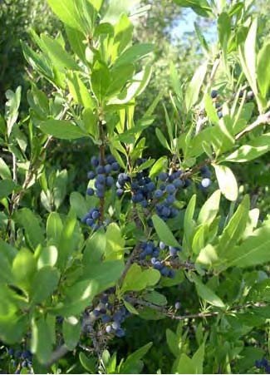

**Stretchberry**

**Alternate Names**

*Forestiera neomexicana*, New Mexico forestiera, New Mexico olive, New Mexico privet.

**Uses**

Stretchberry has several conservation applications including windbreaks, shelterbelts, and living snowfences. It can be used in wildlife plantings for nesting, cover, and food. Although the species performs best when provided with adequate soil moisture, it is considered fairly drought tolerant and can be used in Xeriscapes® and for mine land reclamation.

**Status**

Please consult the PLANTS Web site and your State Department of Natural Resources for this plant’s current status (e.g., threatened or endangered species, state noxious status, and wetland indicator values).

**Description and Adaptation**

Stretchberry is a multi-stemmed, perennial shrub reaching a mature height of 12 to 15 feet under ideal conditions (high soil moisture, good nutrition). It has numerous, sometimes interlocking branches, and is capable of sprouting from the base. The light-green to grayish-green oblong simple leaves have an opposite arrangement on the stem. New bark is smooth and light gray to brown; old bark tends to be smooth and light gray. The yellow flowers are inconspicuous and borne in dense clusters in the axils of the previous year’s leaves. Stretchberry blooms in late March or early to mid-April before new leaves appear.

Stretchberry fruit is a round to oblong drupe (berry) that matures to a dark bluish-black to black color from June to September. Fruit retention tends to be moderate, the fruit often lost to birds before falling to the ground. Stretchberry is comparable to skunkbush sumac *Rhus trilobata* in function and use. It tends to form dense, almost impenetrable hedges, although the branches of stretchberry are more linear, erect, and supple than skunkbush sumac.

Stretchberry is native to southwestern United States. It grows along stream courses, moist valleys, hillsides, and mesas at elevations of 3,000 to 7,000 feet. It is well adapted to annual precipitation zones ranging from approximately 9 to 24 inches. It grows best in soils with a pH range of 7.0 to 8.5. It is described as needing a minimum of 160 frost-free days, although it grows well in Montana in areas characterized by a 135-day growing season.

*Distribution*: Stretchberry is found in Arizona, California, Colorado, Nevada, New Mexico, Oklahoma, Texas and Utah. Please consult the Plant Profile page for this species on the PLANTS Web site.

**Establishment**

Stretchberry establishes from seed, containerized, or bareroot stock. Plant seeds in moist soil in the fall or prior to February for natural stratification. Seedlings emerge by May. For spring planting in May, seeds must be stratified for 30 days in moist sand at 38 degrees Fahrenheit. Thin seedling to two-foot spacing within rows.

**Management**

Although stretchberry is considered drought tolerant, its performance is improved with supplemental watering and fertility. As with other woody plants, it is important to control weeds during establishment with tillage, weed cloth, or careful application of herbicides.

**Pests and Potential Problems**

No serious insect or disease problems have been observed.

**Environmental Concerns**

None

**Cultivars, Improved, and Selected Materials (and area of origin)**

“Jemez” stretchberry was released in 1978 by the Agricultural Experiment Stations at New Mexico State and Colorado State Universities, the New Mexico Highway Department and Los Lunas New Mexico Plant Materials Center. The original seed was collected from a population at Jemez Springs, New Mexico in 1939.

**Prepared By:**

*James S. Jacobs*, Plant Materials Specialist, USDA-NRCS, Bozeman, Montana.

**Citation**

Jacobs, J. 2009. Plant fact sheet for stretchberry (*Forestiera pubescens* Nutt.*)*. USDA-Natural Resources Conservation Service, Federal Building, Bozeman, MT 59715.

Published September, 2009

Edited: 17Aug09JSJ

For more information about this and other plants, please contact your local NRCS field office or Conservation District <<http://www.nrcs.usda.gov/>>, and visit the PLANTS Web site <[http://plants.usda.gov](http://plants.usda.gov/)> or the Plant Materials Program Web site <<http://plant-materials.nrcs.usda.gov>>

**USDA IS AN EQUAL OPPORTUNITY PROVIDER AND EMPLOYER**