

Plant Fact Sheet

# slender-spiked mannagrass

## Glyceria leptostachya Buckley

Plant Symbol = GLLE2

*Contributed by*: USDA NRCS Plant Materials Center, Corvallis, Oregon

*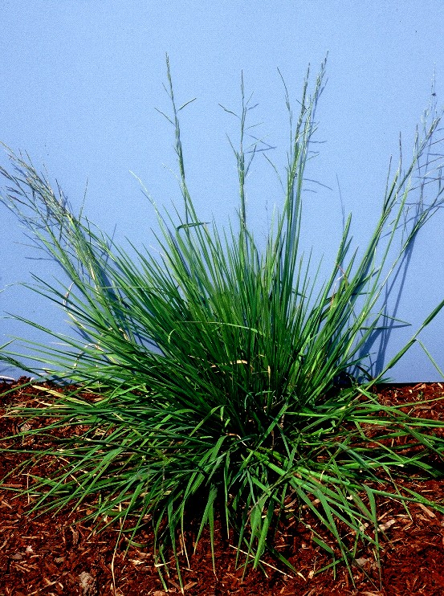 Photo by Dale Darris, Corvallis Plant Materials Center.*

### Alternative Names

*Alternate Common Names:* davy mannagrass, slimheaded mannagrass, soft mannagrass

*Alternate Scientific Names: Glyceria davyi* (Merr.) Tzvelev

Uses

Slender-spiked mannagrass is a lesser known, mid-sized native grass suitable for wetland restoration and enhancement. It may also be used for seeding the edges of streams and lakes, as well as the bottom of low gradient drainage ditches and other watercourses. This species exhibits a low growth form and vegetative spread that helps reduce erosion. The prostrate floating leaves and stems may further aid in control erosion by lining the banks of streams, waterways, and channels during high flows. The seed and leaves are a likely source of food for waterfowl, shore birds, songbirds, and small mammals, similar to other mannagrasses. Forage value and palatability for livestock are unknown. However, the tender green foliage is probably utilized by deer and other ungulates.

Status

Please consult the PLANTS Web site and your State Department of Natural Resources for this plant’s current status (e.g. threatened or endangered species, state noxious status, and wetland indicator values).

Description and Adaptation

Slender-spiked mannagrass is a short-lived, perennial, cool season grass with succulent foliage and erect to low-lying stems that are 60 to 110 cm tall. Reportedly, this grass also produces rhizomes (underground stems), but individuals often retain a more bunchgrass appearance. Plants may spread vegetatively from lower stems that root at nodes (joints) in contact with the soil. The leaf blades are flat to rolled slightly inward, 3 to 7 (10) mm wide, and rough on both sides. On land, they develop mostly at the base of the plant, but floating leaves can form when plants are submerged. The flower head (panicle) is open, 20 to 40 cm long, with a few branches pressed close to the main axis. Slender-spiked mannagrass occurs in coastal states and provinces from Alaska south to California, but not further inland. For updated distribution, please consult the Plant Profile page for this species on the PLANTS Web site.

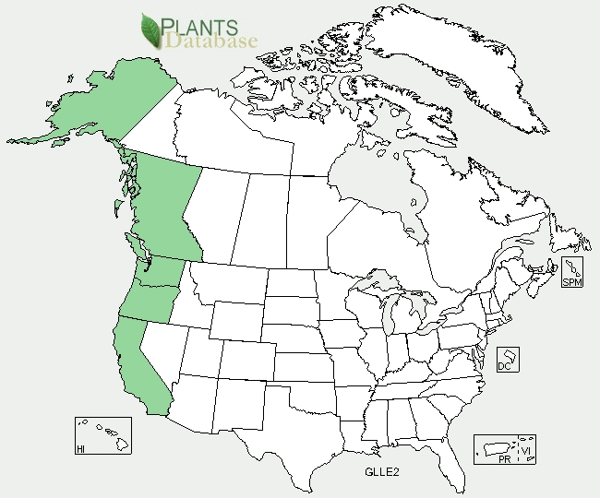

*Slender-spiked mannagrass distribution from USDA-NRCS PLANTS Database.*

### *Relative abundance in the wild:* Generally uncommon throughout its natural range compared to other mannagrasses. Scattered plants are occasionally found along small streams and in riparian wetlands or marshy areas, especially in the Willamette Valley of Oregon and along the Pacific Coast. Seed ripens in July or August. Retention within the panicle is poor to fair at best. Wild collections rarely yield much seed because populations are usually small and plants are widely scattered.

*Key to identification:*In the Pacific Northwest USA, this species resembles a smaller version of western mannagrass (*Glyceria occidentalis*), which is coarser, more open, and has much larger seeds. It can also be confused with northern mannagrass (*Glyceria borealis*), but the latter has a smooth leaf blade, while the upper blades of slender-spiked mannagrass are rough in texture. Consult a botanical key to distinguish these species.

### Line drawing of slender-spiked mannagrass with permission by the University of Washington Press.

*Line drawing of* Glyceria leptostachya *reprinted with permission, University of Washington Press.*

*Adaptation:*This species is well adapted to wet meadows, the margins of streams, lakeshores, freshwater marshy areas, and other depressions that stay moist in summer. It easily withstands year round inundation by developing a floating leaf growth form. However, longevity may be reduced. This species is found on acidic soils that are coarse to fine textured. Tolerance to salinity, alkalinity, or high soil acidity is unknown. Slender-spiked mannagrass typically grows in full sun.

Establishment

Slender-spiked mannagrass seed has no strong dormancy and germinates at a moderate rate in fall or spring. Establishment rate is intermediate. Hulls are loosely attached and may be readily removed during seed processing. There are approximately 1,300,000 seeds per pound (± 30%). A sowing rate of one pound per acre of pure live seed will result in about 30 live seeds per square foot. The potential high cost of seed may limit its use to mixtures with other native grasses. Based on seed size and seedling vigor alone, a seedling rate of 2 to 5 lbs/ac may be adequate for a single species stand.

Management

There is a lack of information about the management of slender-spiked mannagrass for livestock or other purposes. Succulent growth should favor palatability, but grazing would be inappropriate or restricted under the wet environments where this species grows. Seed production requires extensive irrigation, poorly drained soils, seasonal wetlands, or shallow water impoundments. Regeneration is favored by disturbance and the presence of open mud or prolonged moist soil that is sparsely vegetated.This species may be suited to moist soil management (slow de-watering, disking, etc.) of impounded wetlands for improving waterfowl, shorebird, and other wildlife habitat.

Limitations and Environmental Concerns

It is difficult to obtain seed of any volume from the wild. In western Oregon, other mannagrasses, especially western mannagrass, are considered weeds in low lying fields of Italian ryegrass (*Lolium* spp.) grown for seed. Apparently, slender-spiked mannagrass is of infrequent or lesser concern. It is not reported to be a competitive, weedy or invasive plant species.

Cultivars, Improved, and Selected Materials (and area of origin)

This species is rarely sold as seed or plants. Availability depends on wild collections or contract growing with producers who specialize in native herbaceous plant seed.

Prepared By:

*Dale Darris*, USDA NRCS Plant Materials Center, Corvallis, Oregon

**Citation**

Darris, D. 2005. Plant fact sheet for slender-spiked mannagrass (*Glyceria leptostachya)*. USDA-Natural Resources Conservation Service, Plant Materials Center, Corvallis, OR.

Published January 2005

Edited: 21Mar2006jsp; 17Sep2008 dcd; 19Sep2008 jsp; 17Feb2012 aym

For more information about this and other plants, please contact your local NRCS field office or Conservation District <<http://www.nrcs.usda.gov/>>, and visit the PLANTS Web site <[http://plants.usda.gov](http://plants.usda.gov/)> or the Plant Materials Program Web site <<http://plant-materials.nrcs.usda.gov>

**USDA IS AN EQUAL OPPORTUNITY PROVIDER AND EMPLOYER**