

Plant Fact Sheet

# puget sound gumweed

## Grindelia integrifolia DC.

Plant Symbol = GRIN

Contributed by: USDA NRCS Corvallis Plant Materials Center, Oregon

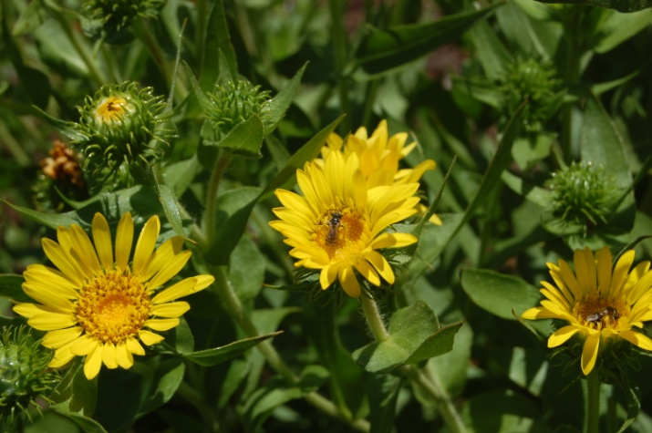

Photo by Amy Bartow, NRCS Corvallis Plant Materials Center, 2009

### Alternative Names

*Alternate Common Names:* Willamette Valley gumweed, Puget Sound gumplant, entire-leaved gumweed, gum plant, gum weed, resinweed

*Alternate Scientific Names: Grindelia integrifolia* DC.var*. integrifolia*

### Uses

Puget Sound gumweed can be used in prairie and wetland restoration projects, pollinator enhancement plantings, hedgerows, and is a good plant for reclaiming seaside land. It is also an attractive ornamental for use in wildflower meadows, butterfly gardens, and gardens close to the coast. Several tribes in the Pacific Northwest extracted a resin from gumweed that was used to treat asthma, bronchitis, whooping cough, and dermatitis caused by poison ivy.

This species is the dominant late-summer blooming plant in much of its native wetland prairie or salt marsh habitat, so it is serves as an important late-season source of pollen and nectar for butterflies, native bees, syrphid flies, wasps and other beneficial insects. Willamette hybrid gumweed populations provide a critical pollen resource for an endemic native wetland-prairie solitary bee (*Melissodes pullatela*), and are the preferred nectar and extra-floral resin food source for the rare wetland great copper butterfly (*Lycaena xanthoides*) in the Willamette Valley of Oregon.

### Status

Puget Sound gumweed is classified as a facultative wetland plant, meaning it usually occurs in wetlands, but is occasionally found in non-wetlands. Please consult the PLANTS Web site and your State Department of Natural Resources for this plant’s current status (e.g., threatened or endangered species, state noxious status, and wetland indicator values).

### Description and Adaptation

Puget Sound gumweed, a member of the sunflower family (Asteraceae), is a native, perennial, tap-rooted, herbaceous to semi-woody subshrub that grows 8 to 40 inches tall. The stout, branched stems are leafy, upright or reclining on the ground but with tips ascending, and are generally covered in long, soft, shaggy but unmatted hairs. Basal leaves are lance-shaped, slightly wider near the tip, with smooth or toothed edges, up to 16 inches long and 1½ inches wide. Stem leaves are alternate, stalkless, often with clasping bases, up to 3 inches long, usually with smooth margins, and dotted with stalked glands that produce a sticky resin. Immature flower heads ooze a sticky, white latex that gives them a milky appearance. When open, the daisy-like flower heads are 1 to 2 inches across and are composed of 10 to 35 yellow, petal-like ray flowers 1/3 to 4/5 inch long surrounding the yellow disk flowers in the center. Below the flower head is a whorled cup of green bracts that are sticky-glandular with long, thin tips that are spreading or sometimes curved back from the flower head. Fruits are small, wind-borne achenes that are somewhat-flattened with a pappus of two to several firm but deciduous awns. Plants flower from June to November.

*Grindelia integrifolia* readily hybridizes with *G. nana* var. *nana* where the two species co-occurin the Willamette Valley of western Oregon. *Grindelia integrifolia* x *nana* var. *nana*, commonly called Willamette hybrid gumweed, is locally common in spring-wet areas, dry pastures and roadsides. *Grindelia integrifolia* also hybridizes with the coastal species *G. stricta* in the Puget Sound region of Washington.

Puget Sound gumweed is a locally common wildflower found along beaches, rocky shores, wet meadows, wetland prairies, ditches, pastures and salt marshes. It tolerates poor, sandy to clayey and saline soils, and prefers full sun to light shade and moist soil. This species is distributed along the coast of Oregon, Washington, British Columbia, and the panhandle of Alaska, and inland in the Puget Trough of Washington through the Willamette Valley of Oregon at elevations below 650 ft. For updated distribution, please consult the Plant Profile page for this species on the PLANTS Web site.

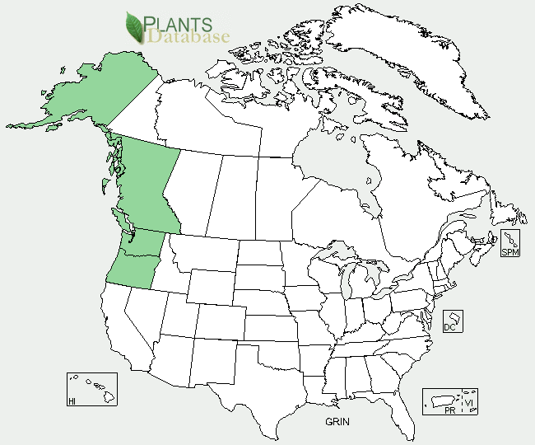

Puget Sound gumweed distribution from USDA-NRCS PLANTS Database.

### Establishment

Propagation is easiest from seed, and germination rates are generally high. Seed can be sown in containers or directly on site in the fall or spring, and seedlings usually germinate in 2 to 3 weeks at 50-60°F. The recommended single-species seeding rate is about 2 pounds per acre at a depth of ¼ to ½ inch, or about 0.25 lb/acre in a mix. There are approximately 128,000 seeds per pound, resulting in about 3 live seeds per square foot when seeded at a rate of one pound per acre. Plants may also be propagated vegetatively by root or stem cuttings, but these methods are very labor-intensive and result in fairly low establishment rates.

### Management

Once established, plants require little management.

### Pests and Potential Problems

There are no known significant pests or diseases of Puget Sound gumweed.

### Environmental Concerns

Established plants will readily self-sow and may spread into adjacent areas, so flower heads should be removed after blooming if spread is not desired.

### Cultivars, Improved, and Selected Materials (and area of origin)

There are no developed cultivars of Puget Sound gumweed, but both non-certified and certified source identified seed is generally available from commercial sources. Container plants are also sometimes available from native plant nurseries in the Pacific Northwest.

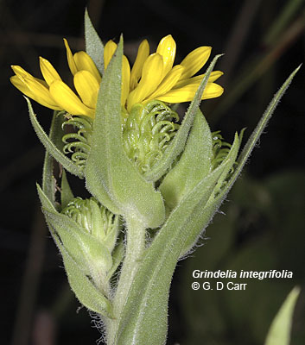

Photo copyright Gerald D. Carr, 2006

### Prepared By

*Annie Young-Mathews*

USDA-NRCS Corvallis Plant Materials Center, Oregon

### Citation

Young-Mathews, A. 2012. Plant fact sheet for Puget Sound gumweed (*Grindelia integrifolia)*. USDA-Natural Resources Conservation Service, Corvallis Plant Materials Center, Corvallis, OR.

Published April 2012

Edited: 16Dec2011 dcd; 09Jan2012 klp; 17Apr2012 jab; 26Apr2012 gm

For more information about this and other plants, please contact your local NRCS field office or Conservation District <<http://www.nrcs.usda.gov/>>, and visit the PLANTS Web site <[http://plants.usda.gov](http://plants.usda.gov/)> or the Plant Materials Program Web site <<http://plant-materials.nrcs.usda.gov>>

**USDA IS AN EQUAL OPPORTUNITY PROVIDER AND EMPLOYER**