|  |
| --- |
| smooth oxeye |
| *Heliopsis helianthoides* (L.) Sweet var. *scabra* (Dunal) Fern. |
| Plant Symbol = HEHES |

Contributed by: USDA NRCS Manhattan Plant Material Center

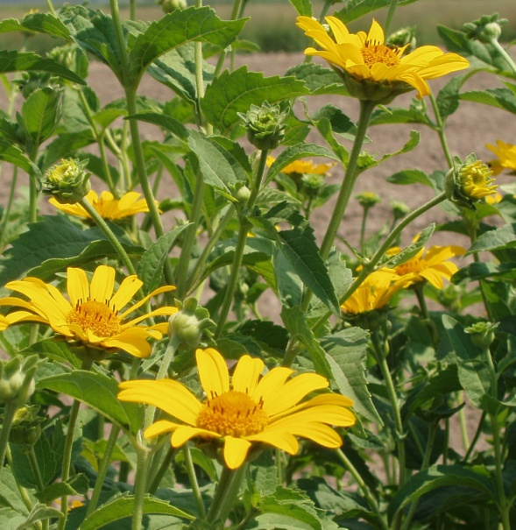

R. Alan Shadow

USDA NRCS Manhattan PMC

Alternate Names

Smooth Oxeye, False Sunflower, Oxeye, Oxeye Daisy, Heliopsis Sunflower

Uses

*Ethnobotanica*l: It is reported that American Indians made a tea from this plant as a cure for various lung ailments.

*Landscaping and Wildlife*: Smooth oxeye is a very hardy plant that produces many attractive, yellow flowers throughout the summer. It does well in flower gardens, especially in drier areas, and is relatively maintenance free. It also makes an attractive roadside plant. Insects are attracted to its bright flowers during the summer, and birds are attracted to its seed in the fall.

Status

Please consult the PLANTS Web site and your State Department of Natural Resources for this plant’s current status (e.g. threatened or endangered species, state noxious status, and wetland indicator values).

Description and Adaptation

Smooth Oxeye is a member of the daisy family, Asteraceae. It is a vigorous, upright, native, perennial forb growing to .4-2 meters in height. The stem is smooth while the leaves are coarsely serrated, having rough, siliceous-based hairs on both surfaces. The stems may be topped with a single, yellow flower, or may branch in to multiple stems with many yellow flowers. The flowers have 10 or more rays and are 3-7 cm in diameter. Unlike sunflowers, each ray may form a fruit that yields a viable seed. The seed is smooth and hard having four sides with fine hairs for wind distribution of seed. It generally does not have a pappus. Though it is a perennial, it is often short-lived.

*Distribution*: This species is widely distributed across the eastern half of the United States, though it is most often found in the prairie regions of the central United States. It prefers dry soil and open spaces, but will also tolerate moist areas. It can often be found in disturbed areas.

Establishment

Smooth Oxeye can be established from seed. Planting should occur in the spring, between March and April. Cold, damp stratification for 30 days at 4o C is suggested to improve germination, but is reportedly not necessary. The seed may be drilled on 32-40 inch rows at 4.7 pounds per acre or broadcast at 5.2 pounds per acre. The target rate is 45 PLS/ft when drilled and 15 PLS/ft2 when broadcasted.

Management

Smooth Oxeye is a very hardy plant with relatively few problems. This species has proven to perform best in the 11.8+ cm (4.6 inches +) precipitation zone and moderate levels of N, P, K are desirable.

Pests and Potential Problems

Birds will feed on the seed of Smooth Oxeye in the fall. This may be of concern to the commercial growers. Plant size often inhibits cultivation after 8 weeks when planted in rows.

Cultivars, Improved, and Selected Materials (and area of origin)

‘Midas’ – (Kansas) was released in 1984. It is adapted to the eastern half of Nebraska, Kansas, and Oklahoma extending into western Iowa, Missouri, and Arkansas. This cultivar is tolerant of dry conditions, though adequate moisture is necessary for proper growth. Midas is readily available through commercial sources.

Central Iowa Germplasm – (Iowa) was released in 1996. It is source – identified material that is especially adapted to central Iowa. It is commercially available.

Northern and Southern Iowa Germplasms – (Iowa) were released in 1997, and are also source - identified materials that are especially adapted to those regions in Iowa. They are also commercially available.

Prepared By & Species Coordinator:

R. Alan Shadow, USDA NRCS Manhattan Plant Materials Center, Manhattan, Kansas

Edited: 25jan06 jsp; 060801 jsp

For more information about this and other plants, please contact your local NRCS field office or Conservation District, and visit the PLANTS Web site<<http://plants.usda.gov>> or the Plant Materials Program Web site <<http://Plant-Materials.nrcs.usda.gov>>

*The U.S. Department of Agriculture (USDA) prohibits discrimination in all its programs and activities on the basis of race, color, national origin, sex, religion, age, disability, political beliefs, sexual orientation, and marital or family status. (Not all prohibited bases apply to all programs.) Persons with disabilities who require alternative means for communication of program information (Braille, large print, audiotape, etc.) should contact USDA's* [*TARGET Center*](http://www.usda.gov/oo/target.htm) *at 202-720-2600 (voice and TDD).*

*To file a complaint of discrimination write USDA, Director, Office of Civil Rights, Room 326-W, Whitten Building, 14th and Independence Avenue, SW, Washington, DC 20250-9410 or call 202-720-5964 (voice or TDD). USDA is an equal opportunity provider and employer.*

*Read about* [*Civil Rights at the Natural Resources Convervation Service*](http://www.nrcs.usda.gov/about/civilrights/)*.*