|  |
| --- |
| Stiff sunflower |
| *Helianthus pauciflorus* Nutt. |
| Plant Symbol = HEPA19 |

Contributed by: USDA NRCS Bismarck Plant Materials Center

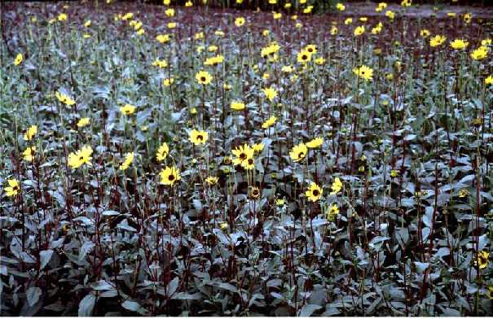

Bismarck Plant Materials Center

Bismarck, North Dakota

Alternate Names

few-leaved sunflower

Uses

This wildflower can be used to add diversity in prairie restoration and range mixtures. It also provides erosion control, quality forage, and wildlife benefits.

Status

Please consult the PLANTS Web site and your State Department of Natural Resources for this plant’s current status (e.g. threatened or endangered species, state noxious status, and wetland indicator values).

Description

Stiff sunflower is a strongly rhizomatous, native, perennial forb which often forms dense colonies. Plant height varies from 1 to 5 feet. The stiff, leathery leaves occur mostly at the base of the plant and have 3 prominent ribs; stems are stiff and rough. Blossoming occurs in late summer. The 2½ inch wide flowers have yellow petals surrounding the brown to purplish centers.

Adaptation and Distribution

Stiff sunflower is primarily native to the Midwest, from Michigan and Indiana to Montana and New Mexico; it occurs less frequently in the Northeast. The plant grows on many different soils but usually is found on upland range sites with silty, shallow, thin soil. This plant is readily eaten by livestock, so it is rarely found on lands which have been long overgrazed.

For a current distribution map, please consult the Plant Profile page for this species on the PLANTS Website.

Establishment

Stiff sunflower is not usually seeded as a single species but rather in a mix of other native species. On moist sites, it can be included with little bluestem, big bluestem, and switchgrass. On drier sites, it can be mixed with blue grama, little bluestem, and western wheatgrass. There are approximately 85,000 seeds/lb. As part of a mixture, a seeding rate of ¼ pure live seed (PLS) lb/ac will result in about one seed per every two square feet. If a denser stand of stiff sunflower is desired for specific areas, seeding rates up to 1 PLS lb/ac may be used.

Stiff sunflower is a small, smooth seed that flows easily through most drills. Generally, seed is mixed with other native species. If seed settles to the bottom of the box, it should be added in frequent intervals rather than all at once. The seed should be planted into a firm seedbed at a depth no greater than ½ inch. Seed of stiff sunflower has high dormancy. A majority of the seed planted in the spring may not germinate until the following spring. Dormant seeding with winter stratification will enhance germination.

Management

Stiff sunflower is persistent and long-lived with good management using key grass species as indicators.

Pests and Potential Problems

Seed weevils and other insects may pose problems for seed production.

Environmental Concerns

On adapted sites, stiff sunflower may spread rapidly by rhizomes. This species is not recommended in small garden or prairie landscape plantings unless spread is not a concern, or precautions are taken (edging, hand-rogueing, or herbicides). Stiff sunflower is readily controlled by most broadleaf herbicides.

Cultivars, Improved, and Selected Materials (and area of origin)

Bismarck Germplasm (North Dakota composite) stiff sunflower is a pre-varietal release of *Helianthus pauciflorus* ssp. *pauciflorus* from the Bismarck, North Dakota Plant Materials Center.

Prepared By & Species Coordinators:

*Mike Knudson*, Assistant Manager/Forester, Bismarck Plant Materials Center, Bismarck, North Dakota

*Dwight Tober*, Plant Materials Specialist, USDA NRCS, Bismarck, North Dakota

Edited: 06Feb2002 JLK; 060801 jsp

For more information about this and other plants, please contact your local NRCS field office or Conservation District, and visit the PLANTS Web site<<http://plants.usda.gov>> or the Plant Materials Program Web site <<http://Plant-Materials.nrcs.usda.gov>>

*The U.S. Department of Agriculture (USDA) prohibits discrimination in all its programs and activities on the basis of race, color, national origin, sex, religion, age, disability, political beliefs, sexual orientation, and marital or family status. (Not all prohibited bases apply to all programs.) Persons with disabilities who require alternative means for communication of program information (Braille, large print, audiotape, etc.) should contact USDA's* [*TARGET Center*](http://www.usda.gov/oo/target.htm) *at 202-720-2600 (voice and TDD).*

*To file a complaint of discrimination write USDA, Director, Office of Civil Rights, Room 326-W, Whitten Building, 14th and Independence Avenue, SW, Washington, DC 20250-9410 or call 202-720-5964 (voice or TDD). USDA is an equal opportunity provider and employer.*

*Read about* [*Civil Rights at the Natural Resources Convervation Service*](http://www.nrcs.usda.gov/about/civilrights/)*.*