

Plant Fact Sheet

**NORTHERN SWEETGRASS**

***Hierochloe hirta* (Schrank) Borbás ssp. *arctica* (J. Presl)**

**G. Weim.**

Plant Symbol = HIHIA

Contributed by: USDA-NRCS Rose Lake Plant Materials Center

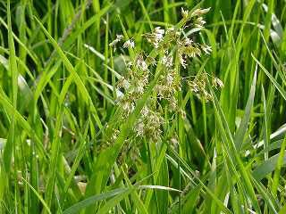

**Rose Lake Plant Materials Center,** East Lansing, Michigan

**Alternate Names**

Sweetgrass consists of several taxa including *Hierochloe odorata* (L.) P. Beauv. HIOD and *Hierochloe* *hirta* (Schrank) Borbás ssp. *arctica* (J. Presl) G. Weim. HIHIA. Other common names for sweetgrass include northern sweetgrass, vanilla grass, holy grass, Seneca grass, and alpine sweetgrass.

**Uses**

*Cultural*: Because of the sweet, vanilla-like fragrance that develops once the plant begins to dry, sweetgrass is commonly used as incense and fragrance by Native Americans. Longer leaves are often braided and burned for religious and peace ceremonies and for various other rituals of cultural significance. Another traditional use of this plant, particularly among the people of the Great Lakes and Northeast, is for handicrafts. Sweetgrass is often used to craft or decorate baskets, bowls, trays, and mats.

**Status**

Please consult the PLANTS Web site and your State Department of Natural Resources for this plant’s current status (e.g., threatened or endangered species, state noxious status, and wetland indicator values).

### Description and Adaptation

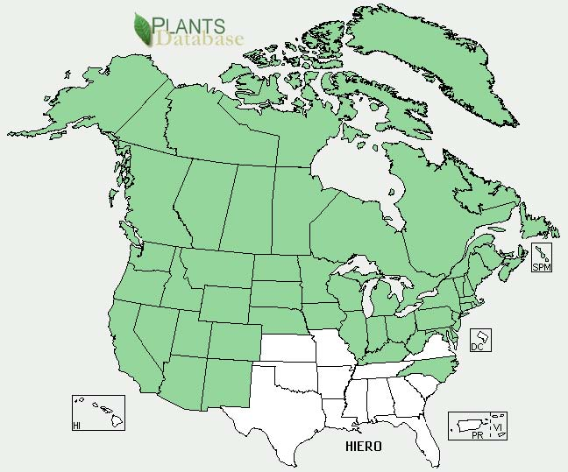

***Hierochloe* distribution from USDA-NRCS PLANTS Database.**

### Sweetgrass is a native perennial grass. The stems are semi-erect, up to 30 inches tall from slender, creeping rhizomes. Leaves are few and rough-edged and have shiny, hairless undersides. Often it has a reddish-purple color near the base of the plant. The highly prized longer leaves that grow on sterile shoots reach 18+ inches in length. The inflorescence is an open, golden brown panicle with slender branches. The fruit is a typical grass seed. Sweetgrass is native to both northern North America and Eurasia. In North America its extensive range traverses the northern regions from Alaska to Newfoundland, down to New England, across the Great Lakes region and the upper Midwest to Oregon, and into the Southwest. Sweetgrass usually inhabits moist ground on shores (fresh or brackish), meadows, and low prairies, at the edges of woods, bogs, and marshes. Normally, it is not found in pure stands, rather it is found among other grasses and shrubs in mid-successional communities. For updated distribution, please consult the Plant Profile page for this species on the PLANTS Web site. Cultivars, Improved, and Selected Materials (and area of origin).

**Establishment**

Sweetgrass spreads vigorously by often-deep, creeping rhizomes. In the spring these rhizomes produce inconspicuous fruiting stems with sparse, short leaves. Longer leaves develop later from separate sterile basal shoots. Although sweetgrass can reproduce by seed, it is mostly infertile, producing few seedheads that contain few seeds. Sweetgrass is extremely cold hardy. It will go dormant in cold weather and resprout once ground temperatures reach 40oF. In the Great Lakes, Northeastern, and Midwestern regions flowering begins in the spring.

Sweetgrass development from seed is very slow. This coupled with the infertile nature of the plant explains why plant division is the most successful method of reproducing sweetgrass. Plant division is accomplished by separating the individual propagules that have developed from the rhizomes of a spreading plant. Each propagule can then be placed in a container for further separation or future planting. Newly separated plants will do best if placed in the shade for 2–3 weeks while their roots establish. Then they may be transplanted at 1-foot spacings into areas of partial shade to full sun.

**Management**

As sweetgrass is not drought tolerant, soil should be kept moist but not saturated. Fertilizer should be applied as appropriate for cool season grasses according to soil test recommendations.

### Stand of northern sweetgrass in bloom

Rose Lake PlantMaterials Center, East Lansing, Michigan

Longer leaves of the sterile shoots may be harvested several times during the year; however, the mid-season growth is considered superior. These leaves may be gathered by grasping the shoots firmly near the ground and pulling until they break from the rootstock an inch or two below the surface of the soil.

Care should be exercised so roots are not pulled and plants are not damaged.

**Cultivars, Improved, and Selected Materials (and area of origin)**

Sweetgrass is available from commercial sources. Horticultural selections or local and regional ecotypes are marketed by nurseries. Contact your local Natural Resources Conservation Service (formerly Soil Conservation Service) office for more information.

**Prepared By**

*John W. Leif,* USDA-NRCS, East Lansing, MI

**Citation**

Leif, J. 2010. Plant fact sheet for sweetgrass [*Hierochloe hirta* (Schrank) Borbás ssp*. arctica* (J. Presl) G. Weim. USDA-Natural Resources Conservation Service, Rose Lake Plant Materials Center, East Lansing, MI 48823.

Published September, 2010

Edited:13Apr2010jwl

For more information about this and other plants, please contact your local NRCS field office or Conservation District <<http://www.nrcs.usda.gov/>>, and visit the PLANTS Web site <[http://plants.usda.gov](http://plants.usda.gov/)> or the Plant Materials Program Web site <<http://plant-materials.nrcs.usda.gov>>

**USDA IS AN EQUAL OPPORTUNITY PROVIDER AND EMPLOYER**