

Plant Fact Sheet

**SWEETGRASS**

***Hierochloe odorata* (L.) P. Beauv.**Plant Symbol = HIOD

Contributed by: USDA-NRCS Rose Lake Plant Materials Center

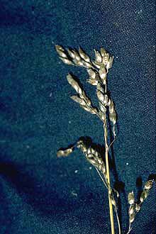**Robert H. Mohlenbrock @ USDA-NRCS PLANTS Database / USDA NRCS. 1992. Western wetland flora: Field office guide to plant speci es. West Region, Sacramento.**

**Alternate Names**

Sweetgrass is native to both northern North America and Eurasia. In North America its extensive range traverses the northern regions from Alaska to

Newfoundland, down to New England, across the Great Lakes region and the upper Midwest to Oregon, and into the Southwest. Sweetgrass usually inhabits moist ground on shores (fresh or brackish), meadows, and low prairies, at the edges of woods, bogs, and marshes. Normally, it is not found in pure stands, rather it is found among other grasses and shrubs in mid-successional communities.

**Uses**

*Cultural*: Because of the sweet, vanilla-like fragrance that develops once the plant begins to dry, sweetgrass is commonly used as incense and fragrance by Native Americans. Longer leaves are often braided and burned for religious and peace ceremonies and for various other rituals of cultural significance. Another traditional use of this plant, particularly among the people of the Great Lakes and Northeast, is for handicrafts. Sweetgrass is often used to craft or decorate baskets, bowls, trays, and mats.

**Status**

Please consult the PLANTS Web site and your State Department of Natural Resources for this plant’s current status (e.g., threatened or endangered species, state noxious status, and wetland indicator values).

### Description and Adaptation

### Hierochloe distribution from USDA-NRCS PLANTS Database.

***Hierochloe* distribution from USDA-NRCS PLANTS Database.**

Sweetgrass is a native perennial grass. The stems are semi-erect, up to 30 inches tall from slender, creeping rhizomes. Leaves are few and rough-edged and have shiny, hairless undersides. Often it has a reddish-purple color near the base of the plant. The highly prized longer leaves that grow on sterile shoots reach 18+ inches in length. The inflorescence is an open, golden brown panicle with slender branches. The fruit is a typical grass seed.

Sweetgrass is native to both northern North America and Eurasia. In North America its extensive range traverses the northern regions from Alaska to Newfoundland, down to New England, across the Great Lakes region and the upper Midwest to Oregon, and into the Southwest. Sweetgrass usually inhabits moist ground on shores (fresh or brackish), meadows, and low prairies, at the edges of woods, bogs, and marshes. Normally, it is not found in pure stands, rather it is found among other grasses and shrubs in mid-successional communities.

For updated distribution, please consult the Plant Profile page for this species on the PLANTS Web site.

**Establishment**

Sweetgrass spreads vigorously by often-deep, creeping rhizomes. In the spring these rhizomes produce inconspicuous fruiting stems with sparse, short leaves. Longer leaves develop later from separate sterile basal shoots. Although sweetgrasscan reproduce by seed, it is mostly infertile, producing few seedheads that contain few seeds. Sweetgrass is extremely cold hardy. It will go dormant in cold weather and resprout once ground temperatures reach 40oF. In the Great Lakes, Northeastern, and Midwestern regions flowering begins in the spring.

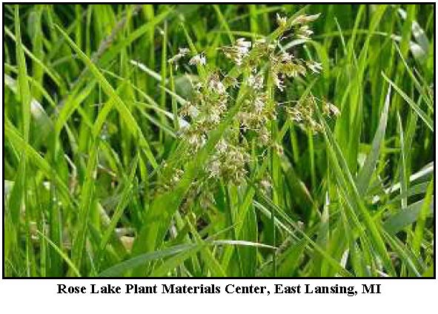

Sweetgrass development from seed is very slow. This coupled with the infertile nature of the plantexplains why plant division is the most successful method of reproducing sweetgrass. Plant division is accomplished by separating the individual propagules that have developed from the rhizomes of a spreading plant. Each propagule can then be placed in a container for further separation or future planting. Newly separated plants will do best if placed in the shade for 2–3 weeks while their roots establish. Then they may be transplanted at 1-foot spacings into areas of partial shade to full sun.

**Management**

As sweetgrass is not drought tolerant, soil should be kept moist but not saturated. Fertilizer should be applied as appropriate for cool season grasses according to soil test recommendations. Longer leaves of the sterile shoots may be harvested several times during the year; however, the mid-season growth is considered superior. These leaves may be gathered by grasping the shoots firmly near the ground and pulling until they break from the rootstock an inch or two below the surface of the soil.

Care should be exercised so roots are not pulled and plants are not damaged.

**Cultivars, Improved, and Selected Materials (and area of origin)**

Sweetgrass is available from commercial sources. Horticultural selections or local and regional ecotypes are marketed by nurseries. Spirit Germplasm Selected Class Sweetgrass was released as vegetative material in 2004 from the USDA-NRCS Plant Materials Center in Bridger, Montana. Spirit was found to be superior in survival, number of tillers produced, spread rate, leaf length, and biomass production. The Bridger PMC maintains a vegetative stooling block and G**0** propagules are available through the Montana Foundation Seed Program at Montana State University-Bozeman and the Wyoming Seed Certification Service at University of Wyoming-Powell. Contact your local Natural Resources Conservation Service (formerly Soil Conservation Service) office for more information.

**Prepared By**

*John W. Leif,* USDA-NRCS, East Lansing, MI

**Citation**

Leif, J. 2010. Plant fact sheet for sweetgrass [*Hierochloe odorata* (L.) P. Beauv]. USDA-Natural Resources Conservation Service, Rose Lake Plant Materials Center, East Lansing, MI 48823

PublishedSeptember, 2010

Edited:09Apr2010jwl

For more information about this and other plants, please contact your local NRCS field office or Conservation District <<http://www.nrcs.usda.gov/>>, and visit the PLANTS Web site <[http://plants.usda.gov](http://plants.usda.gov/)> or the Plant Materials Program Web site <<http://plant-materials.nrcs.usda.gov>>

**USDA IS AN EQUAL OPPORTUNITY PROVIDER AND EMPLOYER**