

Plant Fact Sheet

# BEACH HEATHER

***Hudsonia tomentosa* Nutt**

Plant Symbol = HUTO

Contributed by: USDA NRCS Cap May Plant Materials Center and Columbus Service Center, New Jersey

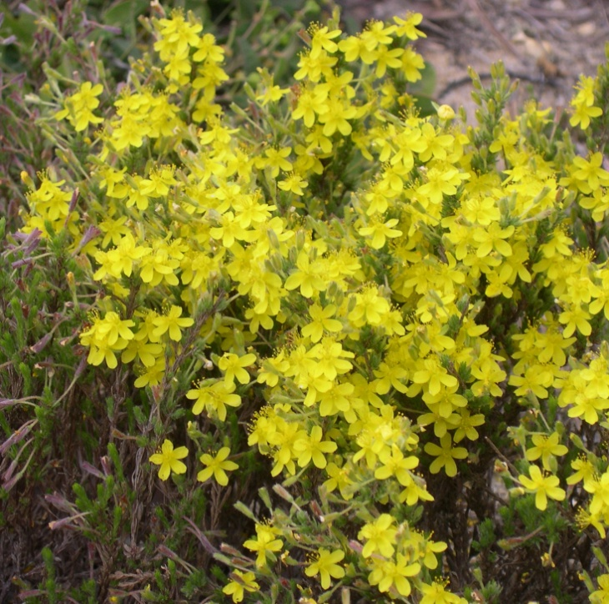Christopher F. Miller, USDA NRCS

Alternate Names

sand heather, woolly hudsonia, false heather, woolly beach heather

Uses

Beach heather is used in the restoration of sand dunes and coastal native plant communities. It can also be used for developing low maintenance, salt tolerant landscapes near the shoreline.

Status

Beach heather is listed as either threatened or endangered in several states. Please consult the PLANTS Web site and your State Department of Natural Resources for this plant’s current status (e.g. threatened or endangered species, state noxious status, and wetland indicator values).

Description and Adaptation

Beach heather is a low growing native shrub usually 3-8 inches tall and finely branched. Leaves are elongated and scale like, usually less than 0.125 inches long, and coated with soft, white, wooly hair. This plant has beautiful yellow flowers that are 5-petaled and about 0.25 inches across. Blooming occurs on average from May through July and provides nectar for pollinator species.

This plant is adapted to sand dunes, sandy pine woods, pine-barrens, and sand hills clearings. Beach heather is much less tolerant of salt spray than the plants in the primary foredune (Dunegrass community) along the New Jersey coast. Beach heather does not compete effectively with Dunegrass community plants that are growing on the exposed primary foredune. Beach heather tends to grow in the backdune areas at an elevation of about 9 feet above sea level. The backdune habitat is more protected from salt spray and sand movement than the primary foredune, but it is very dry. Several of the plant species in the backdune, including beach heather, exhibit adaptations to dry conditions such as reduced leaf surface, prostrate growth, and leaf surfaces covered with hair or waxy covering to reduce water loss.

Green sands are associated with beach heather growing in sand dunes in Alberta, Canada. Green sands were consistently found in the buried phyllosphere and rhizosphere of beach heather, and on the surface to varying depths under the plants. Nitrogen fixing blue-green algae were isolated from the green sands. Beach heather’s preference for an association with blue-green algae may relate to the ability of this dwarf shrub to grow on nutrient poor sand blowouts and dunes. Also, in Alberta, a preliminary study showed that beach heather was associated with ectomycorrhizal symbionts at three active dune sites.

*Distribution*: Beach heather occurs along the Atlantic Coast from Main to North Carolina, along the Great Lakes from New York to Minnesota and along Lake Champlain. Its range extends northwestward to Alberta, Canada. For more information please consult the Plant Profile page for this species on the PLANTS Web site.

Establishment and Management

Beach heather establishment and management guidelines have not been developed at the time of this publication. However, pervious reports indicate that beach heather is short-lived and fairly difficult to grow, but can be propagated from seed and cuttings.

Pests and Potential Problems

Beach heatherhas not been observed to manifest any notable problems with pests. In beach habitat, beach heather is sensitive to trampling, mechanical disturbances by off-road vehicles, and over shading by woody species.

Environmental Concerns

In various coastal locations in the mid-Atlantic, beach heather has been observed to preclude other plants from growing in close proximity. Coastal scientists suspect that beach heather is capable of producing allelopathic compounds to reduce competition from other species

Cultivars, Improved, and Selected Materials (and area of origin)

There are no known commercial sources for this species, nor any developed cultivars

Prepared By:

*William B. Skaradek*

USDA NRCS Columbus Service Center, Columbus, NJ

*Christopher Miller*

USDA NRCS Cape May Plant Materials Center, Cape May, NJ

Species Coordinator:

*William B. Skaradek*

USDA NRCS Columbus Service Center, Columbus, NJ

Published: October 2009

Edited: 08Sep09 rg, 08Sep09 jfh; 17Sep09 mws

For more information about this and other plants, please contact your local NRCS field office or Conservation District <<http://www.nrcs.usda.gov/>>, and visit the PLANTS Web site <[http://plants.usda.gov](http://plants.usda.gov/)> or the Plant Materials Program Web site <<http://plant-materials.nrcs.usda.gov>>

**USDA IS AN EQUAL OPPORTUNITY PROVIDER AND EMPLOYER**