

Plant Fact Sheet

# common st. johnswort

Hypericum perforatum L.

Plant Symbol = HYPE

*Contributed by:* USDA NRCS Cape May Plant Materials Center

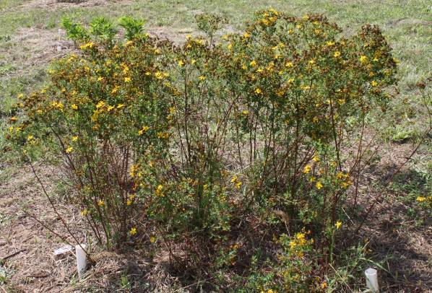

Common St. Johnswort (Hypericum perforatum) Photo by, Jolie Dollar, USDA NRCS.

**Caution: This plant may become invasive.**

**Alternative Names**

*Common Alternate Names:*

Klamathweed

St. Johnswort

Klamath weed

goatweed

perforate St. John’s-wort

Tipton weed

rosin-rose

**Uses**

*Wildlife Use:* Common St. Johnswort provides a nectar source for pollinators and is well-suited for use in pollinator restoration habitat. Preliminary observation found that common St. Johnswort attracted 7 different species of Hymenoptera in Cape May, New Jersey. Brown-belted bumble bee, (*Bombus griseocollis*), common eastern bumble bee (*Bombus impatiens*), and sweat bee (*Lasioglossum tegulare*) were most frequently observed visiting the flower. Field observations suggest that pollinators exhibit a range of responses to this plant. There is not enough conclusive data to determine if the plant is highly preferred or less preferred among pollinators.

*Erosion Control*:

With lateral root growth extending .4–3 in (1–8 cm) below the surface, and taproots extending 2–5 ft deep, St. Johnswort could make a good erosion control plant. However, the benefits of erosion control should be weighed against the plant’s overall aggressive, invasive characteristics.

**Status**

Please consult the PLANTS Web site and your State Department of Natural Resources for this plant’s current status (e.g., state noxious status, and wetland indicator values).

**Weediness**

St. Johnswort is an introduced species that is considered a noxious weed in 7 states in the U.S. Although the plant invades disturbed areas it does not easily invade natural areas. It tends to form dense colonies that crowd-out native plants. Please consult with your local NRCS Field Office, Cooperative Extension Service office, state natural resource, or state agriculture department regarding its status and use. Weed information is also available from the PLANTS Web site at [http://plants.usda.gov](http://plants.usda.gov/). Please consult the Related Web Sites on the Plant Profile for this species for further information.

**Description and Adaptation**

*Description*: Common St. Johnswort is an erect, multi-stemmed, perennial forb that grows to 1–3 ft. It has long slender “runners” or stems growing at the soil surface or just below the ground. It also has aggressive rhizomes. St. Johnswort is part of the family Hypericaceae which includes trees, shrubs, and herbs with resinous sap.

The numerous flowers (roughly 25–100 per stem) are symmetrical around a central point, determinate, in flat-top clusters. The short-stalked flowers are about 1 in across, with five yellow to bright yellow-orange flowers. The petals are peppered with black dots around the edges.

Stems are often reddish and woody at the base. There may be several stems (up to 30) from the base of the plant. St. Johnswort has a tap root and vertical roots extending to 5 ft.

The 1–2 in long, stalk-less leaves are oblong or linear, opposite, round-tipped, and roughly ¼ in wide. The pale green or yellow-green leaves have scattered translucent dots that make the leaf look perforated when held up to the light. The species name for this plant, *perforatum*, denotes this characteristic.

The sticky seed pod is a 3-sectioned capsule that turns deep reddish brown as it matures. The small (1 mm), round, darkly colored seeds have a resinous smell like turpentine.

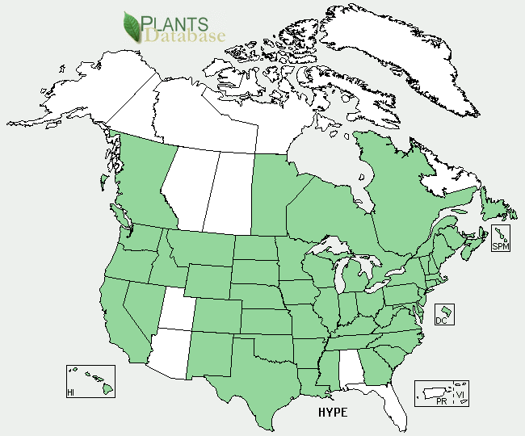

Common St. Johnswort (Hypericum perforatum) distribution from USDA-NRCS PLANTS Database.

*Adaptation:* St. Johnswort is perhaps most commonly found in grasslands, pastures, meadows, and rangelands. But it also occurs in forested areas that have been disturbed by fire, logging, or road construction. Common St. Johnswort prefers well-drained, coarse-textured soils and does not grow well under wet conditions. St. Johnswort has been found to perform equally well in acid and calcareous soils. For updated distribution, please consult the Plant Profile page for this species on the PLANTS Web site.

**Establishment**

Common St. Johnswort is an early-flowing forb (June or July) that requires full sun or part shade. It can be propagated by seed, division, or by softwood cuttings. It grows well in moist, well-drained soils.

First-year seedlings do not produce flowers or seeds. Seedlings are small and tend to grow slowly and are improved when inoculated with arbuscular mycorrhizal fungi. When favorable growing conditions are met, there may be a sudden increase in plant density and new sprouts will create dense mats around the base of parent plant. Interspecies competition will restrict seedling survival. Poor site quality appears to be associated with increased vegetative propagation.

**Management**

Common St. Johnswort does not exhibit invasive tendencies in undisturbed areas, but in disturbed areas it is much more dominant. St. Johnswort can be potentially invasive in prairie, mountain grassland, western hardwoods, maple-beech-birch complex, oak-hickory and oak-pine complexes. Repeated cultivation has been found to destroy the weed. Colonies can also be controlled by mowing several times before maturation. Additionally, a covering of grass litter may be used to reduce germination and shoot extension of St. Johnswort. Vegetative propagation may be encouraged by grazing or fire.

**Pests and Potential Problems**

Winter warming and summer droughts increase herbivory. Insect herbivory has a strong negative effect on populations and when treated with insecticide, treated plots have twice the seedling survival rates as untreated plots. There is a high degree of phenotypic and genotypic variation between St. Johnswort populations, and herbivore resistance is also variable.

**Environmental Concerns**

Common St. Johnswort has small black glands that contain the photodynamic pigment hypericin. Hypericins are found in the flowers, leaves, and buds of the plant. If digested by livestock, hypericin can cause photosensitization, blisters, and lesions; especially in light-skinned animals. More severe symptoms include loss of appetite, diarrhea, blindness, convulsions, coma and death.

**Control**

Please contact your local agricultural extension specialist or county weed specialist to learn what works best in your area and how to use it safely. Always read label and safety instructions for each control method.

**Prepared By:** *Christopher M. Sheahan*. USDA-NRCS, Cape May Plant Materials Center, Cape May, NJ.

**Citation:** Sheahan, C.M. 2012. Fact sheet forcommon St. Johnswort (*Hypericum perforatum*). USDA-NRCS, Cape May Plant Materials Center. Cape May, NJ. 08210.

Published July 2012

Edited:

For more information about this and other plants, please contact your local NRCS field office or Conservation District <<http://www.nrcs.usda.gov/>>, and visit the PLANTS Web site <[http://plants.usda.gov](http://plants.usda.gov/)> or the Plant Materials Program Web site <<http://plant-materials.nrcs.usda.gov>>

**USDA IS AN EQUAL OPPORTUNITY PROVIDER AND EMPLOYER**