|  |
| --- |
| shore juniper |
| *Juniperus conferta* Parl. |
| Plant Symbol = JUCO12 |

Contributed by: USDA NRCS Plant Materials Program

**Uses**

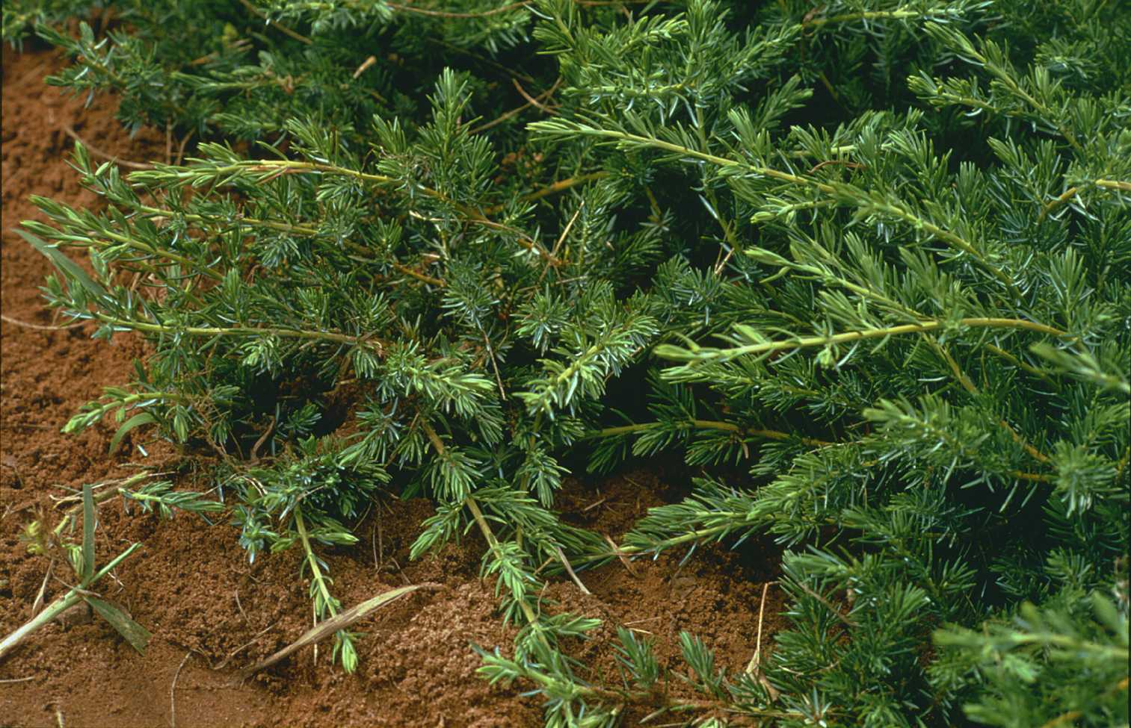

USDA NRCS National Plant Materials Center

Beltsville, MD

Shore juniper is an ornamental, low growing shrub from Japan that has good salt tolerance. It is especially adapted for use on back dune seashore landscapes. When planted on banks and terraces, the dense vegetative mats provide good soil erosion protection.

Status

Please consult the PLANTS Web site and your State Department of Natural Resources for this plant’s current status (e.g. threatened or endangered species, state noxious status, and wetland indicator values).

Description

Shore juniper consists of upright layered stems, growing to one foot tall, that emerge from low growing runner-like stems. Where these stems contact soil adventitious roots will form. Vegetative mats typically form due to this layering process. The evergreen needles have a greenish-blue color, with a waxy coating. The current year’s growth will be terminally located, succulent, and a lighter tone of green. The needles are 1/2 to 1 inch in length and soft. Good color is maintained through winter.

Aromatic, round, blue-green fruit are produced annually. These fruits are produced on second year growth, and are about 1/2 inch in diameter. Shore juniper shows no signs of weediness from natural establishment.

Adaptation and Distribution

Shore juniper will grow well under a wide range of site conditions, from loams to very sandy soils. It performs best under full sunlight, allowing it to perform well under seashore conditions. Sand dune and critical area plantings benefit from partial wind protection and the addition of some top soil in the planting hole.

Shore juniper is sometimes girdled by mice where snow covers are of long duration. Thus it may best be used on coastal areas from New Jersey south even though hardy to the north.

For a current distribution map, please consult the Plant Profile page for this species on the PLANTS Website.

Establishment

Due to the poor production of desirable seed, shore juniper is propagated vegetatively. Cuttings of this juniper are harvested during the dormant season. The use of a rooting hormone increases the success establishing cuttings of shore juniper. Prior to field planting, rooted cuttings should be transplanted into containers. When plants have developed adequate root systems, they can be out planted. As with most rooted cuttings special care must be taken not to damage the root system when transplanting. To aid establishment of shore juniper on sandy sites, a gallon of peat moss should be added to each planting hole. A small amount (100 to 300 lbs./ac./yr.) of a balanced fertilizer, applied within the plants dripline, will also help this species get established. Mulching with bark or wood chips will help conserve moisture and suppress weed invasion. Do not use mulches that may attract rodents.

On field sites plant 18 to 24 inches apart. If fertility and weed control are adequate full ground cover can be expected within two years. To establish nursery cutting blocks, in-row spacings can range from 2 to 4 feet, with 4 to 8 feet row spacing desired.

Management

This section is under development.

Cultivars, Improved, and Selected Materials (and area of origin)

There are numerous cultivated varieties available from commercial nurseries, most of which have been developed for ornamental use. There is only one variety commercially available which is recommended for use on coastal sand dunes in the northeast; this cultivar is ‘Emerald Sea’ (Japan). The breeder’s block of ‘Emerald Sea’ shore juniper is maintained at the Cape May Plant Materials Center in Cape May Court House, NJ. To acquire this plant check with local retail nurseries, or your state’s Plant Material Specialist.

Prepared By & Species Coordinator:

USDA NRCS Northeast Plant Materials Program

Edited: 05Feb2002 JLK; 060801 jsp

For more information about this and other plants, please contact your local NRCS field office or Conservation District, and visit the PLANTS Web site<<http://plants.usda.gov>> or the Plant Materials Program Web site <<http://Plant-Materials.nrcs.usda.gov>>

*The U.S. Department of Agriculture (USDA) prohibits discrimination in all its programs and activities on the basis of race, color, national origin, sex, religion, age, disability, political beliefs, sexual orientation, and marital or family status. (Not all prohibited bases apply to all programs.) Persons with disabilities who require alternative means for communication of program information (Braille, large print, audiotape, etc.) should contact USDA's* [*TARGET Center*](http://www.usda.gov/oo/target.htm) *at 202-720-2600 (voice and TDD).*

*To file a complaint of discrimination write USDA, Director, Office of Civil Rights, Room 326-W, Whitten Building, 14th and Independence Avenue, SW, Washington, DC 20250-9410 or call 202-720-5964 (voice or TDD). USDA is an equal opportunity provider and employer.*

*Read about* [*Civil Rights at the Natural Resources Convervation Service*](http://www.nrcs.usda.gov/about/civilrights/)*.*