|  |
| --- |
| rocky mountain juniper |
| *Juniperus scopulorum*  Sarg. |
| Plant Symbol = JUSC2 |

Contributed by: USDA NRCS Plant Materials Program

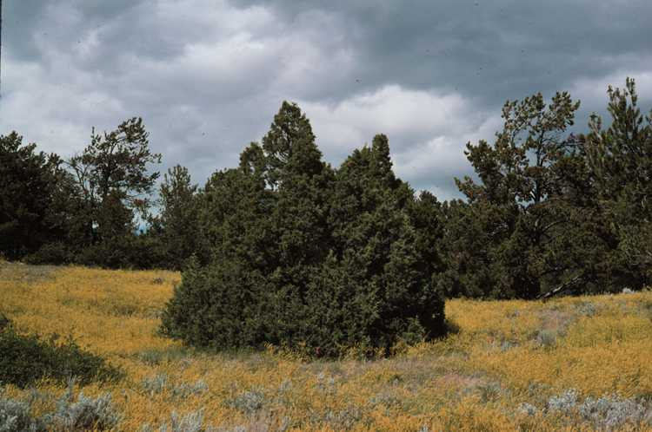

USDA NRCS Bridger Plant Materials Center

Bridger, MT

Uses

*Erosion control*: Plant Rocky Mountain juniper in the outer rows of multi-row plantings where it will not be overtopped by taller trees. It can be used in single-row windbreaks when a dense, medium height barrier is desired.

*Wildlife*: This species provides food and cover for numerous birds and mammals. Winter food and protection is particularly important for pheasant, mule deer, and whitetail deer.

*Recreation and Beautification*: The year-long coloration and attractiveness to wildlife makes this species useful for recreational plantings. It tends to stay green all winter.

Status

Please consult the PLANTS Web site and your State Department of Natural Resources for this plant’s current status (e.g. threatened or endangered species, state noxious status, and wetland indicator values).

Description

*Juniperus scopulorum* Sarg., Rocky Mountain juniper, is a small evergreen tree to 35 feet, often with an irregular crown. A native of western North America, it occurs in mixed or pure stands of open scrub woodland over Wyoming and Colorado at elevations of 5,000 to 7,500 feet, often on dry, rocky ridges. It does well in cultivation, adapted to a wide range of soils and moisture conditions, and is winter hardy, slow growing and very long lived.

Fruits blue with whitish bloom, fleshy “berries” (cones), 1/4 inch in diameter, ripening the second season, seeds 1 to 2 inches each cone, bony-coated; flowers small, cone-like, borne separately on male and female plants; leaves opposite, scalelike, covering older twigs closely in alternating pairs to ¼ inch long, pale to dark green, on new shoots awl shaped, sharp pointed and spreading; stems short, often dividing near ground, branches thick and ascending, bark red to gray-brown, furrowed, thin and shreddy, branchlets very slender; roots deep, widely spreading.

Adaptation and Distribution

Below 7,500 elevation; water relations 10 precipitation equivalent; tolerant of droughty and moist, well-drained sites.

Rocky mountain juniper is distributed throughout the West. For a current distribution map, please consult the Plant Profile page for this species on the PLANTS Website.

Establishment

Seedling should be planted in a firm weed free bed at a spacing of 3 to 6 feet. Seedling should placed in a hole or furrow large enough to contain the entire root system without bending.

Management

Care should be taken to protect young seedlings from feeding damage by small rodents, rabbits, and deer. Weeds and other competing vegetation must be controlled during the first and second years of establishment.

Pests and Potential Problems

Rocky Mountain juniper is relatively free of serious insect and disease problems. It is the alternate host for the cedar-apple rust disease which does very little harm to this species, but causes serious damage to apples and other pome fruits.

Cultivars, Improved, and Selected Materials (and area of origin)

Bridger-Select (Northern Great Plains composite) was developed as a selected pre-varietal release. Seedlings of Rocky Mountain juniper are available from most commercial nurseries in the Rocky Mountain area.

Prepared By & Species Coordinator:

USDA NRCS Plant Materials Program

Edited: 05Feb2002 JLK; 060801 jsp

For more information about this and other plants, please contact your local NRCS field office or Conservation District, and visit the PLANTS Web site<<http://plants.usda.gov>> or the Plant Materials Program Web site <<http://Plant-Materials.nrcs.usda.gov>>

*The U.S. Department of Agriculture (USDA) prohibits discrimination in all its programs and activities on the basis of race, color, national origin, sex, religion, age, disability, political beliefs, sexual orientation, and marital or family status. (Not all prohibited bases apply to all programs.) Persons with disabilities who require alternative means for communication of program information (Braille, large print, audiotape, etc.) should contact USDA's* [*TARGET Center*](http://www.usda.gov/oo/target.htm) *at 202-720-2600 (voice and TDD).*

*To file a complaint of discrimination write USDA, Director, Office of Civil Rights, Room 326-W, Whitten Building, 14th and Independence Avenue, SW, Washington, DC 20250-9410 or call 202-720-5964 (voice or TDD). USDA is an equal opportunity provider and employer.*

*Read about* [*Civil Rights at the Natural Resources Convervation Service*](http://www.nrcs.usda.gov/about/civilrights/)*.*