|  |
| --- |
| Prairie junegrass |
| Koeleria macrantha  (Ledeb.) J.A. Schultes |
| Plant Symbol = KOMA |

Contributed by: USDA NRCS Corvallis Plant Materials Center

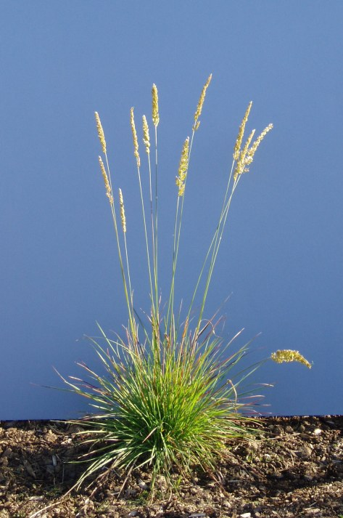

Dale Darris, USDA NRCS Oregon PMC

Alternate Names

Other scientific names include *Aira cristata* L., *Aira macrantha* Ledeb., *Koeleria mukdenensis* Domin, *Koeleria cristata* (L.) Pers., *Koeleria gracilis* Pers., *Koeleria mukdenensis* Domin, *Koeleria nitida Nutt.*, *Koeleria yukonensis* and *Koeleria pyrmidata* (Lam.) Beauv. Common names include Junegrass, mountain Junegrass, and crested hairgrass.

Uses

Prairie Junegrass is useful in seed mixes for restoration of native prairie, savanna, coastal scrub, chaparral and open forest habitats across much of North America. Good drought tolerance and fibrous roots make it useful for revegetation and erosion control on mined lands, over septic systems, and on construction sites, burns and other disturbed areas. Active growth begins early in spring providing good forage for livestock, deer, antelope and elk. Declining palatability during seed formation rebounds in late summer where there is adequate moisture. Bighorn sheep and mountain goats graze this species from rocky soils at high elevation. It provides feed for upland game birds, small mammals, and numerous grasshoppers and leafhoppers. Prairie Junegrass may also be cultivated for forage or fodder and is used as a low input turfgrass (e.g. golf courses) and as an ornamental grass. Native Americans used the seeds to make flour for bread and mush. They also fashioned paint brushes and brooms from the leaves.

Status

Prairie Junegrass is considered endangered in Ohio and Kentucky and critically impaired in Louisiana.

Consult the PLANTS Web site and your State Department of Natural Resources for this plant’s current status (e.g. threatened or endangered species, state noxious status, and wetland indicator values).

Description

Prairie Junegrass is a highly variable, moderately long-lived, cool season perennial bunchgrass that grows 0.5 to 2 ft. tall. Clusters of narrow, markedly veined, light green to bluish green leaves grow to about 7 in. tall. The leaves are flat to in-rolled with slightly rough edges and boat-shaped, pointed tips. Erect seedheads appear as dense, pale green to purplish spikes, tapered at both ends, and 2 to 5 in. long, that are often held well above the foliage. They fluff open somewhat during flowering. There are 2 to 4 flowers per spikelet.

**Adaptation**

Prairie Junegrass is adapted to a wide variety of climates, soils and native plant communities. The North American distribution of this circumpolar species ranges from eastern Alaska, down through California into Mexico, and east to Alabama, Delaware, and Ontario. For additional information on distribution, consult the Plant Profile page for this species on the PLANTS Web site. Prairie Junegrass is most commonly found on rocky to sandy loam soils of low fertility but also occurs on clay bearing soils with adequate drainage. This plant prefers a soil pH of 6.0 to 8.0. A frequent component of both seral and climax plant communities from 4,000 to 12,000 ft., prairie Junegrass occasionally dominates northern plains mixed prairie. Depending upon seed source, it tolerates cold, heat, drought, fire and serpentine soils. It does not tolerate high soil salinity.

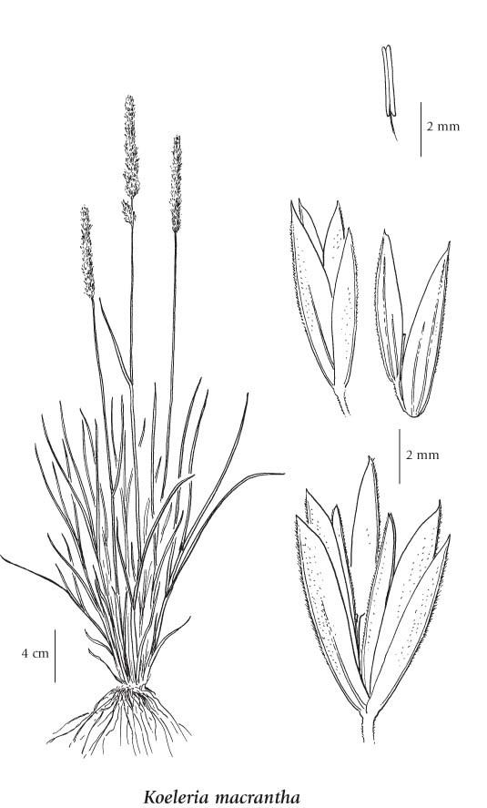

Line drawing courtesy of University of Washington Press

**Establishment**

Prairie Junegrass seed has little dormancy following cold storage through winter and is generally planted in spring. There are about 1.8 million seeds per pound (+/- 20%) although viability is often below 50 percent. For seed production, 0.75 to 2 lb. PLS (pure live seed) per acre is drilled shallowly (for light exposure) in rows 24 to 36 in. apart, depending on available irrigation or rainfall. Narrower (12 in.) rows may be used where cultivation between rows is not required. At least 1 lb. per acre is used to seed pasture which may require 2 to 3 years for establishment prior to grazing. Application of fertilizer to wild ecotypes is usually not recommended. Selective herbicides are available for seed production fields or to aid in pasture or native habitat establishment.

Management

Prairie Junegrass flowers in April to June and seed matures in July or August depending upon location and climate. Once established, it will tolerate moderate grazing to 3 or 4 in., even during the fall months as long as moisture is available to stimulate re-growth. In park settings, this grass tolerates foot traffic better than many other native grasses. At least partially due to its small stature, prairie Junegrass is very resistant to fire and will often increase in percent cover after a fire or other disturbance. In turf settings, this species tolerates repeated low mowing.

Pests and Potential Problems

Prairie Junegrass is often free of significant insect and disease problems but is occasionally the target of striped flea beetles, rusts, leaf spots or blights.

Environmental Concerns

Prairie Junegrass usually spreads slowly if at all, and only by seed. However, it played an important role in prairie revegetation following severe drought and dust storms in the 1930s. It generally provides 5% or less of the herbaceous cover in natural settings.

Cultivars, Improved, and Selected Materials

‘Barkoel’prairie Junegrass is an improved cool-season turfgrass cultivar developed from plants native to northern Europe. ‘Barkoel’ seed is available from Barenbrug USA, Tangent, OR. Two native germplasms selected for roadside planting, prairie restoration, and landscaping have been released from the Elsberry Plant Materials Center in Elsberry, IA.

Prepared By

*Pete Gonzalves* and *Dale Darris*, USDA NRCS, Plant Materials Center, Corvallis, Oregon

Species Coordinator

*Daniel G. Ogle,* USDA NRCS Idaho State Office, Boise, Idaho

Edited: 23apr08pjg; 080915jsp

For more information about this and other plants, please contact your local NRCS field office or Conservation District, and visit the PLANTS Web site<<http://plants.usda.gov>> or the Plant Materials Program Web site <<http://Plant-Materials.nrcs.usda.gov>>

*The U.S. Department of Agriculture (USDA) prohibits discrimination in all its programs and activities on the basis of race, color, national origin, sex, religion, age, disability, political beliefs, sexual orientation, and marital or family status. (Not all prohibited bases apply to all programs.) Persons with disabilities who require alternative means for communication of program information (Braille, large print, audiotape, etc.) should contact USDA's* [*TARGET Center*](http://www.usda.gov/oo/target.htm) *at 202-720-2600 (voice and TDD).*

*To file a complaint of discrimination write USDA, Director, Office of Civil Rights, Room 326-W, Whitten Building, 14th and Independence Avenue, SW, Washington, DC 20250-9410 or call 202-720-5964 (voice or TDD). USDA is an equal opportunity provider and employer.*

*Read about* [*Civil Rights at the Natural Resources Conservation Service*](http://www.nrcs.usda.gov/about/civilrights/)*.*