|  |
| --- |
| flatpea |
| *Lathyrus sylvestris* L. |
| Plant Symbol = LASY |

Contributed by: USDA NRCS Plant Materials Program

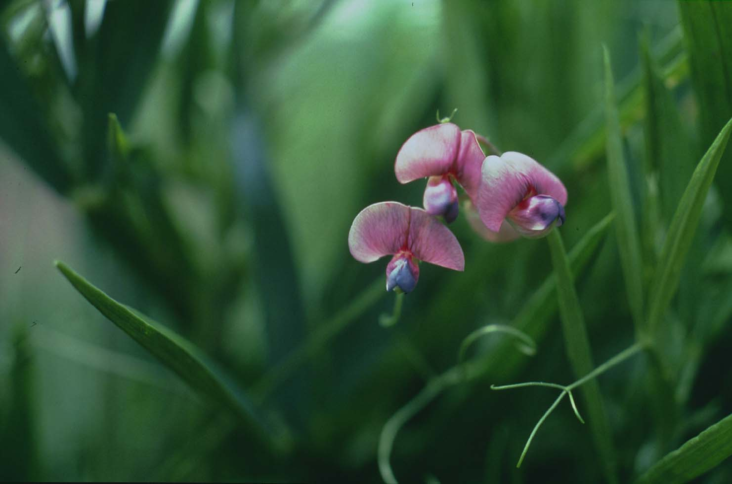

USDA NRCS

National Plant Materials Center

Beltsville, MD

**Uses**

Flatpea is a long-lived erosion control plant that can grow on severely disturbed soil under acid conditions and begin a soil improvement process. It requires little input once established. Flatpea will inhibit the ability of other plants to invade the stand after it acheives full cover, and can be used to control woody plant encroachment of utility rights-of-way. Flatpea has also received extensive interest as a forage due to the high protein content, however the presence of high concentrations of diaminobutyric acid (DABA) has rendered this use unlikely. DABA is toxic to non-ruminent livestock, and also to ruminants if fed in quantity before the rumen is acclimated to it. Birds will utilize the seed and are not affected by DABA.

Status

Please consult the PLANTS Web site and your State Department of Natural Resources for this plant’s current status (e.g. threatened or endangered species, state noxious status, and wetland indicator values).

Weediness

This plant may become weedy or invasive in some regions or habitats and may displace desirable vegetation if not properly managed. Please consult with your local NRCS Field Office, Cooperative Extension Service office, or state natural resource or agriculture department regarding its status and use. Weed information is also available from the PLANTS Web site at plants.usda.gov.

Description

Flatpea climbs through the use of tendrils and can attain heights of 5-7 feet if support is available. When no support is nearby, the plant has a height of 18-30 inches. In either case, a well-established stand forms a dense mat of vegetation. The stems and petioles are winged with leaf-like appendages. The leaf consists of two long, narrow leaflets with parallel veins and bears the tendril from juncture of the leaflets. The flowers are deep pink, and produce 2-inch long seed pods that contain the hard round seed. Both the seed and the pod are black or dark gray at maturity. Flatpea closely resembles sweetpea and perennial pea.

Adaptation and Distribution

Flatpea is adapted throughout the Northeast to soils that are moderately well drained or drier. It may also grow well on some sloping soils that are somewhat poorly drained. It is drought tolerant once established, and will grow on soils with a fines content as low as 15 percent (passing a 200 mesh seive). Low fertility and acid soils can successfully grow flatpea, and it will tolerate moderate shade better than will crownvetch.

Flatpea is distributed primarily in the northwest and scattered throughout the eastern United States. For a current distribution map, please consult the Plant Profile page for this species on the PLANTS Website.

Establishment

Flatpea will not establish successfully unless the seed is incorporated into the soil. Broadcast and hydroseeding will not work unless subsequent erosion covers the seed, or a heavy mulch is applied. The best way to incorporate flatpea seed on disturbed sites is to track it in with a bulldozer. Inoculated flatpea seed must be spring planted, or dormant planted in mid-fall. A drill can also used to plant the seed 1-1 1/2 inches deep. Flatpea is always planted with a grass companion (typically tall fescue) to provide quick cover during the 2-3 year establishment period. With good agronomics on a good site, flatpea will cover the soil in 2 years. With poor methodology it may never be successful.

Lime is needed if the soil is below a pH of 5.0, and moderate levels of phosphorus and potash are beneficial. Coat the seed with the specific inoculant immediately prior to planting. Plant flatpea at 20 pounds per acre with 15 pounds of tall fescue. More seed will not make up for lack of incorporation as outlined above.

Management

None is required. Mow the stand no more than once per year, after full bloom, and no sooner than the third year after planting.

Cultivars, Improved, and Selected Materials (and area of origin)

**‘**Lathco’ (western WA) is the only cultivar, and is available in the seed trade.

Control

Please contact your local agricultural extension specialist or county weed specialist to learn what works best in your area and how to use it safely. Always read label and safety instructions for each control method. Trade names and control measures appear in this document only to provide specific information. USDA, NRCS does not guarantee or warranty the products and control methods named, and other products may be equally effective.

Prepared By & Species Coordinator:

USDA NRCS Plant Materials Program

Edited: 05Feb2002 JLK; 060802 jsp

For more information about this and other plants, please contact your local NRCS field office or Conservation District, and visit the PLANTS Web site<<http://plants.usda.gov>> or the Plant Materials Program Web site <<http://Plant-Materials.nrcs.usda.gov>>

*The U.S. Department of Agriculture (USDA) prohibits discrimination in all its programs and activities on the basis of race, color, national origin, sex, religion, age, disability, political beliefs, sexual orientation, and marital or family status. (Not all prohibited bases apply to all programs.) Persons with disabilities who require alternative means for communication of program information (Braille, large print, audiotape, etc.) should contact USDA's* [*TARGET Center*](http://www.usda.gov/oo/target.htm) *at 202-720-2600 (voice and TDD).*

*To file a complaint of discrimination write USDA, Director, Office of Civil Rights, Room 326-W, Whitten Building, 14th and Independence Avenue, SW, Washington, DC 20250-9410 or call 202-720-5964 (voice or TDD). USDA is an equal opportunity provider and employer.*

*Read about* [*Civil Rights at the Natural Resources Convervation Service*](http://www.nrcs.usda.gov/about/civilrights/)*.*