|  |
| --- |
| bicolor lespedeza |
| *Lespedeza bicolor* Turcz. |
| Plant Symbol = LEBI2 |

Contributed by: USDA NRCS Plant Materials Program

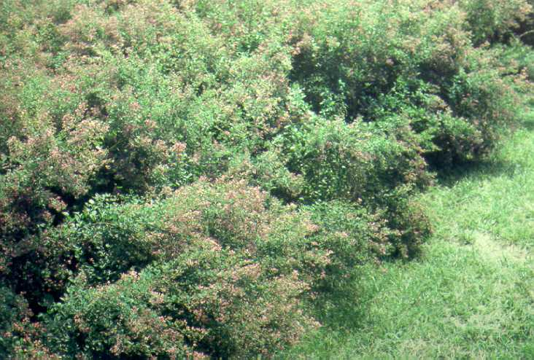

USDA NRCS National Plant Materials Center

Beltsville, MD

##### Caution: This plant may become invasive.

Uses

Bicolor lespedeza was introduced primarily to provide legume food and cover to popular game animals. Target wildlife have included ringneck pheasants, bobwhite quail, cottontail rabbits, and whitetailed deer. Honeybees are also attracted to their pinkish to purple flowers which bloom in late summer when few other plants valuable to beekeepers are blooming. The masses of late summer blooms also make it a valuable landscaping plant for borders and hedges.

Bicolor lespedeza is best used as field borders and along woodlands, on spoilbanks resulting from ditching and in small odd areas devoted to wildlife habitat improvement. The value of this shrub lespedeza for wildlife improves when planted in conjunction with rows of switchgrass (*Panicum* *virgatum*).

Status

Please consult the PLANTS Web site and your State Department of Natural Resources for this plant’s current status (e.g. threatened or endangered species, state noxious status, and wetland indicator values).

Weediness

This plant may become weedy or invasive in some regions or habitats and may displace desirable vegetation if not properly managed. Please consult with your local NRCS Field Office, Cooperative Extension Service office, or state natural resource or agriculture department regarding its status and use. Weed information is also available from the PLANTS Web site at plants.usda.gov.

Description

Bicolor lespedeza is a perennial semi-woody legume native to Japan. Allowed to grow naturally, it can reach a height of 8 to 10 feet with 1/2 inch diameter stems. If cut back, stems will grow 4 to 6 feet tall. The abundant trifoliate oval leaves are usually 1.5 inches long and 1 inch wide. The pink to purple colored flowers of ‘Natob’ appear first in late June to early July and continue for 4-6 weeks. *The outstanding quality of ‘Natob’ is that the seed matures at least a month earlier than common bicolor lespedeza.* Bees and insects are necessary to adequately pollinate lespedezas. The small, black, bean-like, seeds are singlely produced in pods which open when mature. Seed maturity occurs from late September to early October. Some plants hold seed into the winter but most seeds fall by January. Approximately 300 to 500 pounds of seed is produced per acre. There are about 72,000 seeds per pound.

Adaptation and Distribution

Bicolor lespedeza performs well on droughty, well drained, or somewhat poorly drained soils of variable texture. This species does not tolerate poorly drained sites. For seed to fully mature, a growing season no less than 160 days long is required. ‘Natob’ is more winter-hardy than other bicolor and shrub lespedezas grown in the Northeast.

Establishment

‘Natob’ plantings can be established with 1 year old field-grown seedlings, but direct seeding is the preferred method. For seedings to be effective, good site preparation is necessary. In mid spring a weed free, firm, seedbed must be well worked for good seed establishment. To insure first year germination, the seed should be first scarified by abrasion or acid. Prior to sowing, the seed must be inoculated with the proper rhizobial bacteria. Seeding should occur from the date of last expected frost to no later than June 1. If established with broadcasting techniques, 8 to 10 pounds of seed per acre should be used on well-worked soils; if drilled into rows, 6 to 8 lbs./ac. will be acceptable rates. When co-planting switchgrass with bicolor lespedeza, add 5 to 7 pounds of grass seed to the rates listed above. Seed should be sown 1/2 to 1 inch deep depending on soil conditions. Use an adequate mulch such as straw or wood fiber mulch to hold seed in place on highly erodible sites and help retain moisture on droughty sites.

Use normal tree planting procedures to establish seedlings at 2 to 3 feet in row spacing with 3 to 4 feet row spacing. This method is usually more expensive than seeding, but a good stand can be attained more quickly.

Management

Before or at the time of seeding, 300 to 500 pounds of 0-12-12 or 0-20-20 fertilizer can be applied to the planting area. Use 100-200 lbs./ac. of 0-20-20 annually in the spring to maintain a good stand. The site’s pH should be corrected to 6.5, if it is below 5.5. Seedlings do not compete well with over-topping weed growth. Control is best attained by allowing weeds grow to a height from 18 to 24 inches tall. Then, mow the weeds to a height equal to that of the lespedeza seedlings.

Cultivars, Improved, and Selected Materials (and area of origin)

‘Natob’ (China) is a cultivar of bicolor lespedeza developed and released to the commercial market. It was released cooperatively with the USDA-ARS and the Maryland Agricultural Experiment Station in 1952. Other cultivars are commercially available as wildlife food sources.

Bicolor lespedezas is distributed throughout the East. For a current distribution map, please consult the Plant Profile page for this species on the PLANTS Website.

Control

Please contact your local agricultural extension specialist or county weed specialist to learn what works best in your area and how to use it safely. Always read label and safety instructions for each control method. Trade names and control measures appear in this document only to provide specific information. USDA, NRCS does not guarantee or warranty the products and control methods named, and other products may be equally effective.

Prepared By & Species Coordinator:

USDA NRCS Plant Materials Program

Edited: 05Feb2002 JLK; 24may06jsp

For more information about this and other plants, please contact your local NRCS field office or Conservation District, and visit the PLANTS Web site<<http://plants.usda.gov>> or the Plant Materials Program Web site <<http://Plant-Materials.nrcs.usda.gov>>

*The U.S. Department of Agriculture (USDA) prohibits discrimination in all its programs and activities on the basis of race, color, national origin, sex, religion, age, disability, political beliefs, sexual orientation, and marital or family status. (Not all prohibited bases apply to all programs.) Persons with disabilities who require alternative means for communication of program information (Braille, large print, audiotape, etc.) should contact USDA's* [*TARGET Center*](http://www.usda.gov/oo/target.htm) *at 202-720-2600 (voice and TDD).*

*To file a complaint of discrimination write USDA, Director, Office of Civil Rights, Room 326-W, Whitten Building, 14th and Independence Avenue, SW, Washington, DC 20250-9410 or call 202-720-5964 (voice or TDD). USDA is an equal opportunity provider and employer.*

*Read about* [*Civil Rights at the Natural Resources Convervation Service*](http://www.nrcs.usda.gov/about/civilrights/)*.*