

Plant Fact Sheet

# rice cutgrass

## Leersia oryzoides (L.) Sw.

Plant Symbol = LEOR

*Contributed by*: USDA NRCS Plant Materials Center, Corvallis, Oregon

*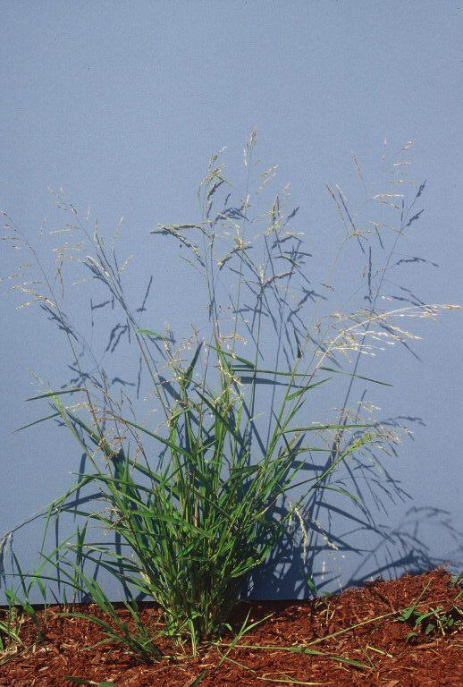 Photo by Dale Darris, Corvallis Plant Materials Center.*

### Alternative Names

*Alternate Common Names:* sicklegrass

*Alternate Scientific Names: Homalocenchrus oryzoides* (L.) Pollich, *Phalaris oryzoides* L.

Uses

Rice cutgrass is valuable for wildlife habitat improvement, wetland restoration, and erosion control in ditches and other watercourses. The seeds are an important food source for waterfowl, small mammals, and shorebirds. Ducks pull up and consume underground stems (rhizomes). Dense coloniesprovide cover and habitat for fish, reptiles, and amphibians. The forage produced is highly palatable. This plant’s creeping rhizomes and spreading habit are good for sediment stabilization along the immediate shorelines of streams and lakes. Tolerant of highly acidic conditions (pH 3.0), the species is being studied for use in constructed wetlands and for the treatment of acid mine drainage. It may have potential for vegetated drainage ditches that mitigate agricultural runoff, including pesticides.

Status

Please consult the PLANTS Web site and your State Department of Natural Resources for this plant’s current status (e.g. threatened or endangered species, state noxious status, and wetland indicator values).

Description and Adaptation

Rice cutgrass is a native cool season grass that grows and flowers comparatively late in summer. The seed ripens in late August to early October, more typical of a warm season species. This short- to medium-lived perennial spreads by scaly, underground rhizomes and often forms dense colonies. The stalks (stems) are upright to sprawling, velvety at the nodes (joints), and 90 to 125 (150) cm tall. Leaf blades are 7 to 30 cm long, 6 to 15 (20) mm wide, and yellow-green in color. They have a coarse or rough upper surface and are lined with tiny teeth along the margins. The flowerhead (panicle) is open, often drooping, and 10 to 20 cm long. Some panicles remain enclosed within the lower leaf sheaths and release seeds upon decay of the stem. The seed hull is covered with minute bristles that readily cling to clothing or fur for dispersal. Rice cutgrass is widespread across southern Canada and most of the United States. It is also found in the warmer parts of Europe.

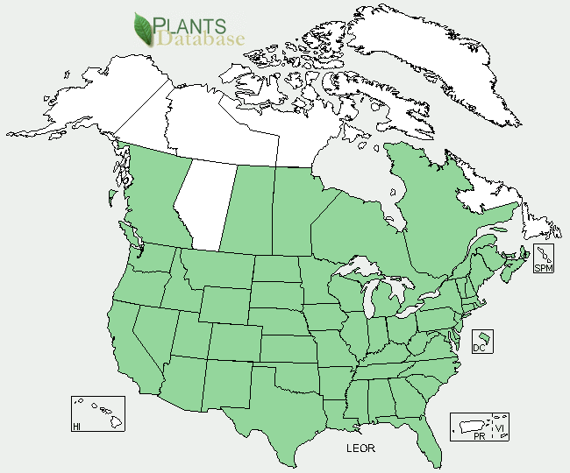

*Rice cutgrass distribution from USDA NRCS PLANTS Database.*

### *Key to identification:* This grass is quickly identified by running a hand through it. The sharp leaves can cut flesh and tear weaker clothing. They are abrasive and sandpapery to the touch. Seeds resemble rice and are not easily confused with other native grasses. The spikelets hang in a single row creating a one-sided appearance to each panicle branch. Rice cutgrass can easily be confused with two other species of *Leersia* commonly found in North America. Consult botanical keys for proper identification.

### Line drawing of rice cutgrass with permission from the University of Washington Press.

*Line drawing of rice cutgrass reprinted with permission of University of Washington Press*

*Relative abundance in the wild:* Rice cutgrass is occasional to very abundant. Once stands are located, seed is easily stripped by hand. Retention of seed is fair at best as seed shatters (drops) readily at maturity.

*Adaptation:* Rice cutgrass can be found in a variety of wet, sunny, and partially shaded sites. However, it is most common near streams, ponds, or beaver areas, and in ditches, canals, or freshwater marshes. This species thrives best in nutrient rich mud and slow moving or stagnant water. Seedlings may not survive submergence for more than 2 to 3 days, while mature plants easily tolerate seasonal to permanent flooding. Reportedly, this grass can grow in standing water up to 0.5 ft (15 cm), 1 ft (30 cm) or 3 ft (1 meter) deep. It can be found in other habitats where soils are saturated at or near the surface year round or continuously moist in summer. It occasionally co-exists with reed canarygrass (*Phalaris arundinacea*) on wetter sites, but is much less broadly adapted. Soils may range from acid to alkaline (usually pH 5.1 to 8.8) sands, silts, loams, or clays. For natural regeneration, rice cutgrass needs bare mud and an open vegetative structure created by seasonal inundation and regular disturbance.

Establishment

Rice cutgrass seed possesses physiological dormancy requiring a 180 to 270 day period of cool, moist stratification (moist chilling). Gentle scarification (abrasion of the seed coat after hull removal) may improve germination as well. Late summer or early fall seeding is recommended. Seeds will germinate the following spring. There are approximately 360,000 seeds per pound (± 20%). A seeding rate of 1 lb/acre of pure live seeds will result in 8 live seeds per square foot. Rarely sown alone due to cost, it typically comprises 1 to 20% of a seed mix. Rhizomes, rootstock, and container plants are also used for establishment. A spacing of 1 to 3 feet (30-90 cm) will achieve uniform ground coverage in one to three years respectively. Rhizomes should be planted 2 to 5 inches (5-12 cm) deep.

Management

Plants develop relatively slowly in spring, becoming most productive during the summer. The seed matures in late August or September and the plants go dormant soon after (October to November). Stand maintenance or proliferation requires adequate soil fertility, regular flooding, and soil disturbance every two to three years to create open areas. For wildlife enhancement, this species is well suited to moist soil management techniques (slow summer de-watering, soil disking, etc.) applied to certain wetlands and shallow water impoundments. In some cases, disturbance and regeneration have been promoted by grazing cattle.

Environmental Concerns

Rice cutgrass has a narrow ecological adaptation and may not persist well. However, it is also a weed in some situations, including commercial cranberry beds (bogs) in the Pacific Northwest and the Northeast. It is sometimes considered a weed in the Southeast as well. This species can form dense colonies to the potential exclusion of other native marsh grasses and herbs. However, under undisturbed conditions it is regularly replaced by other species. The abrasive leaves may cause skin injury.

Cultivars, Improved, and Selected Materials (and area of origin)

Seed sources can be hard to locate for Oregon, Washington, and California. Container plants and rootstock are somewhat more common. It is readily available in the Midwestern states from seed producers and nurseries.

Prepared By:

*Dale Darris* *and* *Amy Bartow*, USDA NRCS Plant Materials Center, Corvallis, Oregon

**Citation**

Darris, D., and A. Bartow. 2004. Plant fact sheet for rice cutgrass (*Leersia oryzoides)*. USDA-Natural Resources Conservation Service, Plant Materials Center, Corvallis, OR.

PublishedDecember 2004

Edited: 21Mar2006 jsp; 16Sep2008 dcd; 17Sep2008jsp; 21Feb2012 aym

For more information about this and other plants, please contact your local NRCS field office or Conservation District <<http://www.nrcs.usda.gov/>>, and visit the PLANTS Web site <[http://plants.usda.gov](http://plants.usda.gov/)> or the Plant Materials Program Web site <<http://plant-materials.nrcs.usda.gov>>

**USDA IS AN EQUAL OPPORTUNITY PROVIDER AND EMPLOYER**