|  |
| --- |
| shrub lespedeza |
| *Lespedeza thunbergii* (DC.) Nakai |
| Plant Symbol = LETH4 |

Contributed by: USDA NRCS Plant Materials Program

**Caution: This plant may become invasive.**

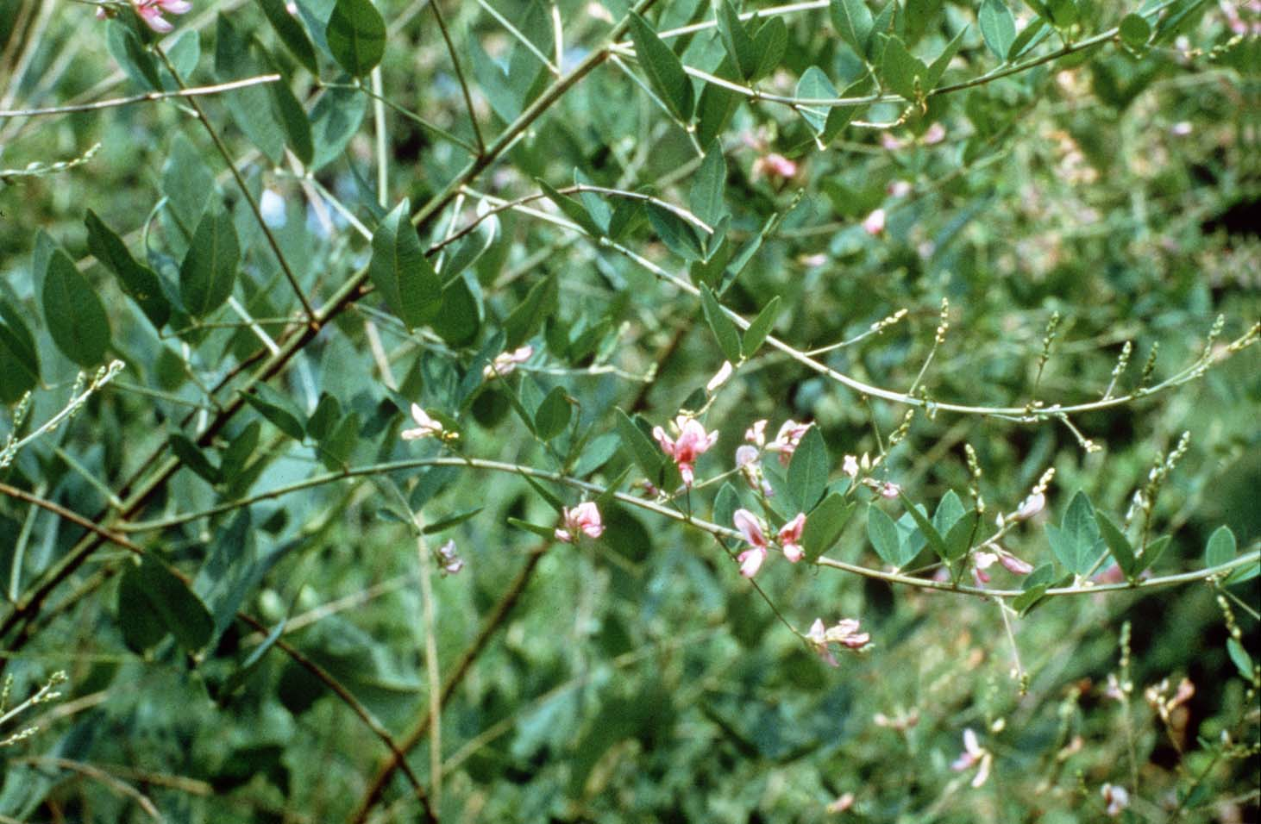

USDA NRCS National Plant Materials Center

Beltsville, MD

Uses

Shrub lespedeza was introduced primarily to provide legume food and cover to popular game animals. Target wildlife have included ring-neck pheasants, bobwhite quail, cottontail rabbits, and white-tailed deer, but honeybees have also been attracted to their flowers. The value of shrub lespedeza for wildlife improves when planted in conjunction with rows of switchgrass (*Panicum* *virgatum*).

Status

Please consult the PLANTS Web site and your State Department of Natural Resources for this plant’s current status (e.g. threatened or endangered species, state noxious status, and wetland indicator values).

Weediness

This plant may become weedy or invasive in some regions or habitats and may displace desirable vegetation if not properly managed. Please consult with your local NRCS Field Office, Cooperative Extension Service office, or state natural resource or agriculture department regarding its status and use. Weed information is also available from the PLANTS Web site at plants.usda.gov.

Description

Shrub lespedeza is a perennial legume native to eastern Asia. It grows 4 to 6 feet tall stems that may reach 1/2 inch in diameter. These stems die back to the ground annually. The leaves are usually 2 inches long and 1/2 inch wide, with a more linear appearance than oval. The pink to purple colored flowers emerge in great masses during late summer. Bees and insects are necessary to adequately pollinate lespedezas. This species of lespedeza easily hybridizes with others of the genus, so isolation is necessary. The small, black, bean-like, seeds are singly produced in pods which open when mature. Seed maturity occurs from late September to early October. Approximately 300 to 500 pounds of seed is produced per acre on production fields. There are about 72,000 seeds per pound. This species has a high frequency of hard-coated seed which must be cracked or removed to initiate germination.

Adaptation and Distribution

Shrub lespedeza performs well on droughty, well drained, or somewhat poorly drained soils of variable texture. This species does not tolerate poorly drained sites. For seed to fully mature, a growing season no less than 160 days long is required.

Shrub lespedeza is distributed throughout the East. For a current distribution map, please consult the Plant Profile page for this species on the PLANTS Website.

Establishment

Shrub lespedeza can be established with 1 year old field-grown seedlings, but direct seeding is the preferred method. For seedings to be effective, good site preparation is necessary. In mid-spring a weed free, firm, seedbed must be well worked for good seed establishment. To insure first year germination, the seed should be first be scarified by abrasion or acid. Do not forget that prior to sowing, the proper bacteria should be used to inoculate the seed. Seeding should occur from the date of last expected frost to no later than June 1. If established with broadcasting techniques, 8 to 10 pounds of seed per acre should be used on well-worked soils; if drilled into rows, 6 to 8 lbs./ac. will be acceptable. When co-planting switchgrass with shrub lespedeza, add 5 to 7 pounds of grass seed to the rates listed above. Seed should be sown 1/2 to 1 inch deep depending on soil conditions. Sawdust, wood chips, hay, straw, or wood fiber mulching is effective at holding seed in place on highly erodible sites, and retaining moisture on droughty sites.

To establish shrub lespedeza in nursery beds, place 12 to 20 seeds, 1/4 to 1/2 inch deep, per linear foot of row; space rows 3 to 4 feet apart. Use the seeding recommendations stated above. Use normal tree planting procedures to establish seedlings at 2 to 3 feet in row spacings with 3 to 4 feet row spacing. This method is usually more expensive than seeding, but a good stand can be attained more quickly.

Management

Since shrub lespedeza is a legume, capable of fixing its own atmospheric nitrogen, inorganic forms are not necessary. Before or at the time of seeding, 300 to 500 pounds of 0-12-12 or 0-20-20 fertilizer can be applied to the planting area. The site’s pH should be corrected to 6.5, if it is below 5.5.

Seedlings do not compete well with over-topping weed growth. Control is best attained by allowing weeds grow to a height of 18 to 24 inches tall. Then, mow the weeds to a height equal to that of the lespedeza seedlings.

Cultivars, Improved, and Selected Materials (and area of origin)

Two cultivars of shrub lespedeza have been developed and released to the commercial market by the USDA-Natural Resources Conservation Service. ‘VA-70’ (Manchuria, China) was selected for its wildlife value and cold hardiness by the Cape May Plant Materials Center, Cape May Court House, NJ. ‘Amquail’ (Japan) was developed at Americus, GA

Plant Materials Center for its wildlife food and cover attributes for use in the southeastern U.S. Foundation seed for both released cultivars is available to commercial nurseries.

Control

Please contact your local agricultural extension specialist or county weed specialist to learn what works best in your area and how to use it safely. Always read label and safety instructions for each control method. Trade names and control measures appear in this document only to provide specific information. USDA, NRCS does not guarantee or warranty the products and control methods named, and other products may be equally effective.

Prepared By & Species Coordinator:

USDA NRCS Plant Materials Program

Edited: 05Feb2002 JLK; 24may06jsp

For more information about this and other plants, please contact your local NRCS field office or Conservation District, and visit the PLANTS Web site<<http://plants.usda.gov>> or the Plant Materials Program Web site <<http://Plant-Materials.nrcs.usda.gov>>

*The U.S. Department of Agriculture (USDA) prohibits discrimination in all its programs and activities on the basis of race, color, national origin, sex, religion, age, disability, political beliefs, sexual orientation, and marital or family status. (Not all prohibited bases apply to all programs.) Persons with disabilities who require alternative means for communication of program information (Braille, large print, audiotape, etc.) should contact USDA's* [*TARGET Center*](http://www.usda.gov/oo/target.htm) *at 202-720-2600 (voice and TDD).*

*To file a complaint of discrimination write USDA, Director, Office of Civil Rights, Room 326-W, Whitten Building, 14th and Independence Avenue, SW, Washington, DC 20250-9410 or call 202-720-5964 (voice or TDD). USDA is an equal opportunity provider and employer.*

*Read about* [*Civil Rights at the Natural Resources Convervation Service*](http://www.nrcs.usda.gov/about/civilrights/)*.*