|  |
| --- |
| sweetgum |
| *Liquidambar styraciflua* L. |
| Plant Symbol = LIST2 |

Contributed by: USDA NRCS Plant Materials Program

Alternate Names

redgum, sapgum, starleaf-gum, bilsted

Uses

*Erosion Control*: Sweetgum is a good choice as a windbreak tree because of its fast growth and tolerance of a wide variety of sites.

*Wildlife*: Its seeds are eaten by birds, squirrels, and chipmunks.

*Timber*: Sweetgum is primarily used for lumber, veneer, plywood, slack cooperage, railroad ties, fuel and pulpwood. Its wood is used for veneer, furniture, interior trim, and wooden ware, in addition to pulpwood for fine papers.

*Recreation and Beautification*: It is used as a specimen plant, shade tree, and street tree.

Status

Please consult the PLANTS Web site and your State Department of Natural Resources for this plant’s current status (e.g. threatened or endangered species, state noxious status, and wetland indicator values).

Description

*Liquidambar styraciflua* L., sweetgum, is native to southeastern, east-central, and south-central United States, southern Mexico, and central America. It is a large deciduous hardwood tree, which can grow to over 100 feet in height and 3 to 5 feet in diameter, with a symmetrical, cone-shaped crown. The bark is grayish brown, deeply furrowed into narrow, somewhat rounded ridges. The leaves are alternate, simple, and palmately lobed with 5-7 points resembling a star in shape, dark green and lustrous above, paler underneath. Flowers are monoecious, female, on a slender stalk terminated by a ½ inch diameter globose head consisting of 2-beaker ovaries subtended by minute scales. The fruit is a dangling brown, woody spiny tipped “gum ball” with seeds brownish and winged.

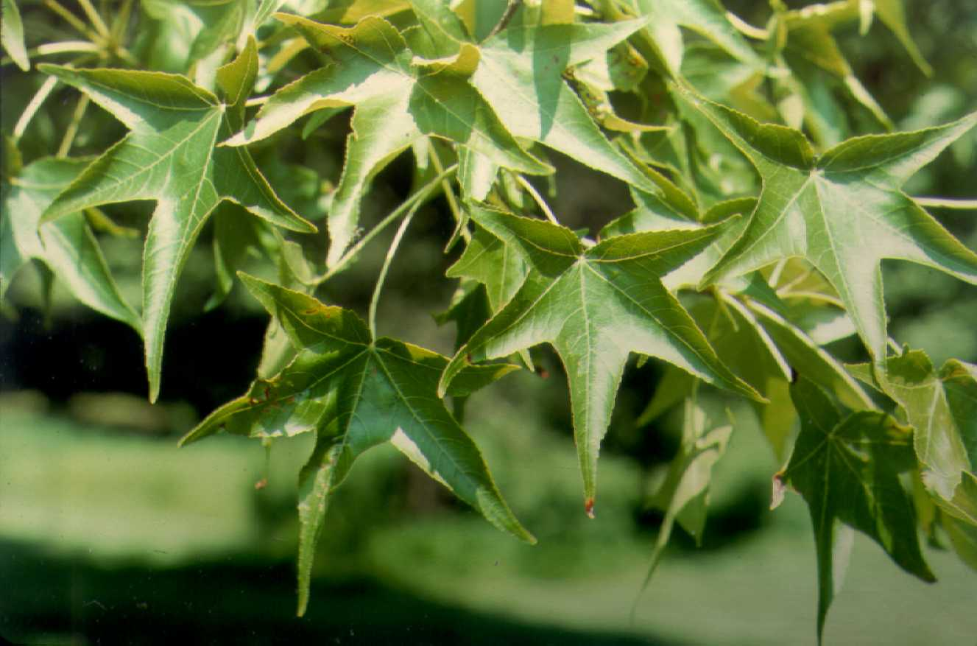

USDA NRCS National Plant Materials Center

Beltsville, MD

Adaptation and Distribution

In the wild, sweetgum grows in bottomland areas with rich, moist soil, but can tolerate a variety of soil conditions. The tree does not do well planted in locations where roots are limited in their development. It grows best on moderately coarse to fine soils that are well drained and slightly acid (pH 6.1- 6.5). It develops a deep taproot with numerous highly developed laterals on well drained bottomland sites and a shallow, wide spreading root system on poorly drained sites. Sweetgum is very intolerant to shade but tolerant to flooding. It also tolerates seaside sites if protected from high winds.

Sweetgum is distributed throughout the east and southeast portions of the United States. For a current distribution map, please consult the Plant Profile page for this species on the PLANTS Website.

Establishment

Sweetgum can regenerate naturally from root sprouts following logging. It can be successfully established using quality seedlings with a large root-collar diameter of at least ¼ inch. Mycorrhizae can significantly improve seedling quality. Soil amended with as little as ½ inch of sewage sludge (disked into the soil) can result in better growth at outplanting.

Leafy cuttings taken with a heel can be readily rooted under mist in summer. Transplant balled and burlapped plants in spring into deep, moist, slightly acid soil, full sun. The root system is fleshy, not greatly fibrous, and takes a while to reestablish.

Seeds exhibit only a shallow dormancy, but germination rate is considerably increased by cold, moist stratification at 41 °F for 15 to 90 days in moist sand. Prechilled seeds should be broadcast or drilled to achieve a seedling density of 20-25 per square ft. Seeds should be sown on the soil surface and lightly pressed into the soil. A mulch of sawdust, sand or chopped pine needles should be applied. There are approximately 0.8 lb of clean seeds per bushel of fruit and the average number of seeds per lb is 82,000.

Management

Adequate sunlight is required for sweetgum to reach its potential. Young trees are able to withstand crowding, however, they become intolerant to competition with increasing age. Removal of overstory trees results in rapid growth of young sweetgum trees.

Pests and Potential Problems

Sweetgum is susceptible to iron chlorosis on high pH soils, frost damage to late summer shoot growth, occasional bleeding necrosis, leader dieback, sweetgum blight, leaf spots, sweetgum webworm, caterpillars, cottony-cushion scale, sweetgum scale, and walnut scale.

Cultivars, Improved, and Selected Materials (and area of origin)

‘Burgundy,’ ‘Moraine,’ ‘Festival,’ ‘Obtusiloba,’ ‘Gumball,’ ‘Palo Alto,’ ‘Levis,’ and ‘Variegata.’ Sweetgum seeds are commercially available from forest seed companies.

Prepared By & Species Coordinator:

USDA NRCS National Plant Materials Center

Beltsville, Maryland

Edited: 05Feb2002 JLK; 060802 jsp

For more information about this and other plants, please contact your local NRCS field office or Conservation District, and visit the PLANTS Web site<<http://plants.usda.gov>> or the Plant Materials Program Web site <<http://Plant-Materials.nrcs.usda.gov>>

*The U.S. Department of Agriculture (USDA) prohibits discrimination in all its programs and activities on the basis of race, color, national origin, sex, religion, age, disability, political beliefs, sexual orientation, and marital or family status. (Not all prohibited bases apply to all programs.) Persons with disabilities who require alternative means for communication of program information (Braille, large print, audiotape, etc.) should contact USDA's* [*TARGET Center*](http://www.usda.gov/oo/target.htm) *at 202-720-2600 (voice and TDD).*

*To file a complaint of discrimination write USDA, Director, Office of Civil Rights, Room 326-W, Whitten Building, 14th and Independence Avenue, SW, Washington, DC 20250-9410 or call 202-720-5964 (voice or TDD). USDA is an equal opportunity provider and employer.*

*Read about* [*Civil Rights at the Natural Resources Convervation Service*](http://www.nrcs.usda.gov/about/civilrights/)*.*