

Plant Fact Sheet

# riverbank lupine

## Lupinus rivularis Douglas ex Lindl.

Plant Symbol = LURI

Contributed by: USDA NRCS Corvallis Plant Materials Center, Oregon

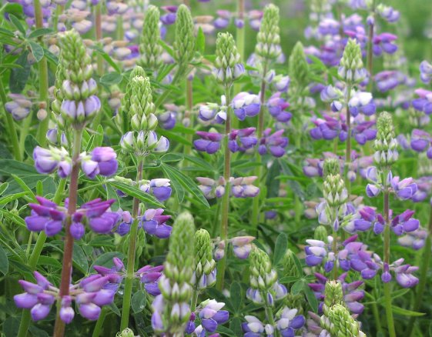

Photo by Amy Bartow, NRCS Corvallis Plant Materials Center, 2008

### Alternate Names

*Alternative Common Names:* riverside lupine, streambank lupine, stream lupine, nine finger

*Alternative Scientific Names:* *Lupinus lignipes* A. Heller, *Lupinus amphibium* Suksd.

### Uses

*Erosion control*: Given riverbank lupine’s rapid growth, it can be used as quick cover on critical erosion sites, including droughty, steep, low-fertility slopes. Because of the species’ ability to add nitrogen to the soil (through N-fixing bacteria), it can also facilitate the establishment of grasses and other wildflowers in restoration seedings.

*Wildlife and Livestock*: Several species of birds use the seed for food. Birds, rabbits, and other small game use the abundant stems for cover. The flowers provide pollen and nectar for bumblebees and other native pollinators and beneficial insects. This species is a potential butterfly host plant for the orange sulphur (*Colias eurytheme*) and the western tailed blue (*Everes amyntula*). Riverbank lupine appears to be compatible with livestock grazing as it has low levels of alkaloids, and does not contain anagyrine, a compound found in many other lupines that causes the birth defect known as ‘crooked calf disease’. Likewise, the cultivar ‘Hederma’ produced no toxic symptoms in sheep or calves in a feeding trial, and was found to contain very low concentrations of alkaloids.

*Cover Crop*: For soil enrichment through nitrogen fixation and addition of organic matter, riverbank lupine can be seeded as a winter cover and green manure crop, or used in reforestation projects. From laboratory assays, nitrogen fixation rates of its root nodules appear high, but actual levels of increase in field soil nitrogen have not been fully quantified.

### *Ornamental*: The plant’s showy floral display and pleasant scent make it appropriate for certain landscape uses along roadsides, around residential areas, and within parks where a larger, short-lived wildflower is desired.

*Ethnobotanic*: The plants are reported to have been used medicinally by the Thompson Indians of British Columbia.

### Status

Riverbank lupine is on red list 1-E (endangered) in British Columbia, but is fairly common throughout the rest of its range. It is considered a facultative upland plant (usually occurring in non-wetlands, but occasionally found in wetlands) in the northwest, but a facultative plant (equally likely to occur in wetlands or non-wetlands) in California. Please consult the PLANTS Web site and your State Department of Natural Resources for this plant’s current status (e.g., threatened or endangered species, state noxious status, and wetland indicator values).

### Description and Adaptation

Riverbank lupine is a native, rapid-developing, deep tap-rooted, multi-stemmed, erect forb, 1 to 5 feet tall. The plant may be an annual, biennial, or short-lived perennial. In Oregon, its habit can be like an evergreen subshrub. At least some populations appear to possess few if any basal buds, with most new shoot growth arising primarily from aerial portions of the plant in the second year. The leaves are alternate, palmately compound, with 5 to 9 leaflets that average 1½ inches long. Attractive purple-blue to white pea-type flowers bloom March to July, depending on latitude and elevation, and last for about two to four weeks. The sparsely hairy pods up to 2 inches long contain 6-10 seeds that are gray with dark mottling, often with a black stripe on each side.

Riverbank lupine is adapted to well-drained, sandy or gravelly soils of Oregon and Washington west of the Cascades, southwestern British Columbia, and northwestern California at elevations below 6,000 feet in regions with a precipitation range of 18 to 100 inches. Persistence is best on soils low in nitrogen, such assand dunes, cut slopes along roadsides, or dredge spoils, where competition is reduced. Best growth and development are achieved when the plant is grown in full sun. It is an excellent pioneer species. For updated distribution, please consult the Plant Profile page for this species on the PLANTS Web site.

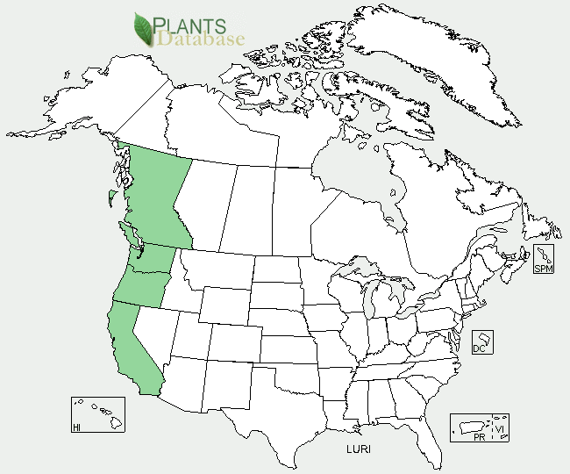

Riverbank lupine distribution from USDA-NRCS PLANTS Database.

### Establishment

Seed should be mechanically scarified or soaked in hot water (180°F) to overcome physical dormancy and enhance germination rates. Establishment and subsequent growth may also be improved by inoculating with the appropriate rhizobia (N-fixing bacteria) prior to planting. Riverbank lupine can be seeded either in early fall or in the spring at 4 to 20 lbs/acre, depending on the site and seed mixture desired, at a depth of ½ to ¾ inch. Strips for landscaping, hedgerows, or wildlife use can be broadcast seeded at about 20 lbs/acre. For all conservation uses riverbank lupine can be seeded alone at about 10 lbs/acre, or with companion grass-legume mixtures, or into existing grass stands at 4 to 20 lbs/acre, depending upon need. Seed production fields can be established on most well-drained tillable soils, and are typically planted at 10 lbs/acre on 24-inch rows. Summer-seeded, irrigated fields should produce a seed crop the following year, but fall or spring seeding (with or without irrigation) will not produce a seed crop until the second full growing season. Plants do not generally re-sprout after they are cut, so only one seed crop is produced. There are between 15,000 and 31,000 seeds per pound.

### Management

Riverbank lupine often shades out weedy competitors with its rapid growth, and thus requires little weed control after establishment. For seed production, the crop should be harvested just before fully mature to avoid excessive shatter. It can be direct combined or windrowed onto tarps or paper rolls to dry. Green seeds thus harvested have dried without any apparent loss in viability.

### Pests and Potential Problems

Insect damage is significant only during seed production and is controlled with normal spray programs. Adult diabrotic or striped cucumber beetles (*Diabrotica trivittata*) feed on leaves and blossoms, while lygus bugs (*Lygus pratensis*) cause damage by sucking out the juices of developing flowers and fruit. Powdery mildew is common in some years, but is generally not considered a problem for wildlife or critical area plantings.

### Environmental Concerns

It is unknown if all populations of riverbank lupine have low toxicity to livestock similar to the cultivar Hederma. Because of the production of “hard” seed, volunteer plants may appear in agricultural seed production fields a number of years after stand removal. Riverbank lupine is known to hybridize extensively with the invasive yellow bush lupine (*Lupinus arboreus*), as well as the native seashore lupine (*L. littoralis*), and these hybrid swarms may displace or genetically swamp native stands of riverbank lupine. Seed collection and propagation from these hybrids populations by wildflower enthusiasts poses a significant threat to the genetic integrity of the species.

### Cultivars, Improved, and Selected Materials (and area of origin)

‘Hederma’ (Oregon) is a short-lived perennial; in its area of adaptation, it may survive three to four years, but it tends to act as a biennial. It is intended for use in western Oregon, western Washington, and northwestern California, for sites up to 3,000 feet in elevation. While the plant exhibits partial dieback primarily in the second winter, it has some evergreen stems and foliage. This cultivar produces 20,000 to 25,000 seeds/lb. Seed is available from several commercial producers or vendors.

### Prepared By

Dale Darris and Annie Young-Mathews

USDA NRCS Plant Materials Center

Corvallis, Oregon

### Citation

Darris, D., and A. Young-Mathews. 2012. Plant fact sheet for riverbank lupine (*Lupinus rivularis)*. USDA-Natural Resources Conservation Service, Corvallis Plant Materials Center, Corvallis, OR.

Published March 2012

Edited: 13Sep2011 aym; 09Jan2012 klp; 13Jan2012 jab; 09Apr2012 aym

For more information about this and other plants, please contact your local NRCS field office or Conservation District <<http://www.nrcs.usda.gov/>>, and visit the PLANTS Web site <[http://plants.usda.gov](http://plants.usda.gov/)> or the Plant Materials Program Web site <<http://plant-materials.nrcs.usda.gov>>

**USDA IS AN EQUAL OPPORTUNITY PROVIDER AND EMPLOYER**