|  |
| --- |
| alfalfa |
| *Medicago sativa* L. |
| Plant Symbol = MESA |

Contributed by: USDA NRCS Plant Materials Program

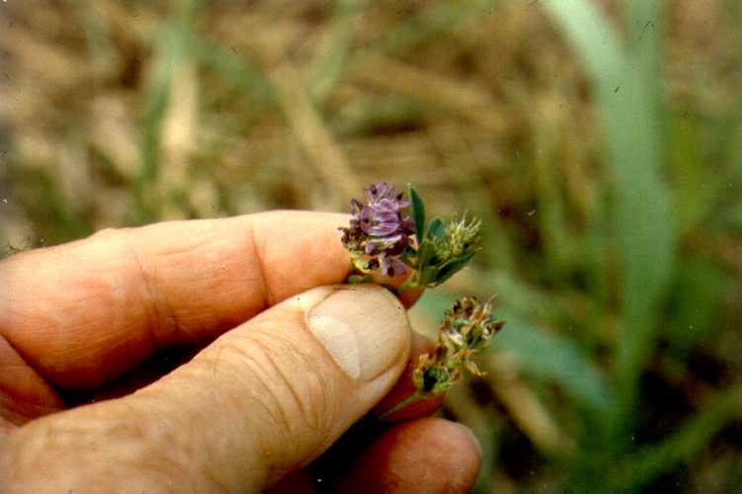

USDA NRCS National Plant Materials Center

Beltsville, MD

Uses

*Crops*: Alfalfa is harvested as hay which is processed or fed directly to livestock, or for seed production. It is also used in pellets as forage supplements.

*Livestock*: This plant is grown in combination with grasses in improved pastures. It is grazed by all types of domestic livestock. Caution should be taken when using alfalfa for grazing due to its high bloat hazard.

*Wildlife*: Alfalfa is an excellent food for antelope, deer, elk, Canada goose, and sage and sharp tail grouse. It is fair food for sandhill crane, mallard, Hungarian partridge, and pheasant.

In addition to providing high quality hay, grazing, and wildlife forage and protection, alfalfa is an important source of leaf meal used for fortifying baby food and other special diet foods prepared for human use. Large quantities of dehydrated alfalfa are also used in manufacturing concentrated feeds for poultry and livestock.

Status

Please consult the PLANTS Web site and your State Department of Natural Resources for this plant’s current status (e.g. threatened or endangered species, state noxious status, and wetland indicator values).

Weediness

This plant may become weedy or invasive in some regions or habitats and may displace desirable vegetation if not properly managed. Please consult with your local NRCS Field Office, Cooperative Extension Service office, or state natural resource or agriculture department regarding its status and use. Weed information is also available from the PLANTS Web site at plants.usda.gov.

Description

*Medicago sativa* L., alfalfa, is a long-lived perennial 1egume. Flowers vary in colorfrom purple to yellow and are borne in loose clusters. Pods of alfalfa range from the sickle type to those that are twisted into spirals. Each pod contains several small kidney‑shaped seeds. Alfalfa’s stems are erect and grow from a woody crown to about 2 to 3 feet tall. New growth occurs from buds in the crown. The plant has a tap root which may penetrate deep into the soil. Leaves are alternately arranged on the stem and are normally trifoliate.

Adaptation and Distribution

Alfalfa grows best on deep, well-drained, friable soils. Lands subject to frequent overflows or high water tables are unfavorable for alfalfa. The pH of the soil should be 6.5 or above.

Alfalfa is distributed throughout the entire United States. For a current distribution map, please consult the Plant Profile page for this species on the PLANTS Website.

Establishment

A seedbed must be smooth, firm, free of weeds and trash, and contain adequate moisture for germination and emergence. Land grading must be sufficient to ensure good surface draining. Alfalfa should not be seeded as a first crop on newly leveled land where fill may settle and cause poor surface drainage.

Five pounds of scarified, properly inoculated pure live seed (PLS) per acre evenly drilled ¼-inch deep on adapted, properly prepared sites will produce adequate stands. A combination drill and packer is desirable.

Cultipacking soil before and after seeding is helpful to establishing a stand. Seeding depths should be no greater than ¼ inch on finer textured soils and no greater than ½ inch on sandy soils Spring seedings can be made 30 days before the average date of last killing frost. Other dates of seeding may be made during the late summer.

Management

In general, graze or cut for hay when alfalfa is in early bloom. Graze or cut to about a 2-inch height. Successive grazings and cuttings for hay should occur at ¼ bloom stage or after a 5 to 6 week recovery period. Alfalfa can best withstand grazing if rotated frequently or grazed in small strips. The last cutting of alfalfa should be made 3 to 4 weeks before the first killing frost date.

Alfalfa may cause livestock to bloat. Care should be used in managing such grazing to reduce the possibility of this hazard.

Pests and Potential Problems

Alfalfa is susceptible to the spotted or pea aphid, alfalfa weevil, stem nematode, bacterial wilt, snout beetle, and several leaf spots.

Cultivars, Improved, and Selected Materials (and area of origin)

Alfalfa is the oldest crop grown for forage and there are many cultivars available on the open market. More than 440 publicly and privately developed cultivars were approved for certified seed production in the U.S. between 1962 and 1992. For a specific state or region of the U.S., use cultivars that are adapted and have been tested for local performance. Cultivars are readily available from commercial seed vendors.

Control

Please contact your local agricultural extension specialist or county weed specialist to learn what works best in your area and how to use it safely. Always read label and safety instructions for each control method. Trade names and control measures appear in this document only to provide specific information. USDA, NRCS does not guarantee or warranty the products and control methods named, and other products may be equally effective.

Prepared By & Species Coordinator:

USDA NRCS Plant Materials Program

Edited: 05Feb2002 JLK; 25may06jsp

For more information about this and other plants, please contact your local NRCS field office or Conservation District, and visit the PLANTS Web site<<http://plants.usda.gov>> or the Plant Materials Program Web site <<http://Plant-Materials.nrcs.usda.gov>>

*The U.S. Department of Agriculture (USDA) prohibits discrimination in all its programs and activities on the basis of race, color, national origin, sex, religion, age, disability, political beliefs, sexual orientation, and marital or family status. (Not all prohibited bases apply to all programs.) Persons with disabilities who require alternative means for communication of program information (Braille, large print, audiotape, etc.) should contact USDA's* [*TARGET Center*](http://www.usda.gov/oo/target.htm) *at 202-720-2600 (voice and TDD).*

*To file a complaint of discrimination write USDA, Director, Office of Civil Rights, Room 326-W, Whitten Building, 14th and Independence Avenue, SW, Washington, DC 20250-9410 or call 202-720-5964 (voice or TDD). USDA is an equal opportunity provider and employer.*

*Read about* [*Civil Rights at the Natural Resources Convervation Service*](http://www.nrcs.usda.gov/about/civilrights/)*.*