|  |
| --- |
| bayberry |
| *Morella pensylvanica* (Mirbel) Kartesz |
| Plant Symbol = MOPE6 |

Contributed by: USDA NRCS New York State Office

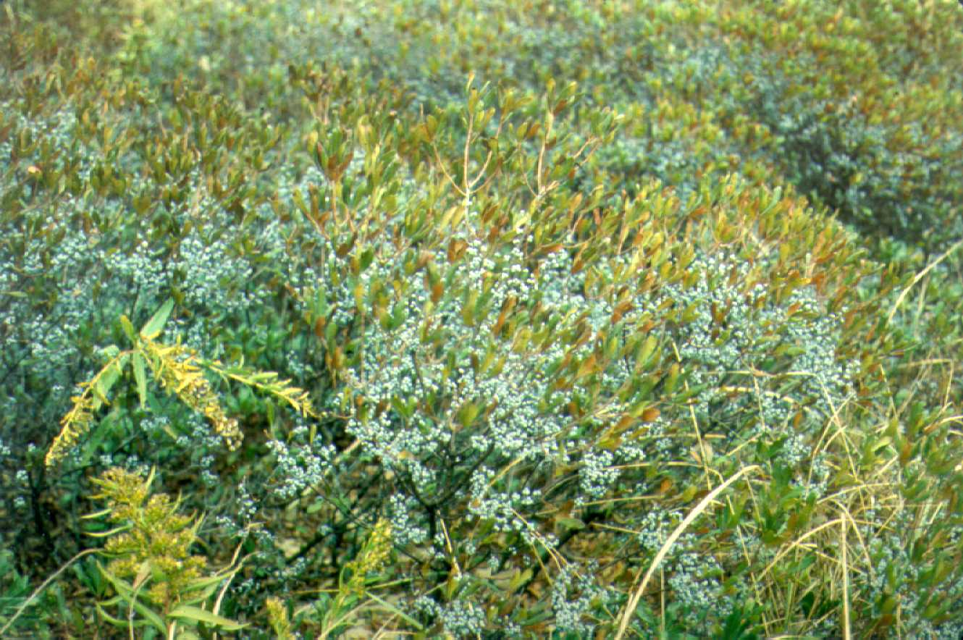

USDA NRCS National Plant Materials Center

Beltsville, MD

Alternate Names

Myrica pensylvanica *Mirbel*

Uses

Colonies of this salt spray tolerant shrub provide excellent secondary stabilization and cover to the back dune areas of the mid-Atlantic coastline. Bayberry is used effectively in hedges, wildlife borders, and on road banks. Because some leaves remain on the plant throughout most of the winter months, it provides year-round shelter for game and non-game animals alike. The berries provide a key energy source for swallows migrating south along the mid-Atlantic coast. These fruit are retained on the plant well into winter above any accumulated snow, making them readily available for bobwhite quail, ruffed grouse, ring-necked pheasant and numerous songbirds to consume.

The highly scented fruit of bayberry was a source of wax for early settlers in America. This scent is still used in candle making. The aromatic fruit laden branches, bare of leaves, have often been utilized for residential decoration in fall and winter.

Status

Please consult the PLANTS Web site and your State Department of Natural Resources for this plant’s current status (e.g. threatened or endangered species, state noxious status, and wetland indicator values).

Description

Bayberry is an upright shrub, which is typically 5 to 8 feet in height, except on sand dunes and poor quality sites. The species has male and female plants. Flowers occur in early spring and are not showy. Female plants produce numerous small, blue-grey, waxy round fruit in the fall.

Adaptation and Distribution

Bayberry is a native of the eastern coastal zone. Although adapted to a variety of soil conditions, it performs best on light textured soils. It naturally spreads to bare soil areas of sandy soils, but not into sod or cultivated sites. As one travels south in bayberry’s native range (south of Delaware) its dominance is given up to another species, wax myrtle (*Myrica* *cerifera*). This species is similar in appearance, but has smaller fruit and narrower elongated leaves.

For a current distribution map, please consult the Plant Profile page for this species on the PLANTS Website.

Establishment

Due to bayberry’s intolerance to competing vegetation, other vegetative cover must be removed or controlled prior to planting. One or two year old nursery grown bare-root or containerized seedling stock should be used for all purposes. Mulching around newly established seedlings aids in moisture retention and weed control. To assure seed production, both male and female plants must be established in close proximity to one another. Unfortunately seedling sex can not be determined before maturity, so several seedlings should be planted in the same area. Plant one or two rows for borders and hedges, at two to four foot spacings. For roadside plantings, establish at three foot spacings. Fertilization on most sites is not necessary, and often will promote non-target species.

Seedlings are easily produced on raised beds in fall, planted once the soil temperature has gone below 40 degrees F. Using a maximum of 4 grams of pure live seed (PLS) per square foot of bed, will produce adequate numbers of quality seedlings.

Management

Bayberry is a natural selection for conservation plantings and for landscaping on coastal sands. Though not a legume, it does "fix" nitrogen and is an important constituent for revegetation efforts. In conservation plantings, this shrub does best where it is allowed to spread naturally by root suckers and where sand is accumulated. The nitrogen that becomes available over time will encourage other vegetation- generally a good thing unless invasive species show up. Shade from taller vegetation will not be tolerated by bayberry and the stand will be reduced.

In landscape plantings, bayberry should be allowed to grow naturally with minimal pruning. Attempts to confine it or shape it will usually reduce its vigor and may eventually lead to problems. Disease and insects are not usually severe pests, especially where grown with other back dune vegetation.

Cultivars, Improved, and Selected Materials (and area of origin)

Only one cultivar of bayberry has been developed: ‘Wildwood’ (NJ and NC). This cultivar was developed and released by the Cape May PMC in 1992. It is the product of open crossing of four native selections of the mid-Atlantic region. Foundation seed and breeders stock plants can be obtained by nurseries from the Cape May PMC, in Cape May Court House, NJ. Planting stock of ‘Wildwood’ and common bayberry can be obtained through numerous native plant nurseries.

Prepared By & Species Coordinator:

*John Dickerson* (retired), USDA NRCS New York State Office, Syracuse, New York

Edited: 05Feb2002 JLK; 060802 jsp

For more information about this and other plants, please contact your local NRCS field office or Conservation District, and visit the PLANTS Web site<<http://plants.usda.gov>> or the Plant Materials Program Web site <<http://Plant-Materials.nrcs.usda.gov>>

*The U.S. Department of Agriculture (USDA) prohibits discrimination in all its programs and activities on the basis of race, color, national origin, sex, religion, age, disability, political beliefs, sexual orientation, and marital or family status. (Not all prohibited bases apply to all programs.) Persons with disabilities who require alternative means for communication of program information (Braille, large print, audiotape, etc.) should contact USDA's* [*TARGET Center*](http://www.usda.gov/oo/target.htm) *at 202-720-2600 (voice and TDD).*

*To file a complaint of discrimination write USDA, Director, Office of Civil Rights, Room 326-W, Whitten Building, 14th and Independence Avenue, SW, Washington, DC 20250-9410 or call 202-720-5964 (voice or TDD). USDA is an equal opportunity provider and employer.*

*Read about* [*Civil Rights at the Natural Resources Convervation Service*](http://www.nrcs.usda.gov/about/civilrights/)*.*