|  |
| --- |
| wild tobacco |
| *Nicotiana rustica* L. |
| Plant Symbol = NIRU |

Contributed by: USDA NRCS Rose Lake Plant Materials Center

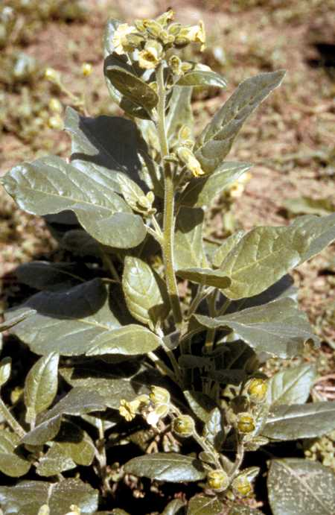

Tony Bush

Rose Lake Plant Materials Center

East Lansing, Michigan

Alternate Names

Aztec tobacco, Native tobacco, Zuni tobacco, Mapacho

Uses

Cultural Wild tobacco is a highly sacred plant in American Indian tribal culture. Although specific tribal uses may vary, it is integral to many ceremonies involving prayer, protection, reverence, and healing.

Status

Please consult the PLANTS Web site and your State Department of Natural Resources for this plant’s current status (e.g. threatened or endangered species, state noxious status, and wetland indicator values).

Description

Wild tobacco is an annual forb that grows to 5 feet tall but commonly shorter in areas north of its natural range. Leaves are alternate, entire, ovate to lanceolate, and up to 12 inches near the base but reduced gradually toward the top. Both the stem and leaves are pubescent. Pale yellow, trumpet-shaped flowers are approximately 1 inch long and borne in terminal panicles or racemes. The flowers also exude a rather unpleasant odor. The numerous, tiny, scarcely flattened, dark seeds form in capsules.

Adaptation and Distribution

Wild tobacco is native to the southwestern United States, Mexico and parts of South America. Given proper care, this species can be grown throughout the continental United States.

For a current distribution map, please consult the Plant Profile page for this species on the PLANTS Website.

Establishment

If starting indoors seed can be planted as much as 10 weeks prior to last expected spring frost. Surface sow seed approximately ½ inch apart on firmed soil in a 2 to 3 inch deep tray. Press seed to soil but do not cover more than 1/16 inch. Keep soil moist and warm. Most seed will germinate within 20 days. Seedlings can be transplanted to individual pots when the second set of leaves appears (approximately 2 inches tall). Transplant outdoors in a sunny location at 18-inch spacings into rich, well-drained soil after any chance of frost. Harden plants by placing pots in a shady outdoors area for 3 or 4 days prior to transplanting.

If seeding directly outdoors plant 4 or 5 seeds every 18 inches after the last expected frost. Thin to one when plants reach 4 to 6 inches. So as not to damage the roots of the desired plants, clip unwanted plants at ground level rather than pulling them.

Management

Wild tobacco can be periodically fed with a dilute liquid or small amount of dry fertilizer. Manure can be added to the soil mix in addition to or in lieu of fertilizer. Irrigate if conditions become droughty but wild tobacco is susceptible to disease problems when the soil is keep too moist. Pruning flowers can stimulate leaf growth. Harvest the leaves before frost and dry in bundles to retain moisture as they cure.

Prepared By/Species Coordinator:

*Tony Bush*, Agronomist, Rose Lake Plant Materials Center, East Lansing, Michigan

Edited: 06Feb2002 JLK; 060802 jsp

For more information about this and other plants, please contact your local NRCS field office or Conservation District, and visit the PLANTS Web site<<http://plants.usda.gov>> or the Plant Materials Program Web site <<http://Plant-Materials.nrcs.usda.gov>>

*The U.S. Department of Agriculture (USDA) prohibits discrimination in all its programs and activities on the basis of race, color, national origin, sex, religion, age, disability, political beliefs, sexual orientation, and marital or family status. (Not all prohibited bases apply to all programs.) Persons with disabilities who require alternative means for communication of program information (Braille, large print, audiotape, etc.) should contact USDA's* [*TARGET Center*](http://www.usda.gov/oo/target.htm) *at 202-720-2600 (voice and TDD).*

*To file a complaint of discrimination write USDA, Director, Office of Civil Rights, Room 326-W, Whitten Building, 14th and Independence Avenue, SW, Washington, DC 20250-9410 or call 202-720-5964 (voice or TDD). USDA is an equal opportunity provider and employer.*

*Read about* [*Civil Rights at the Natural Resources Convervation Service*](http://www.nrcs.usda.gov/about/civilrights/)*.*