

Plant Fact Sheet

# BEAKED PANICGRASS

## Panicum anceps Michx.

Plant Symbol = PAAN

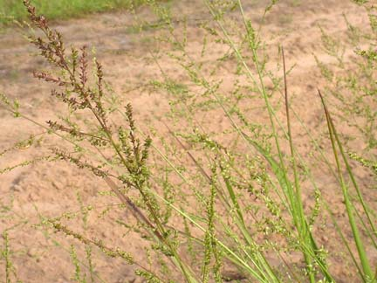Contributed by: USDA NRCS East Texas Plant Materials Center

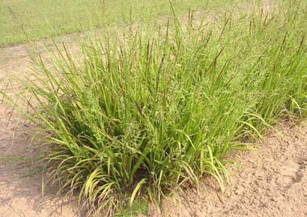

Melinda Brakie, East Texas Plant Materials Center

### Alternate Names

beaked panicum, spreading panicum

**Uses**

*Livestock:*

Beaked panicgrass is grazed by cattle and is of good value for grazing.

*Wildlife:*

Deer will graze beaked panicgrass. The seed are eaten by upland birds and some waterfowl.

**Status**

Please consult the PLANTS Web site and your State Department of Natural Resources for this plant’s current status (e.g. threatened or endangered species, state noxious status, and wetland indicator values).

**Description and Adaptation**

Beaked panicgrass is a native, warm season perennial and a member of the grass family (*Poaceae*). This grass grows from 2 to 4 feet tall (60 to 120 cm). The seedhead (inflorescence) is an open panicle 6 to 14 inches long (15 to 35 cm) and each spikelet ¼” to 1/8” long. The second glume is curved at the end like a bird’s beak, hence the common name.

Vegetative growth begins in February and is usually completed by May or June. Seed is ready for harvest in September. Beaked panicgrass is a prolific seed producer.

Beaked panicgrass occurs from New York to Florida west to Kansas and Texas. In Texas, it is found in the eastern half of the state. This plant prefers moist to wet soils. This plant is found growing in bottomland freshwater marshes and swamps on sandy soils. Beaked panicgrass grows best under 30 to 35 percent shade. The plants form large clumps as they spread from short rhizomes.

Melinda Brakie, East Texas Plant Materials Center

### Known Distribution

Please consult the PLANTS web site for the current distribution of this species.

### Establishment

Beaked panicgrass reproduces from seeds, tillers, and rhizomes. The seeds should be planted in the fall or early winter. If planting in the spring, treatment to overcome seed dormancy is necessary for satisfactory stand establishment. A common method for increasing seed germination is a cold/moist stratification treatment.

Plant vegetative material on three foot centers in the spring.

**Management**

Beaked panicgrass is grazed by cattle and horses. This plant contributes small quantities of forage since it is rarely abundant except on small areas. Close grazing causes the plant’s basal tufts to spread widely and the leaves form a dense cover over small areas.

**Pests and Potential Problems**

Check with your local extension service for recommended herbicides if control is needed.

**Environmental Concerns**

Beaked panicgrass has no known pests or problems.

**Cultivars, Improved, and Selected Materials (and area of origin)**

Presently, there are no commercial releases of beaked panicgrass.

### Prepared By

*Melinda Brakie*, USDA NRCS East Texas Plant Materials Center, Nacogdoches, Texas

**Species Coordinator:**

*Melinda Brakie*, USDA NRCS East Texas Plant Materials Center, Nacogdoches, Texas

Published: September 2007

Edited: 070912jsp

For more information about this and other plants, please contact your local NRCS field office or Conservation District <<http://www.nrcs.usda.gov/>>, and visit the PLANTS Web site <[http://plants.usda.gov](http://plants.usda.gov/)> or the Plant Materials Program Web site <<http://plant-materials.nrcs.usda.gov>>

**USDA IS AN EQUAL OPPORTUNITY PROVIDER AND EMPLOYER**